Dih Sar Expedition 2023 Report
Location: Pakistan, Northern Karakoram, Ghujerab Mountains, Shimshal area Dates: 6 September to 25 September Report by Peter Thompson Contact: peterthompson137@gmail.com

Objectives
To make the first ascent of Dih Sar, 6,207 metres, by the southern slope and east ridge, climbing alpine style.
To make the first ascent of Yazpurz Peak, 6,008 metres, by the southern slope and west ridge, climbing alpine style.

Heights are from Google Earth. The Soviet 1:100,000 map gives heights of 6,200m for Dih Sar and 5,940m for Yazpurz Peak. The Wala map gives heights of 6,200m for Dih Sar and 6,175m for Yazpurz Peak. I think Yazpurz Peak is unlikely to be as high as 6,175m.

Dih Sar 36.584200"N 75.294790"E
Base camp 36.613406"N 75.353493"E

Expedition Members

Peter Thompson
Tim Oates

Summary

Our main objective was to make the first ascent of Dih Sar 6,207m by the east ridge. Our plan involved crossing Joshi Pass 5,423m to reach base camp in the Dih Dur Valley. Unfortunately, Tim got altitude sickness approaching the pass and he returned to Shimshal village to recover. Meanwhile porters carried some climbing gear, a tent and some supplies up to Joshi Pass so Tim and I could operate from there if he returned. We would either go down to Dih Sar base camp to attempt Dih Sar or climb peaks above the pass. While Tim walked back to Shimshal village with the porters, I went up to the pass alone. The next day I climbed along a ridge north of the pass. This was the south ridge of Shar Izat Peak 5,930m, which had been climbed previously by a different route. I crossed two tops on the ridge which was easy (Facile grade) but corniced, and after 1.5 kms reached a third top, the highest at 5,696m (GPS). According to Janusz Mayer, who led a 2022 attempt on Dih Sar, these tops are probably unclimbed. They are marked as 25,26 and unmarked on the Jerzy Wala map. My high point had little prominence as beyond it the ridge dropped a short distance to a col before rising up towards a top marked 29 and then the summit of Shar Izat Peak. The ground ahead looked trickier for solo climbing, so I returned to my tent at the pass. The next morning, I learned by Inreach that Tim was not coming back up, so we arranged porters for our return to Shimshal village, ending the expedition.
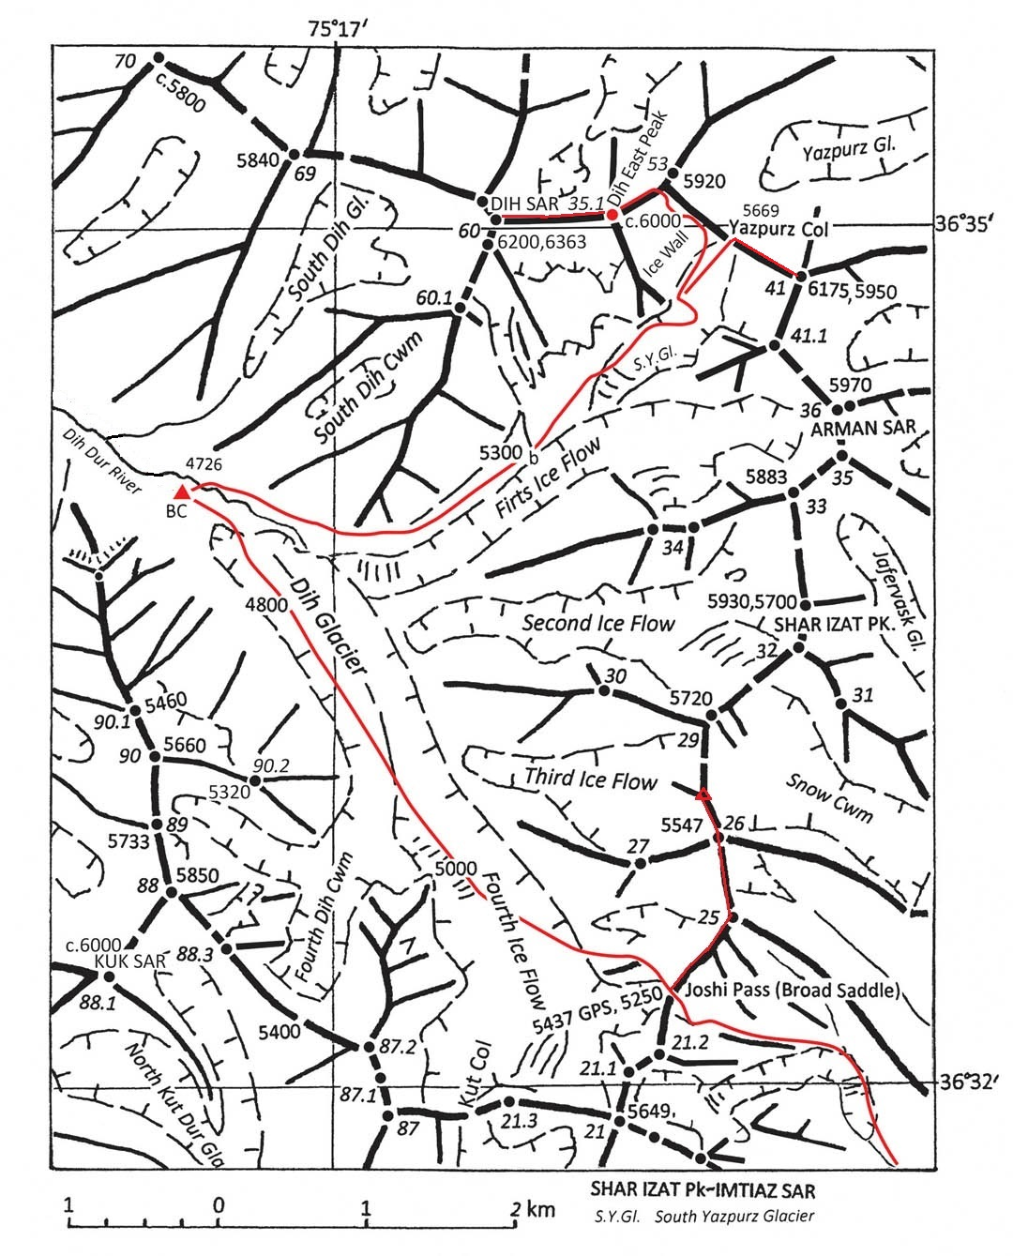

Jerzy Wala map showing our intended approach to Dih Sar base camp over Joshi Pass and our proposed routes on Dih Sar and Yazpurz Peak (marked 41). North of Joshi Pass is the route I climbed to tops 25, 26 and my high point at 5,696m.

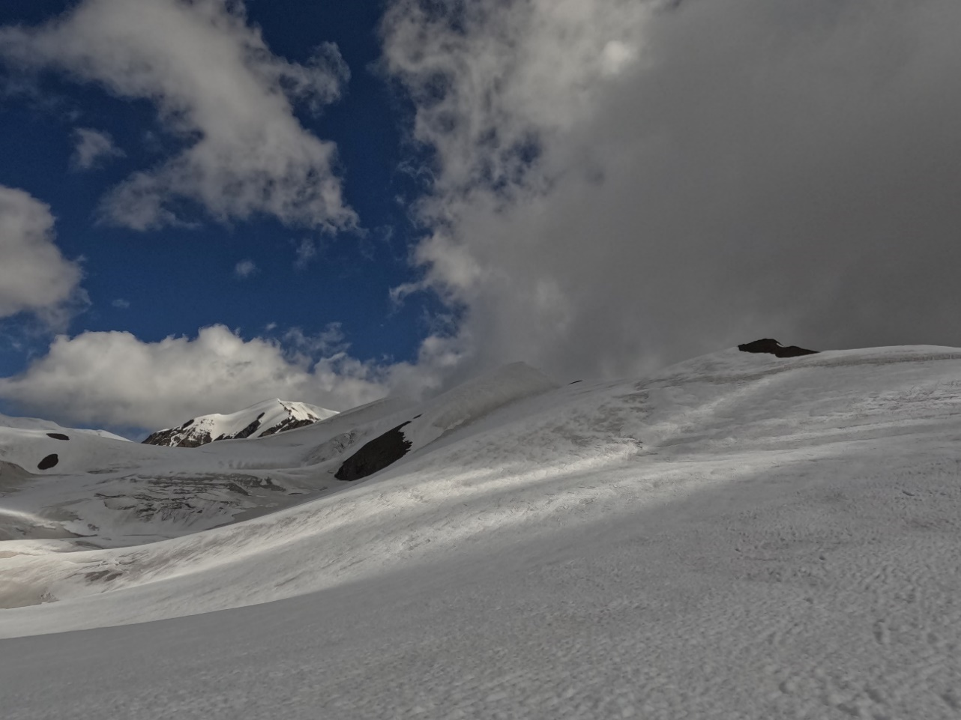
The ridge I climbed with the tops I climbed in shadow and beyond top 29 in the
sunlight.

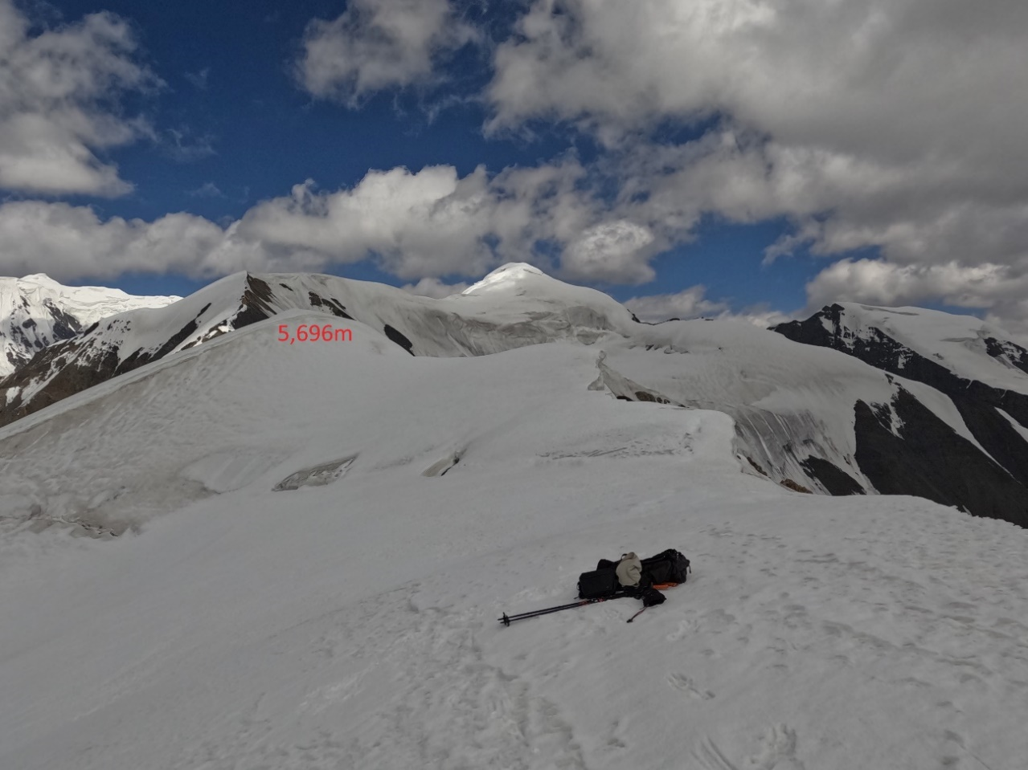
My highpoint with top 29 beyond and Shah Izat Peak in the sunlight beyond that.
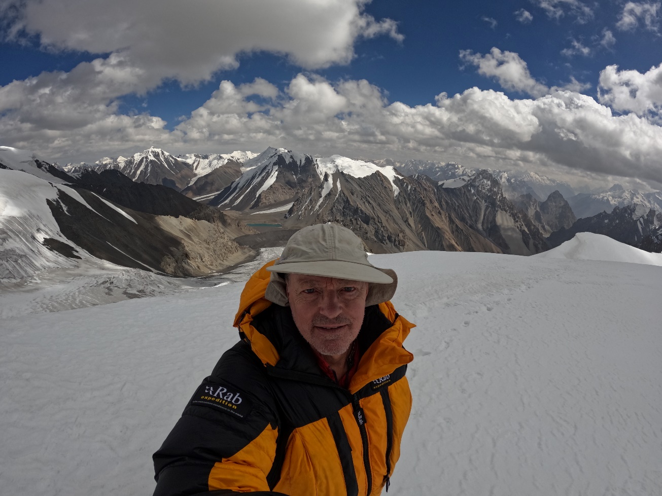
View from my highpoint down towards the lake near Boesam Pass.

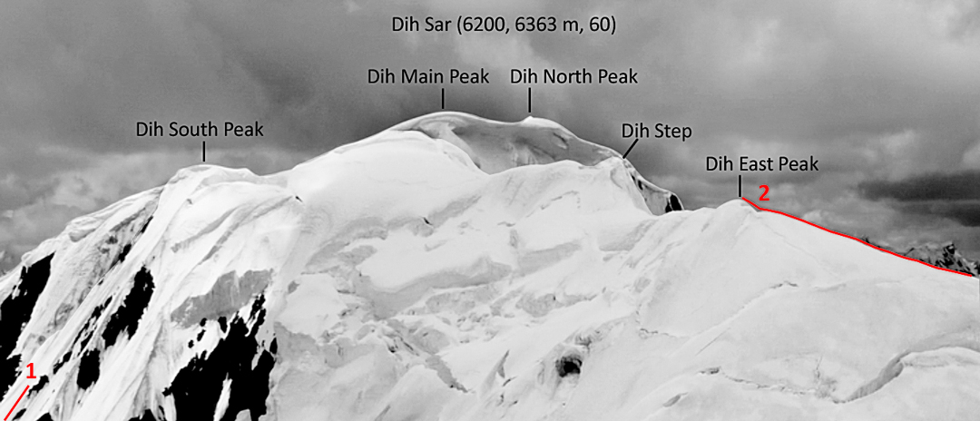
Dih Sar summit area from Krysztof Wielicki’s 2022 expedition showing their high point they called Dih Sar East. There is a report in the Americam Alpine Journal. Photo by Dariusz Zaluski.

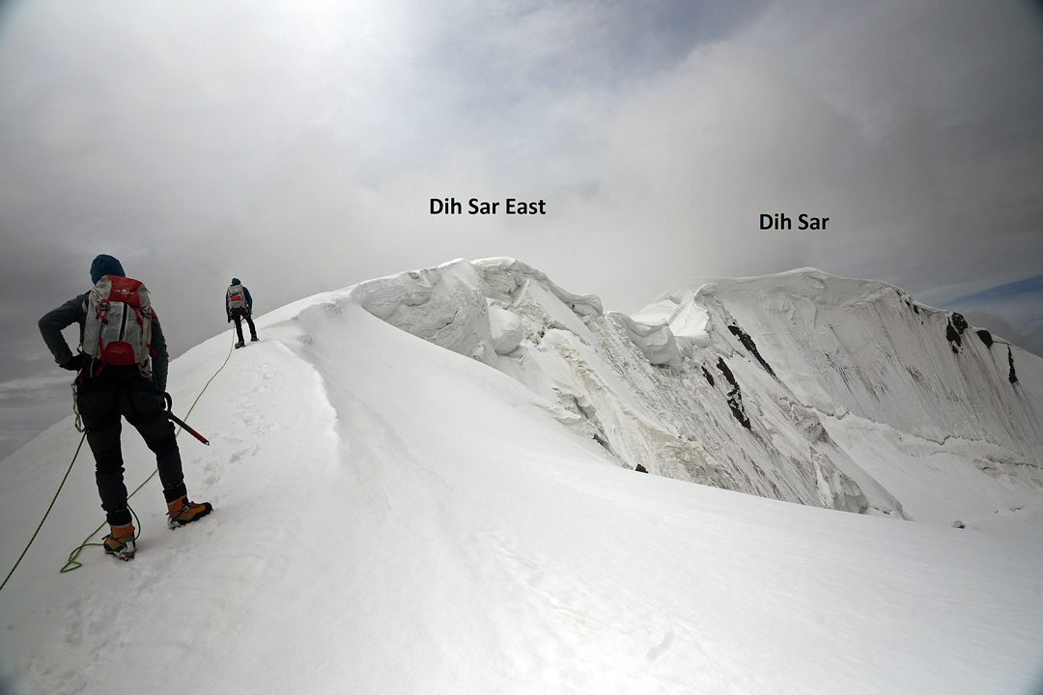
Dih Sar summit area from the Wielicki 2022 expedition. Photo by Dariusz Zaluski.

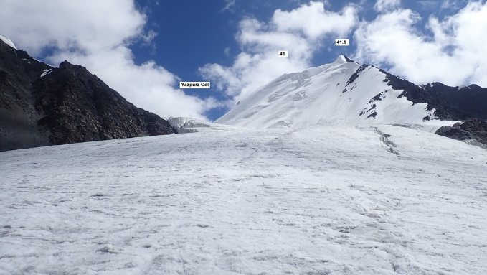
Yazpurz Peak 41. Photo from Wielicki 2022 expedition.

Diary

Sept 6 We flew from Manchester to Islamabad.
7 We flew from Islamabad to Gilgit. We were driven to Karimabad.
8 We met our Guide Muhammad Amin and cook Muntazir from Adventure Tours Pakistan. We went food shopping in Aliabad where there is a good selection.
9 We got a Landcruiser to Shimshal village. We stayed in a guesthouse. We arranged 12 porters including their sirdar Irshad and some donkeys amounting to 16 porter loads.
10 We trekked to Zardgarben 4,055m. Tim and I had headaches.
11 We felt well enough to continue, and opted for a short trek to Schpodeen 4,452m.
12 We trekked to High Camp 4,778m. Tim had altitude sickness with a persistent headache and returned Schpodeen to with two porters.
13 Tim returned with the porters, but headaches returned.
14 Due to limited food and fuel, the porters could not remain at High Camp for much longer. We decided to make High Camp our base camp and sent up some gear to Joshi Pass for an ABC from which to attempt Dih Sar or attempt a peak above the pass.
15 Tim went down to Shimshal village with the porters to recover. I went up to Joshi Pass 5,440m alone. The route was snow-free, fairly easy but with a fair amount of scree.
16 I climbed along the ridge north of Joshi Pass as described above and returned to my tent on the pass for the night. There was also a 5,649m peak south of the pass, probably unclimbed according to Mayer, which I wasn’t willing to solo. It was also an easy glacier descent from the pass to Dih Sar base camp at 4,726m.
17 In the morning, I learned by Inreach that Tim in Shimshal was not coming back up which was understandable. I asked him to send the porters to base camp and I went down to base camp.
18 The porters arrived, collected the luggage from the pass and we went down to Zardgarben. There I met an old climbing friend Lee Harrison and his partner Arran who had been climbing near Boesam Pass and were on their way down.
19 We arrived in Shimshal where happily Tim had recovered. We got a Land Cruiser to Karimabad.
20 Muhammad showed us some Hunza hospitality in Karimabad marking the end of the expedition.
21 After changing our flights we flew back to the UK.

Previous Attempts on Dih Sar

A study by Janusz Majer and Jerzy Wala: "Tupopdan Mountain Group and Karun Koh Mountain Group”, together with an orographic map of the area in the scale of 1: 100,000 issued in 2018, resulted in interest in this previously little-known region of the Karakoram and various peaks have been climbed.

In September 2019, Polish climbers Jakub Bogdanski and Michal Ilczuk, trekked over the Boesam Pass to the Ghujerab Valley and reached the south side of Dih Sar via the Dih Dur Valley. They attempted two routes on the southeast face of Dih Sar reaching 5,950m.

In 2020 Bogdanski and Ilczuk returned and attempted the southeast face of Dih Sar reaching 5,800m before a fall resulted in injuries to Bogdanski. After sending a message with their
Inreach rescue attempts were under way, but Ilczuk fell ill and died during their second night bivvying on the mountain.

In 2022 a largely Polish expedition led by Krzysztof Wielicki approached the same south side of Dih Sar via Joshi Pass. Wielicki, Katarzyna Karwacka-Wielicka and Dariusz Zaluski reached the Yaspurz Col and climbed the east ridge of Dih Sar to their high point on a top they called Dih Sar East ca 6,100m. There is a report with photos in the online American Alpine Journal.

Budget

Expedition Costs |  | Expedition Income
International travel | £1800 | Mount Everest Foundation grant | £4500
Domestic flights and transport | £380 | British Mountaineering Council grant | £650
Offsetting | £140 | Montane Alpine Club Climbing Fund grant | £1000
Agency charge | £400 | Tim | £890
Equipment rental through agent | £460 | Peter | £890
Expedition members' insurance | £280
Inreach subscription | £100
Guide and cook | £1040
Porters including insurance | £2260
Tips | £220
Mountain food and gas | £270
Food and fuel | £250
Hotels | £330
TOTAL | £7930 | TOTAL | £7930

Permits and Insurance

No permit is required in this area for peaks below 6,500m. Nor is a NOC (No Objection Certificate) required any more as was the case a few years ago.

Our insurance through Global Rescue was medical evacuation only up to 4,600m (around base camp). At £140 per person this was far less than full insurance. We had an Inreach communicator.

Guides and Porters

Through our agent Adventure Tours Pakistan we had a guide, cook and kitchen tent for the trek and our time at base camp, and we needed 16 porters. Our agent also arranged the
porters which was quite an expensive way of doing it. There were reasons we used our agent. Firstly, porters can be hard to come by in Shimshal village, particularly if you arrive
unannounced, although men and donkeys are usually readily available. Because we were
going over Joshi Pass, we needed porters rather than donkeys and our agent had arranged a
sirdar, the very capable Irshad, to organise the porters. Secondly, our agent could arrange insurance for our staff and porters. Lastly, I could transfer all the money for the agent’s quote from the UK to save carrying lots of money.

Our cook Muntazir cooked excellent food. We felt that if we had good food on the trek and at base camp it would help our chances to climb Dih Sar. Our guide Muhammad wasn’t really necessary as Irshad organised the porters and knew the lie of the land. Nevertheless, he was very capable and he would keep Muntazir company at base camp.

Through our agent we paid the guide $30 per day plus $100 kit allowance, the cook $25 per day plus $100 kit allowance and the porters around $20 per day. Tips were extra. We paid the guide and cook for the whole time although the expedition finished early. A Landcruiser cost $90 from Karimabad to Shimshal. A Landcruiser was more economical than getting two smaller jeeps.

It is cheaper to hire your own porters in Shimshal village which can be done at the Shimshal Guesthouse. Of course, you can also do your own cooking, and save the considerable expense of a cook, kitchen tent, large kerosene stove etc. The Shimshalis may encourage you to have a guide or sirdar, but he could be employed just to base camp, and return later with the porters.

Weather and Climbing Conditions

The weather was generally good during the time of our trip in September. For the short bit of climbing I actually did, the conditions were good with a firm, frozen surface all day. Given the warm temperatures experienced on 5,000 and 6,000m peaks in the summer months, and the unpredictable weather, September could be a good option on small peaks in this part of the Karakoram.

Acknowledgements
Thanks to the Mount Everest Foundation, The British Mountaineering Council and the Montane Alpine Club Climbing Fund for their support.

