Alaska Expedition Mount Thunder 2019
Team Leader
Tim Blakemore, 48, British Mountain Guide
Been climbing for more than 20 years on every continent on earth. Many Alpine routes and North Faces including Matterhorn, Jorasses, Droites (3 times), Sans Nom, Beyond Good and Evil etc. Longer ridges like Salbitschen, Peutery Integral, Innominata, Brouillard. Scheideggwetterhorn etc
New routes and repeats of hard ice in Norway (Lofoten, Senja and Aurland/Laerdal/Gudvangen) : Gully of the Cods (new route on Vagakellan Scottish VII), Pass the Dutchie (Senja) M7 600m and 1st ascents of Hungry Fossen WI 6 and Voldafossen WI6+.
New routes in UK include Northumberland and Scotland (Ben Nevis and Glencoe, Beinn Bhann etc) inc early hard repeats to VIII (when that was hard) and solos of ice routes to VI.
Attempted new routes in Nepal.
Various expeditions to Nepal, Africa, Ecuador, Mexico, Kyrgyztan, Antarctica.
Exploratory ski/sail trips to Western Greenland, Arctic Norway and Antarctica.
I am a full time IFMGA/UIAGM Mountain Guide
Mike ‘Twid’ Turner ,52, British, Mountain Guide, MIC.
Climbed over 70 E7/8 routes many first ascents, many 8a sports routes. Winter climbing at Scottish 7 ice and mixed 8. M7, Extensive experience winter climbing worldwide. Scotland 30 yrs. of winter climbing, Norway, Iceland, Canada, US, Morocco, Alps, Slovenia. 30 yrs. of Alpine Summer 28 years of winter Alpine Climbing. High lights North faces of Eiger, Jorasses 3x , Doites, Divine Providence, Fisch etc
25+ yrs of Expeditions inc: Alaska 13, Baffin 2, Patagonia 8, Borneo, Pakistan 3, Mali 2, Madagascar, Greenland, US, Brazil, Morocco 15. Last 6 nominee Piolet D’Or.
High Lights Vitalstics E8 Gogarth, Scrabble mixed 8 Scotland, Octopussy M8, Super Supa Alaska, Nawas Pakistan 1300m Big Wall, Arctic Monkeys Baffin 1600m 23 Days,
Contact details
Chalet Namnam et Glouglou,
Chemin des Cible3
Huemoz
1884
Vaud
Switzerland
0041 799588412
twidturner@aol.com

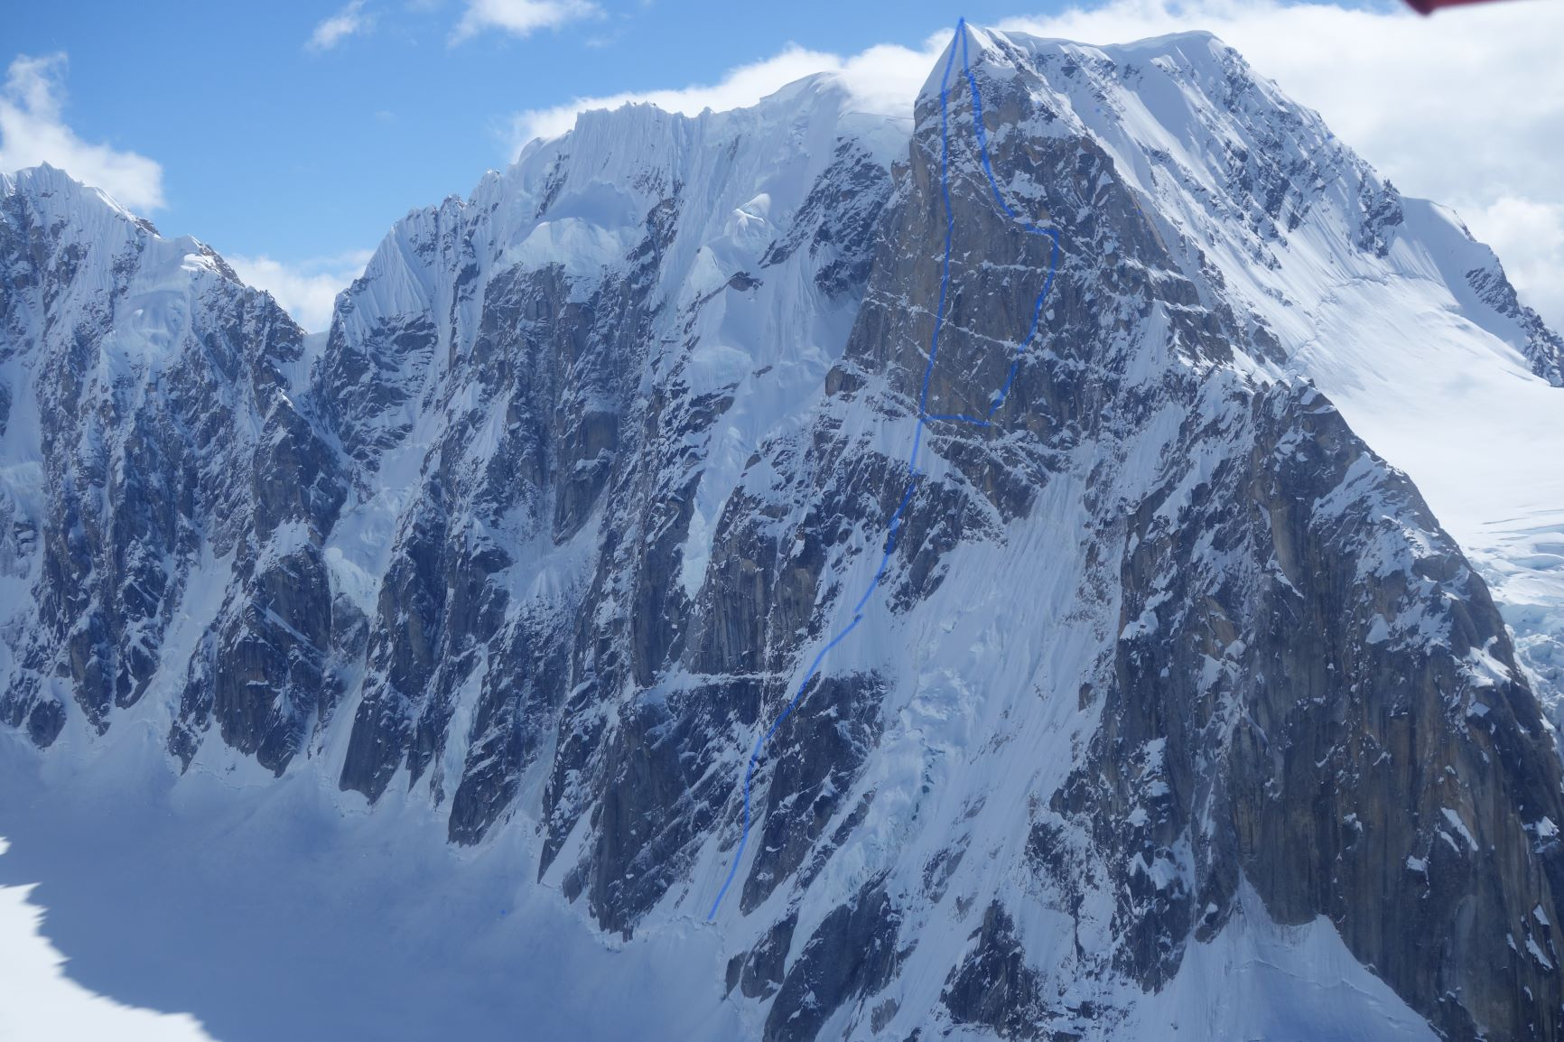
Objective: North Face of Thunder Mountain. To make a new route that attacks the prow of the North Face. Alaska Range.
Google Earth coordinates of main objective 62.886717, -151.102378
Trip Report
Frustration can be a word that can be a word that is often applied to Alaskan climbing. Without any doubt one of the most amazing and inspiring of the Greater Ranges of the world. Alaskan climbing when it comes together is a big adventure. But when the weather follows a path of endless storms and very cold early season the climbing conditions are totally horrendous. This was our experience in 2019, The Expedition was very unfortunately hampered constantly with big storms bringing huge amounts of snow that only made avalanche conditions very bad and buried the climbs. Coupled with the fact that the early season had been very dry of ice. Cold and windy. This meant it was difficult to find good snow, ice and mixed conditions for the climbing.
Thunder Glacier
The team had to wait a number of days before flying into the Thunder glacier due to weather. But eventually Paul Roderick dropped the team below the North Face of this impressive face. The remote feeling soon hits when the small aircraft lifted off and left the climbers. The team put up camp and headed off for an early reconnaissance of the face. As was to be expected with the recent snow fall was plastered with fresh snow. There was 3 potential lines of approach to the face and unclimbed wall:
- A line right of the original ice line of Jack Tackle and Jim Donni. But this was very dry and no ice in the gully. It was also avalanching badly.
- The line we had hoped for was a slanting left to right ramp that lead into a short wall that gave access to the upper safe ice face leading to the main Big wall at the top. The ramp was choked with snow and more importantly had a huge snow mushroom 10m high balanced precariously in the ramp barring the way. The thought of climbing below such a huge mushroom didn’t seem a sensible route and a good chance of the mushroom coming down on top of the climbers.
- The third option was to quest out below the seracs on the right hand side of the face then slant up to below the rock wall. We observed this for a day and thought this a possible solution to tackling the dangerous lower area. We waited till the following morning to see how things might of cleaned up with the snow. The following morning after more snow we sat around waiting for cloud to clear sufficiently to see the face. At moment it cleared and we got a good view. Just at this moment a serac collapsed on the righthand side of the face and the subsequent avalanche racked the whole side of the mountain we had thought to attempt to climb! Clearly this was not going to be an option! After a discussion it was felt the face out of condition and too dangerous to attempt. With no other safe options to climb from the Thunder glacier the team thought to move to another venue.
- Foot note. We felt the line would be climbable but when the ramp would be clear of snow. This will just depend on how seasonally the snow has formed on the ramp. Future teams might get more luck. Having a combination of Big Wall and Alpine equipment, as the team had, seems the sensible approach.
The team then got a second flight to the main base camp approach glacier to Denali. The Kahiltna Glacier is a two ski from the North Buttress on Mount Hunter. The team thought to check out conditions on the face and possible attempt of a new line or repeat of an older classic route. The face was found to be very dry and with very little ice for climbing. Coupled with the mountain of snow it was not looking a promising climb. The weather then had another big storm putting down more snow for a few days. Days went by while the storm passed and then it was obvious that it was going to be some time before anything was possible to climb.
News had come in that perhaps further East there might have been a bit less snow and with the possibility of better climbing conditions. So a third flight was taken to the glacier that leads to the area between The Rooster Combe and Peak 11.300. Commonly called the West Fork of the Ruth. This impressive narrow valley has many incredible faces. The exciting flight drops us in a safe place to camp. With the last weeks of snow this was not always an easy option. Our hopes started to get hopeful with what we could see. We could see many potential lines and possible projects. But has was the season on return to our camp from our initial foray on the glacier it started to snow. So it snowed for a number of days! Avalanches raged around us and we spent our time digging out the tent and using the sat phone asking for weather updates. It was clear a large window of good weather wasn’t going to happen for some time. After days we had a potential ride out with Talkeetna Air Taxis in a small window of weather. Even then it was unlikely the plane would come but Paul Roderick dropped into a hole in the clouds from above and the great escape back to Talkeetna was most welcomed.
Potential lines on the West fork seem worth exploring and we both felt this was an area ripe for further exploration for future climbers.
Observations on the weather/Seasons
As with across the planet it seems Global Warming is changing the seasons. Colder winters with less snow means less potential ice in the Alaskan Range. Storms seem to be in May which normally would be rolling only in April. Its hard to know when to climb in the Range but one thing seems certain going later will get better conditions. Later in the season in June may have been a better bet in 2019 season. June is more like May 10 years back. The Ranger station for Denali seems to be going in later than previous seasons. More chance of ice later seems a better bet.
Travel to Alaska
We flew with Air France/KLM which worked well. They provided one 23kg bag as part of the ticket and we had to buy a second each to get all our climbing equipment to Alaska. The flights where routed through Amsterdam to Seattle then onto Anchorage.
Travel from Anchorage to Talkeetna
We used the transfer company Go Purple run by Gary. They provided a good service, not cheap, but totally reliable and the van had plenty of room. Gary offers a return rate and a good pick up at any time in Talkeetna. Go Purple seems the most reliable and busiest outfit and cheapest. We would certainly recommend using the company. It takes around 3 hours to travel from Anchorage to Talkeetna:
Go Purple Shuttle Tour
P.O.BOX 111036 Anchorage, AK 99511
reservations@gopurpleshuttle.com
907-644-8098
Toll free
866-813-5589
Flying into the Glacier
The team used Talkeetna Air Taxis, as do most of the climbing teams operating in the Alaska Range. Paul Roderick is one of the Ranges most experienced Pilots. He has a large crew, great office support and plenty of planes. Cesnas and Single Super powered Otters take his clients to glaciers of choice. The Climbers get 112lbs in the price to the glacier and then an extra amount per excess. They can provide wands to mark routes and plastic sledges to help haul kit around the glaciers. Essential!
Flying into these more remote areas requires at least a line of sight with the landing. Thunder Glacier was no exception and it took some time for TAT to feel happy to try a landing on this glacier esop as nobody else had landed in the cwm that season(Not uncommon). Loading a Cesna up the team made the flight to the impressive flight into the mountains. Paul flew the team around to check out conditions but that wasn’t really much help as everything was so plastered in new snow. So the team quickly decided to go with the original plan and check out the Thunder mountain North Face from the ground.
Talkeetna Air Taxis
PO Box 545
Talkeetna, AK 99676
907.733.2218
info@talkeetnaair.com
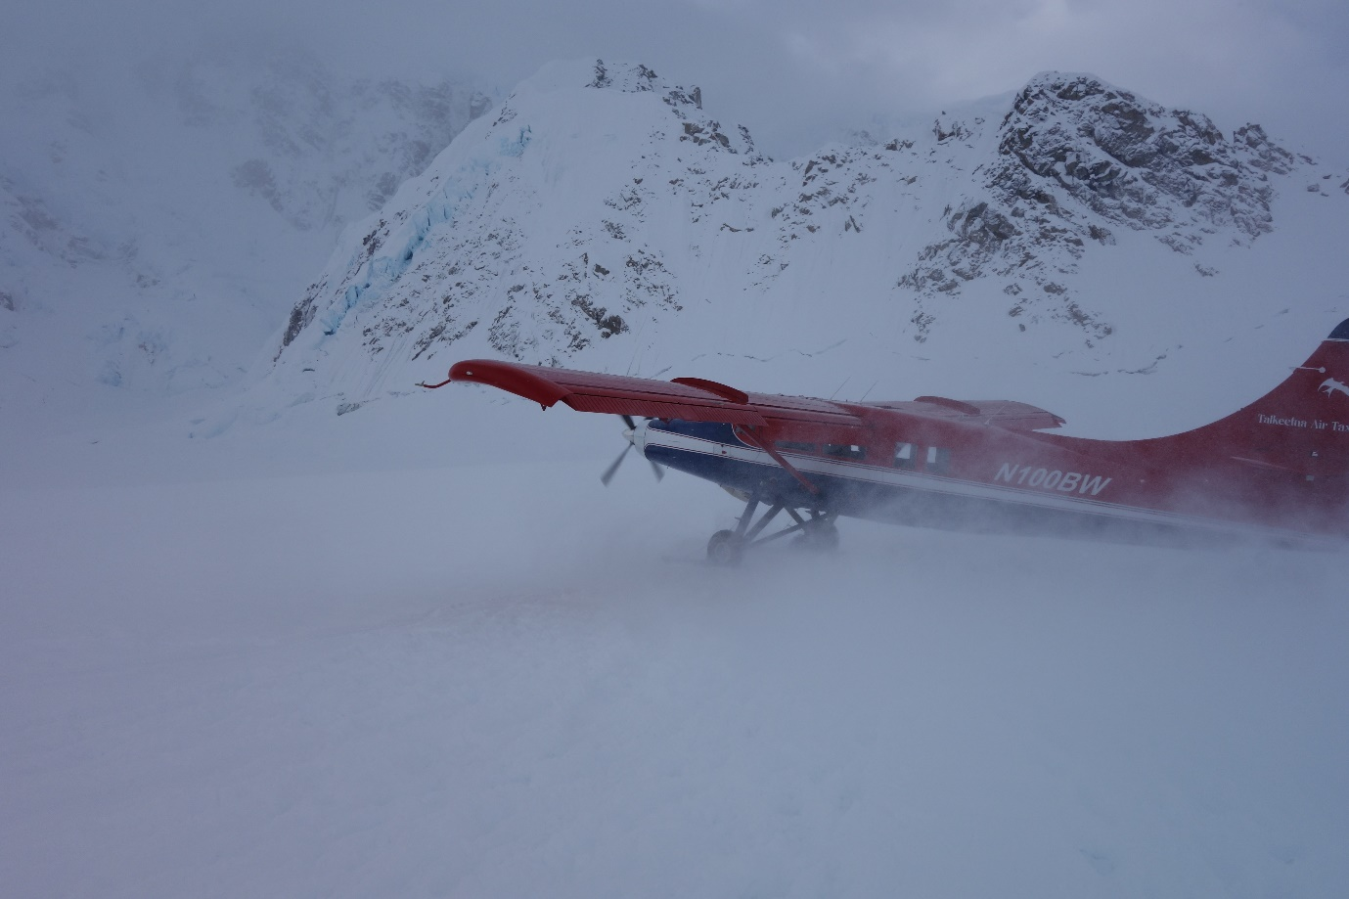
Communications
Its essential to have good coms in the Range. Its impossible to get help otherwise. Many folk, as the team did used a Sat phone. Its worth noting that Iridium are the only reliable system working in Alaska. Other SAT phone systems do not tend to work as well. We had a SAT phone and purchased the smallest sim card amount of $200. This gave us direct communication to the airline TAT for weather updates and pick up. Its also possible to talk to the Ranger station in Talkeetna to get further weather reports. Many climbers now seem to rely on the Garmin Inreach system. Which allows text messaging to folk at much reduced price and reliability. The small in reach module can be easily linked with an app on your iphone to gather data and email.

Permit and Ranger Station
If you are climbing in the Denali reserve you will need a permit to climb. This must be applied for some months before arriving in Alaska. For outside the Park, like Thunder Glacier, you just need a Park ticket which can be bought from the Ranger station. They take your details for emergency and contact details. Generally offer good sound advice for climbers and there is a large resource of climbing documentation on previous ascents and first ascent info.
The Clean Mountain Cans CMC’s are compulsory for all climbing in the Alaska Range. These are sealable bdh canisters with a value for carrying out all your human waste. They also provide free bio degradable bags to go inside the cannisters. On completion of an expedition these are taken back to the Ranger station for disposal. Its free!
Talkeetna Ranger Station
B Street, PO Box 588, Talkeetana, AK 99676,
Dena_talkeetna_office@nps.gov
Opens 8am till 6pm.

Equipment
The team equipped for all eventualities. To travel about its essential to either have skis or snowshoes. The team had both. With the amount of snow that had fallen to move around at all was impossible without. Skis make the easiest form of travel and offer some fun in the powder if weather stops the climbing.
A good base camp tent is always essential and we used shopping bags for life to secure the tent in the snow along with snow stakes. A small bivi tent was taken but not used as was a portaledge.
Standard alpine climbing rack of two light 60m ropes, screws, cams, nuts and pitons along with some Big Wall gear for any technical steep rock.
We had two gas Jet boil stoves for the glacier and plenty of 250gm cartridges. One a day is the normal requirement.
Food and Provisions
In Anchorage you can buy anything you would ever need on Expedition. Best buy all food in Anchorage. There is a small shop in Talkeetna but doesn’t have much and is very expensive.
Gas and Climbing supplies
Alaska Mountaineering and Hiking. AMH.
2633 Spenard Road
Anchorage , Alaska 99503
amh@alaska.net
907.272.1811
The Hoarding Marmot on Spenard is also an excellent shop. It provides second hand equipment left by climbers. It’s a cheap way of replacing any left equipment.
Hoarding Marmot
1231 West Northern Lights Boulevard,
Anchorage,
AK 99503
info@hoardingmarmot.com
REI
Is a huge shop and supplies gear and clothes plus dehydrated food. It has a vast supply of outdoor gear and skis. The shop has moved and is not as useful as it once was. But worth a trip.
500 E Northern Lights Blvd, Anchorage, AK 99503
Accommodation
While staying in Anchorage the team stayed at the Microtel near the Airport. It was inexpensive and had big rooms, close to the airport and handy for late arrivals in Alaska. They have a store room for leaving gear while you are shopping or in the mountains. Its easiest taking a taxi to the main shopping areas around Northern Boulevard.
In Talkeetna TAT provides a free bunkhouse in town where climbers can sleep, cook and sort gear. Its an ideal spot close to the Park Rangers post and restaurants.

Finances of Expedition
The team were extremely grateful for the grants, particularly as the Pound was so weak against the dollar. Alaska is expensive but unrivalled access makes it a good bet if the weather works. We were charged quite heavily for using a UK debit card and in future a card which can be used against all currencies would be used i.e Revolut etc
Flights £1760
Air flights in Alaska Range (TAT) £1690
Excess baggage £380
Airport transfers £110
Bank charges £63.35
Microtel £82
Talkeetna food £112
Purple Taxi £193
Wallmart, gaz etc £176
Satphone £109
Replace broken stove with 2nd hand one £17

Total £4692.35

Referees
Owen Samuel 21 High Street , Llanberis, Gwynedd, LL554EN OWEN@IBEXGUIDES.COM
Jon Bracey 810 Route de Granges, Les Houches, Haute Savoie, 74310, France jonbracey@yahoo.co.uk

