British Chombu Expedition 2019

Supported by:

Berghaus
Mount Everest Foundation
British Mountaineering Council
Black Diamond

Contacts for further information:

Mick Fowler mick.fowler6@gmail.com
Victor Saunders victorsaunders@gmail.com

The compilers of this report and the members of the expedition agree that all or any of it may be copied for the purposes of private research.

Aims of the Expedition

To make the first ascent of Chombu (6,362m) in north Sikkim

The Team

Mick Fowler (62) British. Retired. Leader.

Regular climber in the greater ranges for over 30 years. Recent expeditions include Mugu Chuli West Face (2011), Prow of Shiva (2012), Kishtwar Kailash West Face (2013), Hagshu NE Face (2014), Gave Ding North Face (2015), Sersank North Face (2016)

Victor Saunders (69) British. Mountain Guide

Regular climber in the greater ranges for over 30 years. Six times to the summit of Everest. Expeditions in recent years include Ama Dablam (2011), Everest (2012), Aconcagua (2013), Chamsen (7017m –first ascent - 2013), Manaslu (2014), Sersank North Face (2016)

Introduction

Mountaineering in Sikkim is closely controlled and easy access is only granted to five peaks of which Chombu is not one. To climb any peak aside from the five permitted peaks requires a raft of special permits. Chombu lies in north Sikkim, an area close to the Tibetan border, which is particularly sensitive. It is not practical for mountaineers to secure permits themselves and so complete trust has to be placed in one’s in-country agent.

History

1944 C Cooke and D McPherson tried to reach the foot of the north ridge but failed due to deep snow. (Himalayan Journal 1946)

1952 Reconnaissance by Trevor Braham. No attempt made. (Himalayan Journal 1954)

1961 Ascent by unspecified route claimed by members of Sonam Gyatso’s expedition. Widely disbelieved. (Himalayan Journal 1961)

1992 Japanese attempt from the east via Sebu La and Chombu Glacier. High point reached not far short of summit ridge. (Alpine Journal 1993)

1996 Doug Scott’s expedition turned back on N side by bad weather and soft snow. (American Alpine Journal 1997)

2007 Roger Payne and Julie-Ann Clyma turned back on N side due to ‘interesting’ snow. (American Alpine Journal 2008)

Preparation

All our in-country arrangements were handled by Barap Namgyal Bhutia of Sikkim Tour Trek and Expedition whose services we found to be excellent. His contact details are as follows:

Barap Namgyal Bhutia, Sikkim Tour Trek and Expedition
Sonam Gyatsho Marg
Near Enchay Compound
Tibet Road
Gangtok PIN 73701

E-mail: gosikkim@gmail.com

Timing

We arrived in Sikkim on 1st April and base camp was reached on the 6th April. A further 18 days were spent at or above base camp. From 7th – 12th April we did a reconnaissance and acclimatised. Throughout this period the weather was variable with a couple of clear nights which froze the winter snow and enabled easy travel. From 14th until we left base camp on the 26th the weather was warm and misty with considerable snowfall every day. The old snow never froze and the avalanche risk from the new snow was high. The locals advised us that conditions are likely to be better post monsoon when the weather is colder and night freezes are more likely to result in good climbing conditions.

Travel

Jet Airways more or less folded in the run up to the expedition and the flights we booked months in advance were cancelled. We were fortunate in being able to re-book with Air India and travel without incident from Heathrow to Bagdogra with a change at Delhi. It is worth noting that Air India allow 2 x 23Kg hold bags with an economy ticket.

Arriving at Bagdogra in the morning of the 1st April we were met by Sikkim Tour Trek and Expedition and driven to Gangtok in approximately 5 hours. In Gangtok we collected our gas cylinders and met our expedition staff comprising a Liaison Officer, cook, kitchen boy, and four sherpas. We understood that sherpas are mandatory but future expeditions could probably negotiate the number down from four.

It transpired that winter snows had been so heavy that the Lachung valley was closed and the Lachen valley had only been opened to Tanggu a couple of days previously. Also we were advised that the local people were so keen to be out searching for caterpillar fungus (very valuable on the Chinese medicine market) that they were not interested in portering and our porters had to be brought in from Darjeeling.

On 2nd April two jeeps transported everyone to an overnight stop at Lachen, the last sizeable town in the Tista valley. On 3rd April we continued to Tanggu (3,900m) noting that extensive snow ploughing had been necessary to clear the road of avalanche debris which contained numerous snapped off trees. The true extent of the exceptional winter snows became clear when we reached Tanggu and saw that the roofs of many of the buildings had collapsed under the weight of the snow. Army officials told us that their records showed that the area had experienced its heaviest snowfalls since 1995. Locals told us that seven feet fell in one go!

On 4th April we started up towards base camp. The first 5km would have been a 4x4 motorable road except that it was banked out with snow in numerous places. Fortunately the track was on the south facing side of the valley which had far less lying snow than the north side. We were short of porters and those we did have carried triple loads. The weight and the soft snow slowed things considerably and we only reached a point about half way to base camp on the 4th. The track ahead was curiously well made up but largely covered by snow. Shortage of porters meant that a considerable amount of kit had been left at Tanggu. The porters spent the 5th ferrying this kit up to the point reached on the 4th while we did a reconnaissance with the sherpas up to possible base camp sites. On the 6th the majority of the kit was then taken up to a base camp at c4,600m, 30 minutes short of the remains of the old Himalayan Club hut at the foot of the Sebu La pass.

Acclimatisation

After a rest day at base camp we headed up to bivi at 4,900m and then 5,100m below the west face. The weather was misty and warm and the snow soft, deep and heavy going. On the 9th we got a view of the west face and decided that the conditions were not well suited to an ascent. We then decided to do a reconnaissance of the NW and N sides of the mountain. On the 10th we climbed up to bivi at 5,300m just below the Sebu La pass. We were able to get good views of the N side as we climbed a c5,500 peak on the watershed. After spending two nights at 5,300m we concluded that we were sufficiently acclimatised and descended to base camp. The conclusion of our reconnaissance was that we felt that conditions were not good and our best chance of success lay in climbing a long snow/ice couloir to gain a plateau below the north face and then climbing the face left of the fall line of a big serac to gain the curling summit snow ridge.

Attempt

On return to base camp the weather worsened. We spent two days resting and eating before moving up to the foot of the face through heavy snowfall and deep lying snow. Poor weather continued for the next five days. Every morning we set the alarm ready to get an early start but every morning it was snowing hard and not freezing. The general weather pattern was extremely frustrating. By 8am or so it would be sunny and clear up to around 3pm when it would start snowing. Snow would then fall heavily right through the evening and night, only easing at c8am the next morning. The end result was that every day we had 10cm or so of new snow lying on deep, soft, unfrozen old snow. Effectively it gave the worst of both worlds – high avalanche risk and extremely heavy going.

Ultimately we concluded that it was too dangerous to attempt an ascent and the weather pattern was set to stay such that if we didn’t opt for a lesser objective we were very likely to achieve absolutely nothing beyond testing our Berghaus kit in nasty conditions.

Immediately west of the west face is a small summit on a long ridge stretching north from Chungukang. Chungukang North as we christened the peak had a spot height of 5,322m and gave a pleasant climb, mainly on rock, up its south ridge. The weather pattern had stayed the same and we concluded that we had made the right decision in giving up any idea of attempting Chombu and instead climbing Chungukang North.

We walked out to Tanggu on 26th April and arrived back in the UK on 29th April.

Having concluded that conditions are likely to be better post monsoon we hope to return for a further attempt at some point.

Mick Fowler has written the following article about the expedition:

Chombu Round 1

‘ My hotel is broken’

Victor Saunders and I had arrived in the small village of Tanggu where we were to spend the night en route to attempt Mt Chombu in Northern Sikkim.

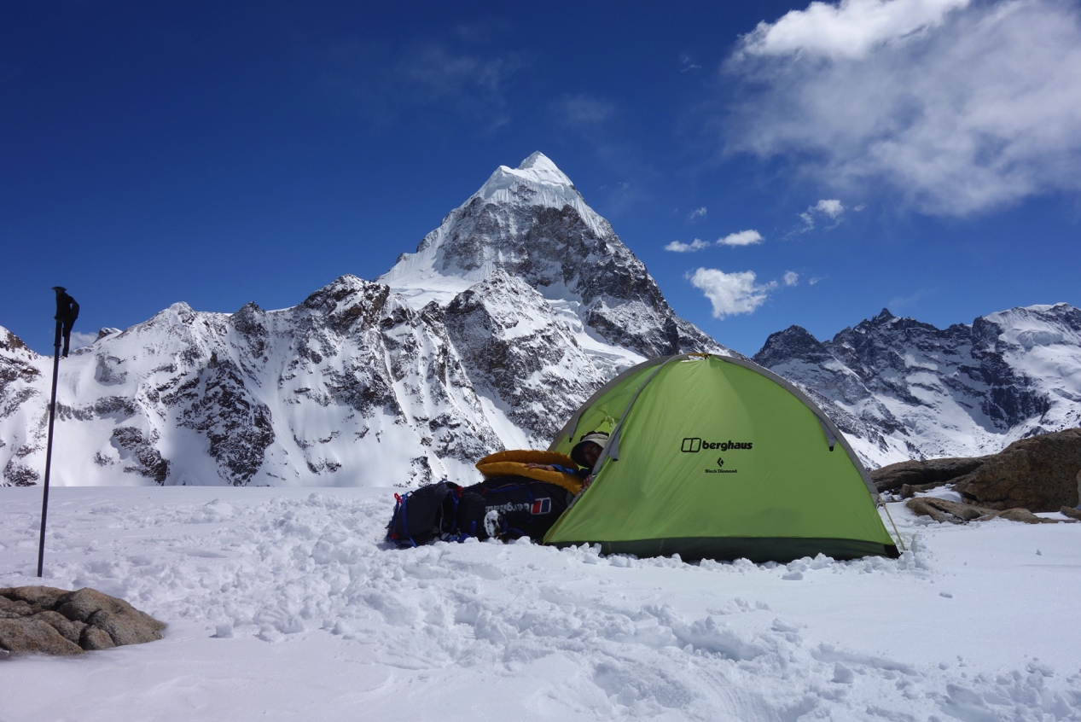
The object of our desires. Chombu from near the Sebu La pass

The hotel owner’s tour of his hotel left us in no doubt that he was not exaggerating. Like 20% or so of the buildings in Tanggu, it was indeed very broken.

‘Seven feet of snow in one storm’ announced a bystander.

‘Heaviest winter snow since 1995’ added an army official.

We had been warned that the winter snows had been heavy but nothing had quite prepared us for tree trunk strewn avalanches across the road and the damage to property. Clearly we were faced with unusually challenging conditions. I made a mental note to spring into clearing action if seven feet of snow should ever look like falling on my roof in the UK.

Sikkim was a new area for both of us and the deep, jungle covered, winding valleys of the foothills made for a grand and varied approach to the mountains of the north. Our approach was along the ‘short route’ followed by the Everest pioneers of the 1920s. ‘Short’ is of course a relative term. In the days before motorised transport the 1921 Everest team took 36 days to walk from Darjeeling to their base camp. The perseverance and commitment of those pioneers in just getting to and from the mountain was remarkable. It was almost enough to make me feel guilty that the approach to our base camp involved ‘only’ flying to Bagdogra, two days of driving to Tanggu and two days of walking.

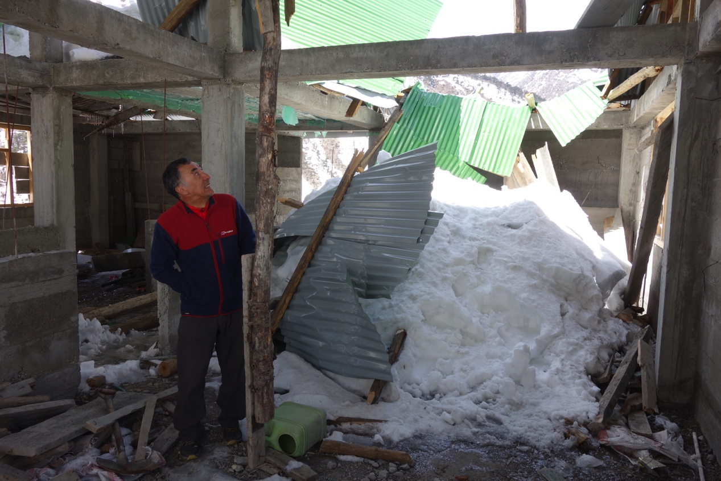
Winter snow damage at our hotel in Tanggu

Much as transport has improved in leaps and bounds since the early Everest days the administrative challenges of climbing in the Himalaya are often as challenging now as they were then. Today almost all the Himalayan countries require those attempting significant mountains to secure bespoke permits and employ a Liaison Officer, a cook and a kitchen boy at the very least. This can be time consuming, expensive and certainly puts people off. In calm moments I celebrate the fact that this shield of bureaucracy has ensured that many fine mountains remain unclimbed - but when caught up in the frequent last minute stress and uncertainty of officialdom I tend not to be quite so appreciative of the administrative challenges.

Partially because of the difficulties, expense and uncertainty involved in securing all the necessary permissions the climbing history of Chombu is relatively short. Bad weather and soft snow stopped Cooke and McPherson in 1944. Doug Scott’s team experienced much the same problem in 1996 as did Roger Payne and Julie-Ann Clyma in 2007. A widely discredited first ascent claim was made in 1961 and the highest point reached, still a long way from the summit, was by a Japanese team in 1992.

Noting the recurring mention of soft snow problems our plan was to attempt the west face which we judged was steep enough to not hold snow and therefore give the kind of move-one-at-a-time mixed climbing that Victor and I prefer. Our plan was to go in the post monsoon (September/October) season of 2017 although when we first started planning in 2016, we could never have dreamed that so many hurdles would arise. Firstly, after an initial failure at the first administrative hurdle, permits were granted for post monsoon 2017 but then withdrawn as a result of a border skirmish with China. Then, out of the blue, I was diagnosed with cancer of the anus. Pre-monsoon 2018 was spent recovering from radiotherapy and after that failed post-monsoon 2018 was spent recovering from an operation to cut out my anus and rectum. And so it wasn’t until pre monsoon 2019 that health and permits issues came positively together and we were finally ready to go. After all the delays, hassle and stress it seemed almost ironic that an email from Jet Airways provided the final hurdle. The message was laughably direct if not welcome.

‘Dear Customer, Your flights have been cancelled. We apologise for any inconvenience. Alternatives are listed below.’

The blank space below said it all.

It felt a huge relief when Victor and I finally managed to re-book and arrive in Sikkim. And even more of a relief to finally battle our way through the snow drifts and avalanche debris to arrive at Tanggu.

Our team to walk in to base camp consisted of the two of us, four sherpas, a cook, a kitchen boy and five porters. There was also a Liaison Officer who returned to Gangtok after ensuring we were underway. It felt an awful lot of people to support a lightweight two man team.

Finding enough porters had been tricky. The local people were much more interested in searching for caterpillar fungus (much in demand in China as an aphrodisiac and cure to most ailments known to man) than portering and the net had to be cast far and wide. The end result was five outrageously strong young men being brought in from Darjeeling. Being as there were so few it was just as well that they were so strong.

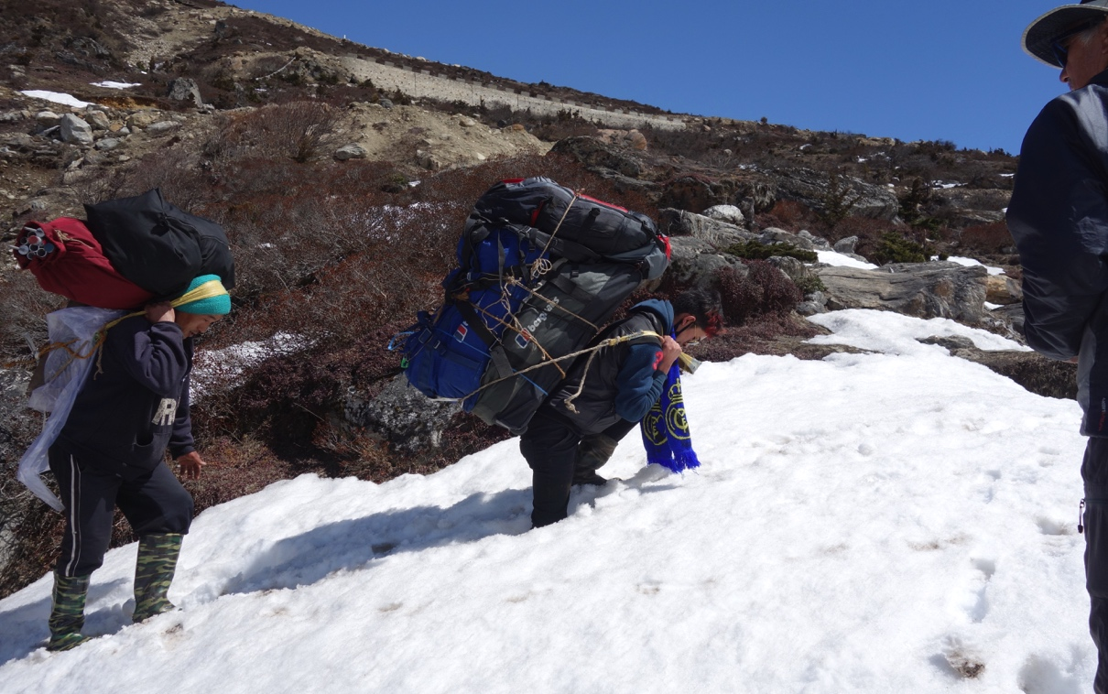
Wellies, 70Kg loads and soft snow. A bad combination.

The triple loads that they shouldered must have weighed 70Kg and matched the heaviest I have ever seen. Unfortunately this meant that, as the day progressed and the snow softened, they sunk in ever more deeply. The snow really was a problem and we were only able to make progress at all because the track stuck to the south facing side of the valley where the winter snows were starting to thin out. The north side looked a lot like the alps after a heavy winter snow fall.

The track on the south side was interesting. In the sections that were not completely snow covered it could be seen that it had been carefully made up with rocks cemented into place in a parallel sided tour de force. Later, when the snows had largely melted, we were to discover that this amazing track did a loop of the valley stretching up to a point only 30 minutes or so from our base camp. We never did get a clear explanation for its existence. Suggestions that it was built for military purposes or to take yaks up to a yak racing ground were dismissed in favour of it being some kind of tourist trail. Either way it would have been very useful had it not been largely covered in snow.

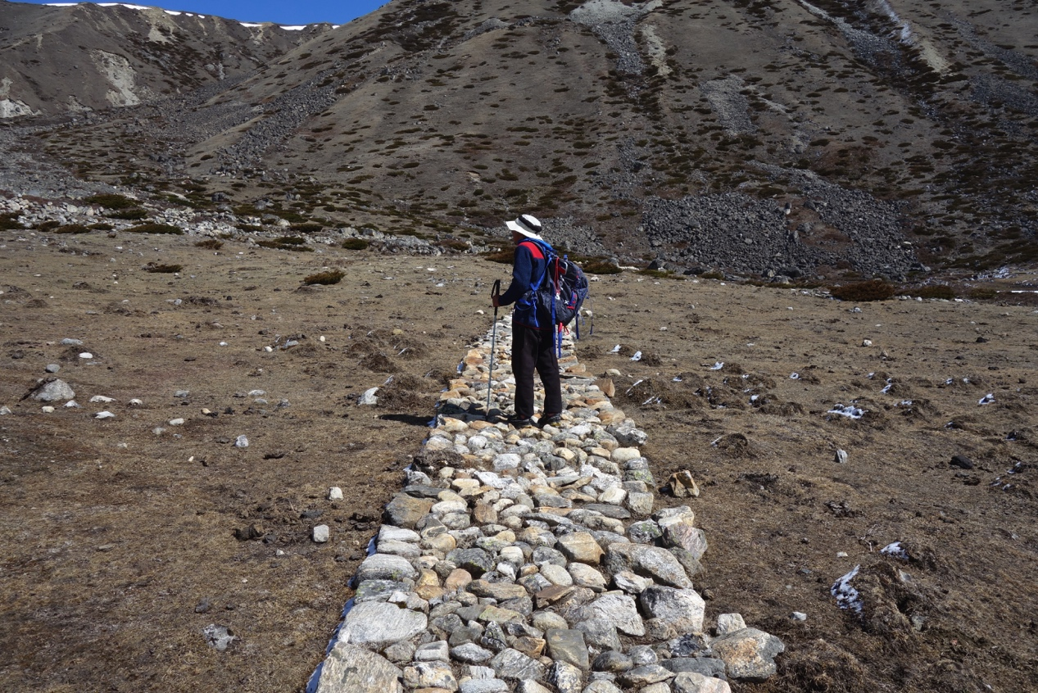
The meticulously made up track appeared to serve no useful purpose whatsoever.

It took two days and several ferries before we set up base camp by an idyllic stream 30 minutes short of the old Himalayan Club hut at the foot of the Sebu La. This pass connects the Lachen and Lachung valleys and back in the days of British control it was a sufficiently popular crossing for the Himalayan Club to judge it worth building a substantial hut either side. Nowadays permits to visit are hard to come by and the remains of the hut crumble quietly in summer yak grazing grounds.

From the Himalayan Hut, it could be seen that, in sharp contrast to virtually everywhere else, the mountain was surprisingly devoid of snow. It did though look exciting with uncompromisingly steep slopes leading up to an enticing curling summit snow ridge. I almost felt quite emotional finally seeing the object of my dreams for the last three years.

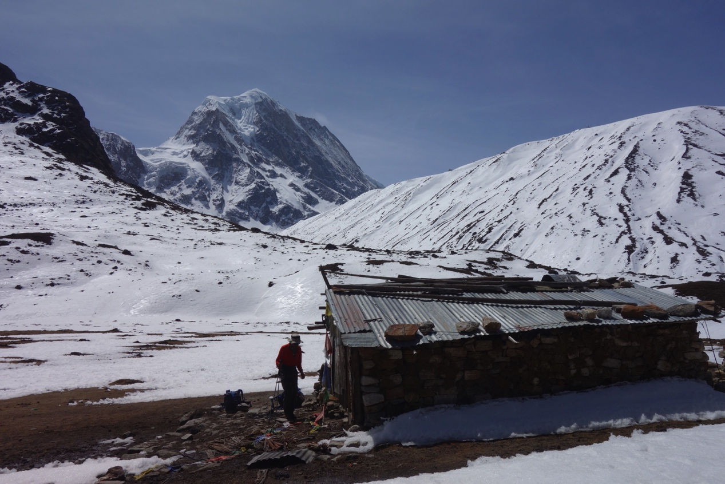
Chombu from the Himalayan Hut

I find acclimatizing the least exciting part of a Himalayan trip. For me it involves getting up to an altitude around 1,000m short of the intended summit and then lying there holding my head for three or four nights before heading down to base camp where I spend a day eating lots of food before starting the fun bit – the climb. At least on this occasion we had four bored and willing sherpas to help us break trail and carry kit. Quite why we had four I wasn’t sure. At one point it seemed that they had been expecting to fix ropes and stock camps for us but another time we were told it was mandatory to have four. Whatever the reasoning their trail breaking ability was much appreciated as we plodded around soaking in 5,000m air, charting lines up the west face and visiting the Sebu La pass to get a view of our preferred descent route. Curiously the way to the pass was marked by an old electric cable which appeared to run from the Himalayan Club hut right the way over the pass.

We climbed an easy 5,500m summit on the watershed, spent a couple of days and nights lying at 5,300m sucking in thin air and, in perfect weather, scrunched down well frozen snow to our base camp in high spirits. We had chosen our line, the weather looked good and all we had to do now was spend a day eating and then start climbing. Life was good.

By the next morning 10cm of snow had fallen, the temperature was hovering around freezing and base camp was in the cloud. Another day of eating was judged appropriate – we had a time cushion of about a week so could afford to be relaxed and wait out some bad weather. The next day dawned the same but, feeling the need to be in position at the foot of our intended line, we trudged up through the falling snow, pitched our little tent at the foot of the face and set the alarm for an early start. But the weather would not play ball. In the early hours it was still snowing and the temperature was clearly too warm for a good freeze. The days passed with little change. The boredom level grew. There is only so much time that can be spent in a two man tent without going stir crazy.

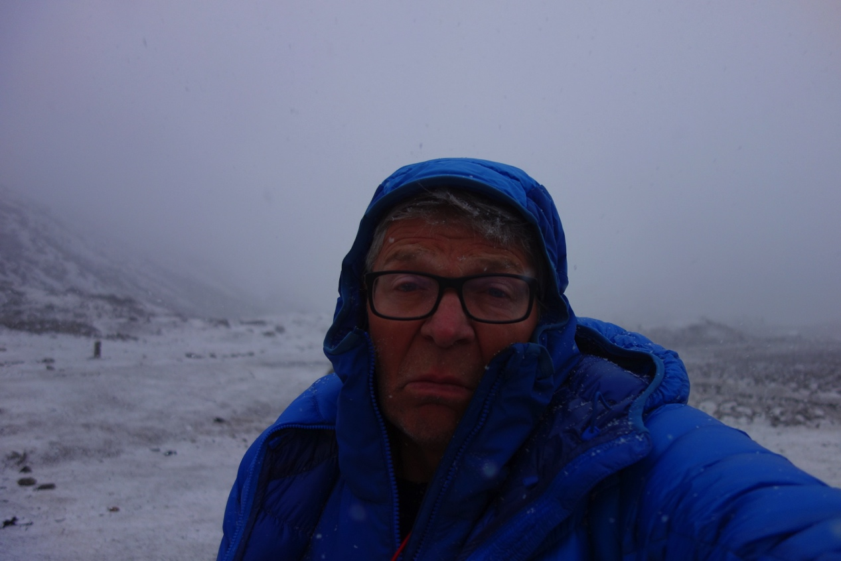
The weather demons take hold ….

This year’s reading material was unusual in that it had been sent to me by a long standing climbing partner of mine, Crag Jones. Doubtless reeling from my frequent abuse for his choosing Stephen Hawking’s ‘Brief History of Time’ on one of our trips together he had taken it upon himself to send me two books for this trip. Barbara Cartland made it to the foot of the route but I’m afraid ‘A short history of the Industrial Revolution’ failed to leave the UK. Sorry Crag! By day three at the foot of the face I had read Barbara Cartland for the second time. Somehow though I didn’t seem to have missed much the first time. Meanwhile Victor busied himself with Wade Davis’s 650 page monster ‘Into the Silence’ which he was kind enough to tear up and hand to me as he finished each chapter. In between reading and brewing we stared at the ceiling, righted the wrongs of the world and discussed the pros and cons of colostomy bags on constricted bivouacs. A small tent was not the harshest of testing grounds but my experience thus far suggested that all would be well on the more difficult bivouacs. In fact having control over when to empty the bag could even be an advantage – no urgent exits into spindrift laden nights for me. Victor, who had a nasty incident of being caught short on our last Himalayan climb together, looked mildly envious without going so far as to wish he could have the operation. In fact though the trickiest problem for me was not being able to sit down properly. The operation had involved plastic surgery across both buttocks and much as well cushioned sitting is bearable a sitting bivouac would require very careful planning. With endless hours to waste we whiled away the time discussing laughably impractical possibilities endlessly.

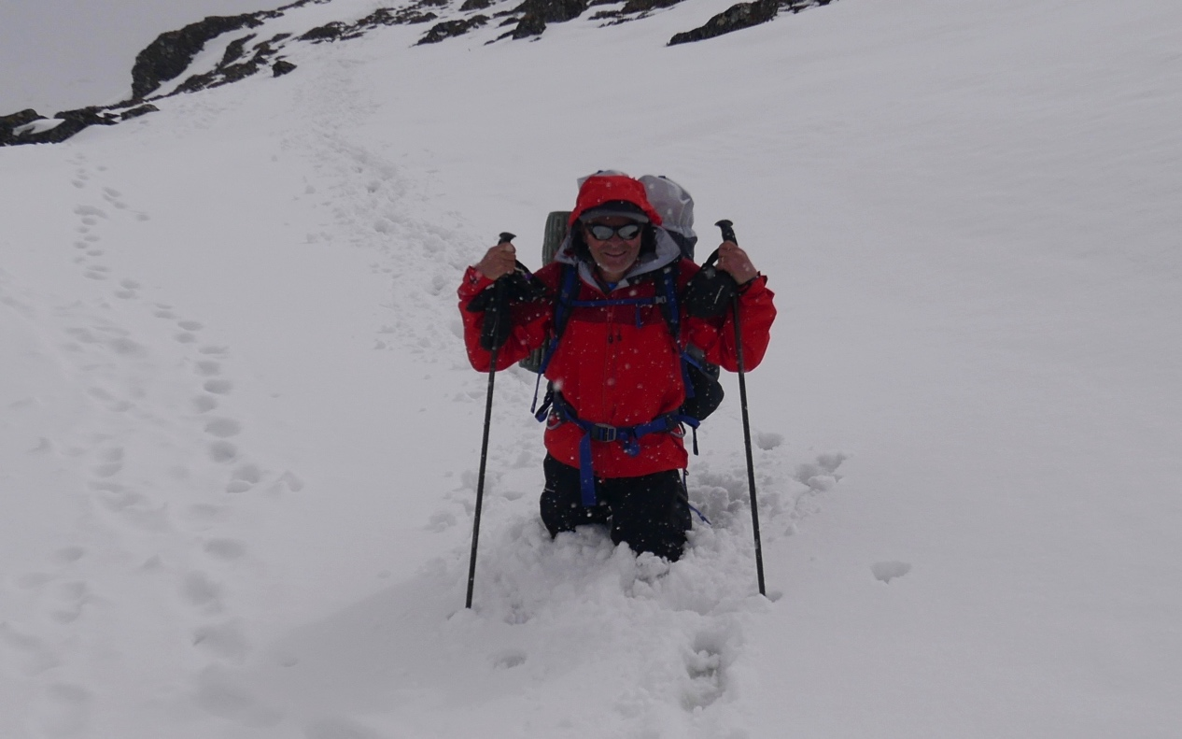
Energy sapping ground at the foot of Chombu.

But the weather wasn’t getting any better. Every morning would be sunny and hot, the snow would melt and we would dream of a safe, frozen surface for the following morning. And then, come 3pm or so, the snow would start again and continue right through until 8am or so. By then 10 cm or so would have fallen, the avalanche risk would be high and the underlying snow would be insulated by the new fall and not freeze. One day only 3cm fell and stars were visible. Excitement mounted. We sprang into action and got out of the tent. But then heavy wet snow started and we sank knee deep in unfrozen snow. Ugh! It was both dangerous and unpleasant such that a return to our sleeping bags was deemed appropriate. Despondency levels were rising but all we needed was one good day to get started. Food ran short and we waded down to base camp and back up with fresh supplies. This ensured full stomachs but had no effect on the weather pattern. All in all it developed into the most frustrating wait that either of us had ever experienced.

Gradually all reading material had been read, all conversation topics exhausted and it became increasingly clear that there was a growing possibility that the main achievement of the British Chombu Expedition might be to wander around testing Berghaus kit in harsh weather conditions.

Immediately across the glacier from the west face of Chombu was a 5,322m peak at the end of a ridge line stretching north from Chungukang. Chungukang North, as we grandly christened it, was insignificant compared to Chombu but it was probably unclimbed and we had reached the stage where exercising and getting to any summit was preferable to continuing to lie unproductively in a small tent.

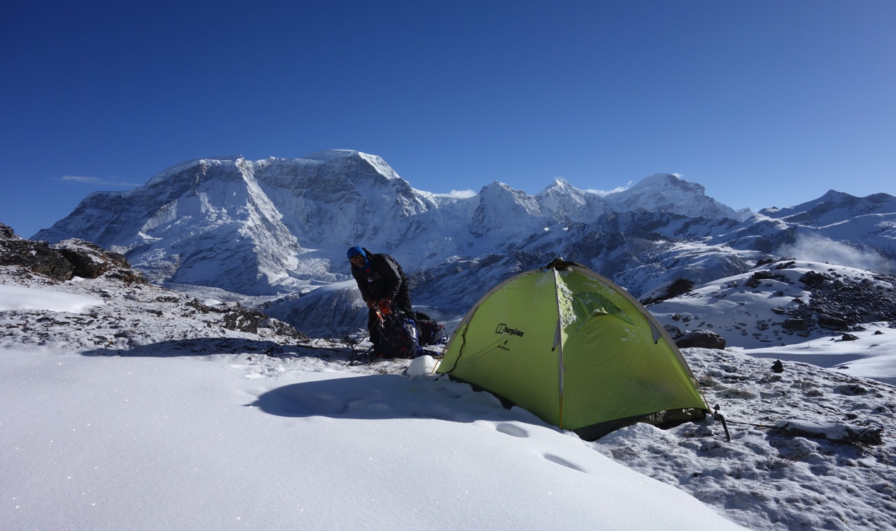
Mid morning views looking north to Kanchengyao. Terrible snow conditions. So frustrating!

Our sherpas had been keeping a close eye on what we were up to and Pasang and Subas, the two youngest and most energetic, were keen to join us. The four of us trudged through enervating knee deep snow and gained the south ridge via a bottomless unfrozen snow slope which was every bit as bad as we had anticipated. Pasang and Subas raced ahead in the morning sun while Victor and I plodded along in their steps stopping frequently to look over our shoulders at the untrodden slopes of Chombu behind us. The ridge, when we reached it, was mainly moderate rock climbing and led enjoyably to the summit as the afternoon clouds began to build.

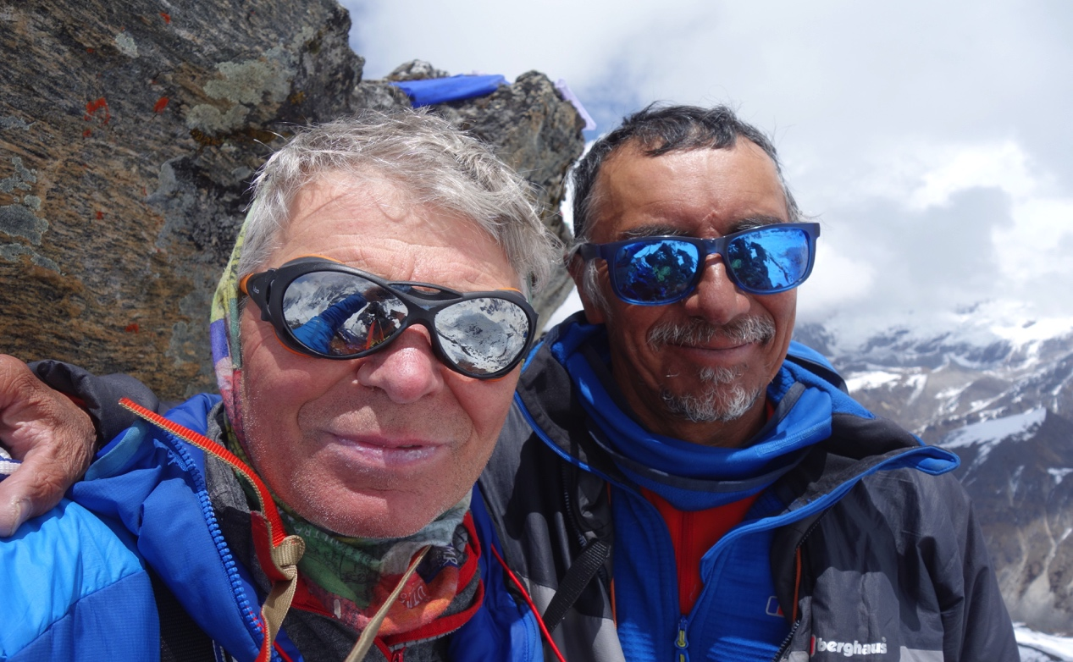
Not the usual victorious summit selfie. But a probable unclimbed summit nonetheless.

By 4pm it was sleeting hard and visibility was zero. The British Chombu Expedition trudged forlornly back to base camp.

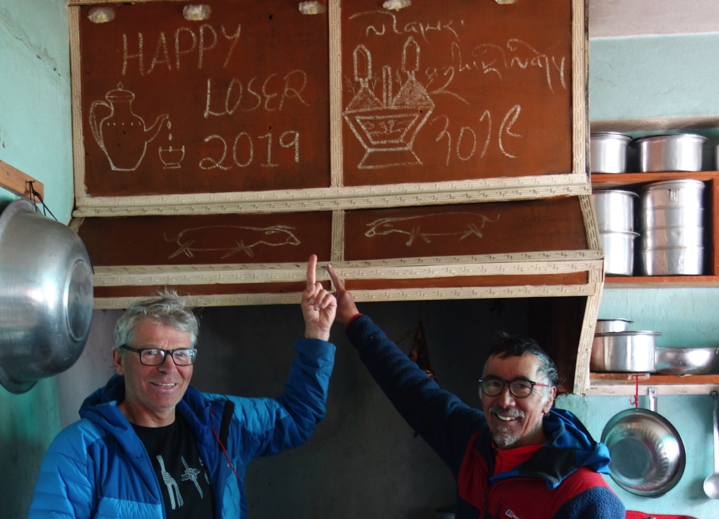
Can’t win them all.

Chombu had beaten us. Sometimes things don’t go according to plan. But we had seen first hand what a special mountain it is.

And we have a plan. We will be back.

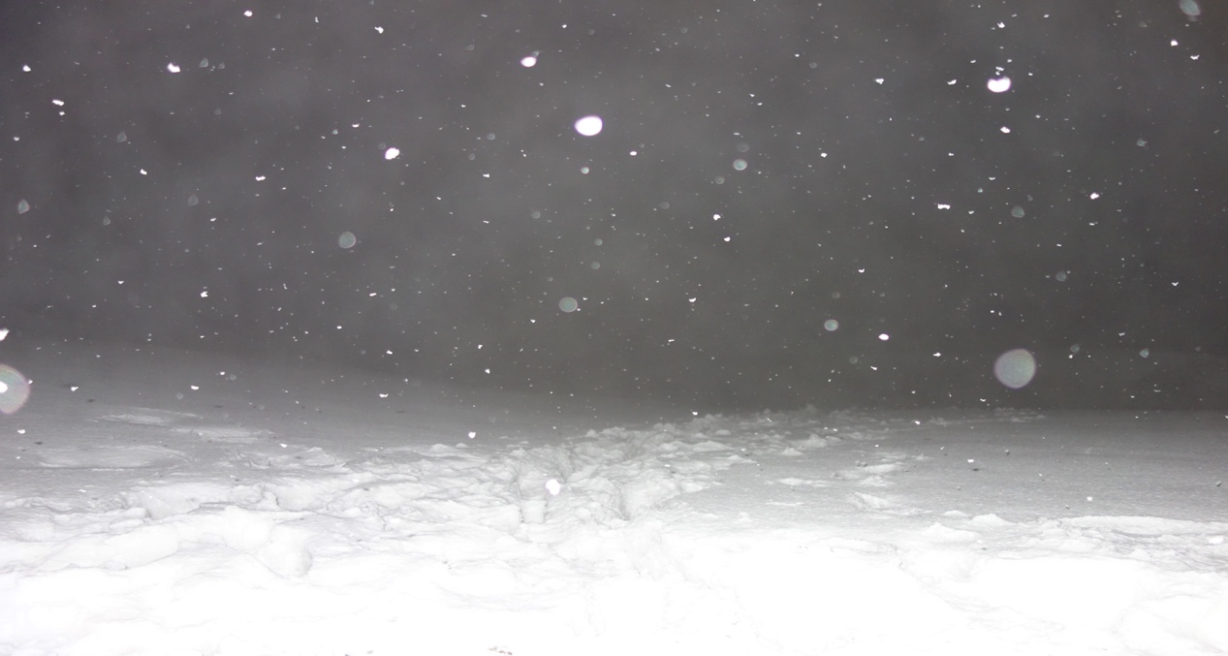
But, in case we should forget, a reminder of our regular early morning view………..

Accounts

Expenditure

Travel Costs 2,229.88
Agent (incl. porters, permits, gas, hotels etc.) 10,462.13
Visas 243.63
Insurance 926.55
Hill Food 243.76
Misc. 463.45
Equipment 78.10

Total 14,647.50

Income

Berghaus 10,000
Mount Everest Foundation 4,750
British Mountaineering Council 1,250

