British Chamlang 2016 Expedition Report

Generously supported by: The BMC, The Mount Everest Foundation, Nick Estcourt Award and The Alpine Club.

Equipment supplied by: The North Face, PHD, Black Diamond, Scarpa, Tendon Ropes, Adidas Eyewear, Lyo Food, Clif Bar and Thermarest

Expedition Members
Andy Houseman
Jonathan Griffith

Dates
8th April to 13th May (we returned 10 days earlier than planned)

Location
Hongu Valley and Khumbu Valley, Nepal

Summary
Jon and myself traveled to Nepal this spring with the main aim of attempting the unclimbed North Ridge of Chamlang, 7,314m. Prior to attempting Chamlang we acclimatized on Ama Dablam in the Khumbu Valley, summiting via the standard route, the South West Ridge. Unfortunately, the conditions and weather we experience on Chamlang were far from ideal and we were not successful with an ascent of the North Ridge, returning home just over a week early.

Acclimatization - Ama Dablam - 8th April to 1st June
We were in the fortunate position of been able to acclimatize on Ama Dablam, 6,812m, before going over to attempt Chamlang. Usually the cost of the permit and another Liaison Officer prevents been able to acclimatize on such a high peak prior to attempting your main objective but this year Jon had a work project on Ama Dablam and employed me as his assistant. This was an ideal opportunity; not only did we get to climb this beautiful peak but it also provided us with the perfect acclimatization program for Chamlang.

Ama Dablam is probably the most iconic peak of the Khumbu, it is the first ‘proper’ peak you get a full view of as you leave Namche Bazaar when trekking up towards Everest. Needless to say, even though it was a work trip and we were climbing it via the normal route we will still very excited to climb it.

The Spring season on Ama Dablam seems to be much quieter than the Autumn, partly due to the fact that most of the major commercial operators are busy on Everest but also, as we found out, due to conditions. In fact whilst we were on the mountain there wasn’t another single team attempting it and there was only one other group in base camp awaiting clients. There were a number of teams heading up when we descended.

The whole Everest region was very dry this year, which upon arrival, we knew straight away did not bode well for our chances on Chamlang. The conditions on Ama Dablam were very poor with very little snow on the mountain. Still very claimable it just meant a lot of black ice and some very loose rock in places. We climb the South West ridge in Alpine style except for using one porter to help carry our equipment up to Camp 1 due to all the extra camera gear we had and we also wanted to use the least energy possible on Ama Dablam to be fully fit for Chamlang! We did not use Camp 2 or 3 and instead used a small camp just below the snow mushroom/plateau that forms Camp 3. This provided a much safer camp than Camp 3.

Although we all enjoyed climbing Ama Dablam we were all very disheartened by the about of garbage left on the mountain, especially at the camps. There is also a vast amount of fixed rope left all over the mountain, not only is this a massive eye sore but one of the biggest hazards was tripping up over it all. This was my first experience on a full on commercial mountain and it was definitely an eye opener. I am not against the mountain being fixed each year but it would be nice if the big companies that use it each year would bring some of the old lines down, or at least chop them.

Chamlang Attempt - 2nd June to 11th June
The conditions in the whole Everest region we very dry this year and looking across to Chamlang from Ama Dablam where we had a great view of our proposed route we know it wasn’t looking very promising. The whole lower section of the line I had attempted on the North Face with Nick Bullock in 2012 was completely dry, where we had climbed steep but perfect neve was just bare rock. Our line on the North Ridge was long and was going to rely on good neve to not only hold the thing together and make it safe but also make the climbing fast enough to be able complete it in the style we wanted.

The Italians who were also there to attempt Chamlang had already bailed telling us it was too loose and dangerous in the current conditions. On hearing this and with what we had seen from Ama Dablam we considered bailing and not even going into base camp. But we have both learnt that one persons take on conditions can be very different to another’s, so with this in mind and with the optimism that things might look better close up we decided to go in and have a look for ourselves.

Approach – the use of helicopters
We had a number of option to approach Chamlang base camp once we had finished on Ama Dablam and our original plan was to carry on up the Khumbu and cross over the Amphu Labtsa pass into the Hongu Valley or if we returned to Lukla go in via the Zatra La and the Mera La - an 8 day walk with porters. Although a number of groups cross it with porters each season we weren’t too keen on the Amphu Labtsa due to the potential avalanche danger if there were heavy spring snows.

Closer to the time we enquired about the cost of a helicopter flight into Chamlang base camp and started looking at this an an option. It turned out to be cheaper for us to fly in by ourselves with a lightweight base camp set up and no cook than it would be to walk in with porters and cook etc. Obviously this was very convenient and very time efficient but we really didn’t know where we stood ethically on it. We chatted to a lot of people before leaving to get their views on it and also weighing up the pros and cons of the environmental impact of flying vs walking in with a large team of porters and a large base camp set up and there was also the issue of putting porters at risk if went over the Amphu Lapsa vs giving work to the locals.

In the end we decided to fly in and after resting in Lukla for a few days and with the promise of a four day weather window approaching we flew into base camp with two weeks of food. I’m sure a lot of people will not agree with this choice and I would be lying if I said convenience wasn’t a big factor in the choice, but time wise and financially it made sense. It also, in our view gave us the best chance of climbing Chamlang by getting in there as quick as possible after Ama Dablam. Right or wrong helicopters are becoming a very popular mode of transport in the Khumbu and I think this will only increase. When you dig a bit deeper it is quite amazing how many climbers use helicopters, it’s just not all of them own up to it or are honest about it!

It didn’t all go according to plan though, to cut a long story short Jon ended up getting dropped with half the gear 1.5 hours walk up the valley from me. Fortunately, we managed to firstly find each very randomly and then even more luckily find a trekking group who’s porters we managed employ to bring all our gear to one point!

Will Himalayan Heli alpinism be the new norm? I fairly confident it won’t, our situation was fairly unique, we were already fully acclimatized having trekked up the Khumbu and climbed Ama Dablam so we could head straight to base camp at 5000m with no problem. The trek in is a massively important part of the acclimatization and I would definitely not consider flying in again if I was going straight to Chamlang. Also if we were flying straight into somewhere like Chamlang the amount of kit and food we would have to take to have time to go through the whole acclimatization process and waiting for weather in base camp would be too much for a single flight and make the whole process too costly compared with walking in with porters.

The only thing that did surprise us was when the helicopter came in to collect us we were obviously 100% fit and fully mobile but even still the pilot just assumed we had called a ‘rescue’. To me, this is the main problem in Nepal with Helicopters, the amount of people calling so called rescues through their insurance cover, a lot of these rescues seem to be a convenient way of getting home quicker. The amount of stories of unnecessary helicopter flights that the insurance companies were forking out for was quite disturbing, which of course pushes insurance premiums up for honest users.

The usual trekking route in to the Hongu from Lukla is as mentioned above via the Zatra La and Mera La passes. This is usually a nine day trek including one rest day, with overnight stops at the villages of Chutanga, a tea house above Chutanga (this seems slow but is the best way to acclimatize for crossing the Zatra La), Tulikarka, Khothe, Tagnag, Khare, and a single basic T-house at the foot of the Mera La in the Hongu.

The rest day is generally taken in Khare before crossing the Mera La from where you can go on an easy hike to gain a small amount of altitude to help the acclimatization. If I were to return to Chamlang I would stop in Khare for a few days and make an ascent of Mera Peak as this would give the best and easiest acclimatization in the Hongu, unless you can justify a permit for Baruntse.

Attempt
The approach to the base of the initial face to access the North Ridge was made directly behind our base camp in the Hongu. A 600m ascent up rocky and grassy slopes leading to a large hanging valley and easy moraine took about 3 hours. We found a great spot for an advance base camp next to a small lake that provided crystal clear drinking water and was about 1 hour from the base of the face.

Our attempt at Chamlang was very short lived. The four day weather window that had been forecast never really appeared with consistent snow fall every afternoon. Unfortunately, our initial fears upon arriving at the mountain were correct and the conditions were far from what we needed. After only a couple of pitches of climbing it was obvious we were not going to reach the summit, to be honest I think we both knew that before even starting up but we wanted to try. The lack of any usable snow meant the climbing was very slow going over dangerously loose rock, and that was just the entry pitches on what was meant to be the simple face to access the spur proper. It was going to be too slow going and very dangerous climbing higher up.

We contemplated continuing up to try and just get a better view of the spur proper as a reccy for a possible future attempt but to be honest the motivation wasn’t there carry on into the approaching afternoon snow only to have to down climb the icy ridge the next day. We were quite glad not to have carried on when back a base camp that same afternoon we were listening to a thunder storm passing overhead! With Plan B, the north face line I had attempted previously also completely out of condition and with no sign of any weather windows bigger than a couple of days we decided to head home early.

Finances

Expenditure |  | Income
Permit and LO | £2000 | The BMC | £2100
Agent Fee | £360 | MEF | £2400
Equipment and Food | £200 | Nick Estcourt Award | £2000
Weather Forecast | £360 | Alpine Club | £1500
Insurance | £230
Porters | £110
Lukla food & accom | £280
Heli Flight In & Out | £3200
TOTAL | £6740 | TOTAL | £8000 (£1300 of which we returned)

Our original estimate for the cost of the expedition was £10,000+ (this did not include international flights or freight as that was covered by the Ama Dablam trip – Nepal is not cheap). As you can see our trip worked out a lot cheaper, this was due to three main reason:
- We managed to share permit and LO costs with the Italian team that was also attempting Chamlang, this saved us around £1600.
- Using the helicopter – had we gone in to Chamlang with porters and cook etc this would have worked out at a minimum of £4500 inc tips.
- Weather forecast – as we had used Meteotest on Ama Dablam they only charged us CHF500 instead of the usual CHF1800

Due to these savings we returned £1300 split equally to the grants listed above.

Useful Info

Flights
We flew to Kathmandu with Turkish Airlines. Their prices are competitive with other airlines but have the added bonus of offering extra sports bags at €80 per bag and you can book up to 5 sports bags per ticket. It is necessary to ring up and book these prior to turning up at the airport as it saves a lot of confusion and ‘discussions’ with the checking agents. This is by far a cheaper option than freighting equipment out before hand.

One other note on flights is we only booked one way flights on the way out. We have both found on numerous previous expeditions that trying to change flight doesn’t really work, there is either no availability on your booked airline or unless you buy a very expensive ticket in the first place it costs a lot to change anyway.

Tips
We were quite surprised with what the porters in the Khumbu expected for tips in comparison with other areas I’ve been to. Expect to tip at least $5 per day per porter. We gave our cook at Ama Dablam a $200 tip, I have no idea if this is the ‘going amount’ but it is what I have usually give in previous trips.

Phone/Internet
There is good phone signal and 3G in Kathmandu and all the way up the Khumbu to Pangboche (I assume it carries on up towards Everest base camp). You could also get phone signal a 10 minute walk down from Ama Dablam Base camp. You can buy a NCell sim card in Kathmandu for about $3.50 and 3GB of data for around $15 - $20. Phone minutes are really cheap and the cheapest way to call back to the UK. There is a Wifi network in the Khumbu called the Everest Link but we found this did not really work.

There is no signal what so ever in the Hongu so a Sat phone is required here.

Costs of trekking in the Khumbu Valley
Here is a rough idea of the cost at lodges in the Khumbu:
1 litre bottled water - $2
Meals - $5-$7 (we usually needed two to fill up!)
Rooms in Lodges - our agent was paying for these so I’m not entirely sure but I got the impression they were either free if you ate there or around $10 - $20 for a room with a toilet.
Hot showers - $5

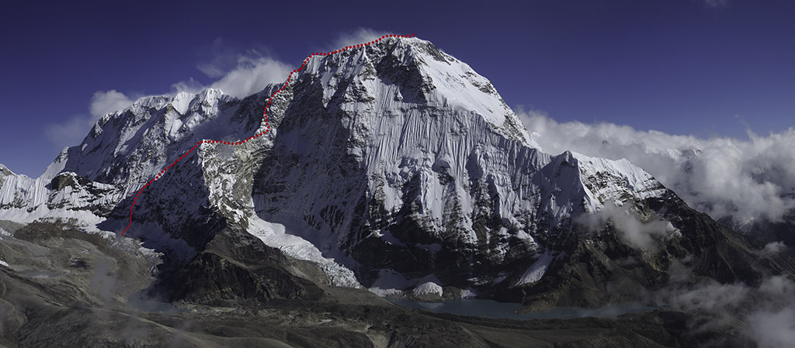

This photo was from 2012, it was not the conditions we experience this year. The solid line shows our attempt this year to our high point and the dotted line was our proposed continuation line.

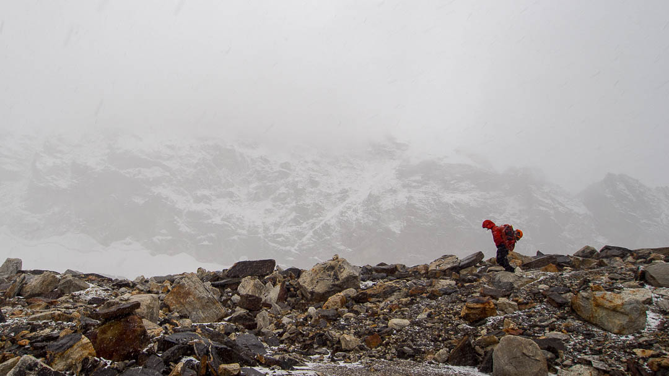

Jon walking below the face of Chamlang in weather that was typical of the entire trip.
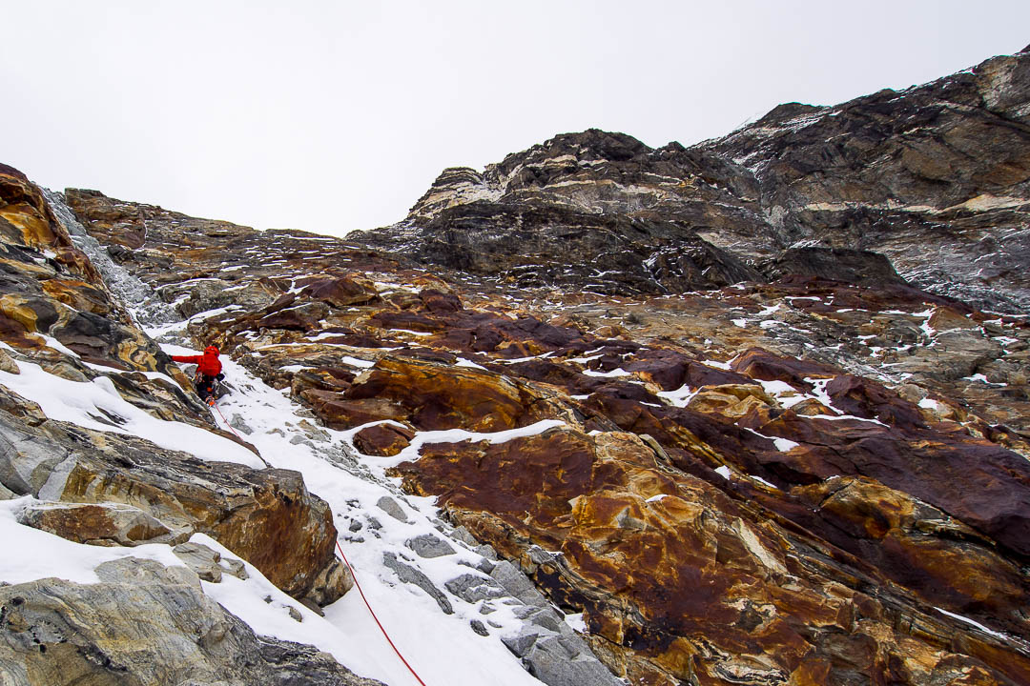

Jon on the first entrance pitch to reach the snow slopes which we’d hoped to climb to take us up to the ridge proper. We’d hoped this would be a nice neve runnel but unfortunately it was unconsolidated loose snow over a very loose seem of rock. We ended up having to climbing the red rock on the left.

