British Hunter Foraker 2016

Climbers:
Ben Silvestre, Pete Graham and Will Harris

Summary

We split our expedition into two parts, the first intending to attempt new routes from the Thunder Glacier, and the second acclimatising on Denali’s west buttress before climbing the Infinite Spur on Mount Foraker. We were unsuccessful on the Thunder Glacier, with poor snow conditions and high levels of objective danger preventing all but one attempted line. We succeeded in making the 10th, and 1st british, ascent of the Infinite Spur. We encountered generally poor weather, with very few days of clear good conditions, having only one window of good weather which we used to climb the Spur.

May 2016
2- Arrive in Anchorage
3- Shopping in Anchorage AM, transfer to Talkeetna PM
4- National Parks briefing AM, flew onto Thunder Glacier PM
5- Scouted new routes on Thunder Glacier
6- Snow
7- Attempted new route on Pt 9000’
8- Light snow
9- Light snow
10- Flew from Thunder Glacier to Denali BC/ Kahiltna Glacier. Moved up to 7,800’ on Denali
11- Moved up to 11,000’ camp in poor weather
12- Carried a load to windy corner on west buttress route in poor weather
13- Moved camp up to 14,000’ on west buttress
14- Collected cache from windy corner
15- acclimatisation run to 16,000’
16- Acclimatisation run to 17,000’
17- Rest day
18- Rest day
19- Acclimatisation to 17,000’. Would have liked to go to summit but poor weather.
20- Storm
21- Moved from 14,000’ to base camp
22- Snow
23-snow
24- Packed for the Infinite Spur
25- Approached the Spur in poor weather
26- Climbed to the base of the 2nd rock band on the Infinite Spur
27- Climbed to the top of the Knife edge ridge
28- Summited and descended most of the way to the Sultana ridge
29- Reversed the sultana ridge, descended most of Mt Croson before snow conditions forced us to wait for a refreeze.
30- Descend to BC. Eat and sleep.
31- Rest
June
1- Rest. Pete and Ben collect skis overnight
2- Snowing
3- Snow AM, fly out to Talkeetna late in evening.

Thunder Glacier

We had seen photos of potential new lines to be climbed on Thunder Mountain and on the south face of Hunter South. Unfortunately, whilst we found a number of potentially interesting lines, the entire Thunder cirque is threatened by a ring of high seracs which make much of the climbing unjustifiably dangerous, to our tastes at least. The unclimbed south face of Hunter South looks particularly dangerous, and sadly the unclimbed west face of Mount Providence, whilst impressive, has an objectively dangerous approach. We attempted to make an ascent of what would have been a 750m long mixed line on point 9000’, but were turned back after approximately 350m vertical by unconsolidated powder on rock. Up to here we found technical difficulties up to Scottish grade VI. We considered another possible line on Thunder Mountain itself, but after watching this avalanche opted to move on to the second part of our trip.

We we’re surprised by the snow accumulation on steep faces whilst in the Thunder cirque. When viewed from the summit of Foraker a month later the faces were much drier, perhaps giving potential mixed/rock climbing on Thunder.

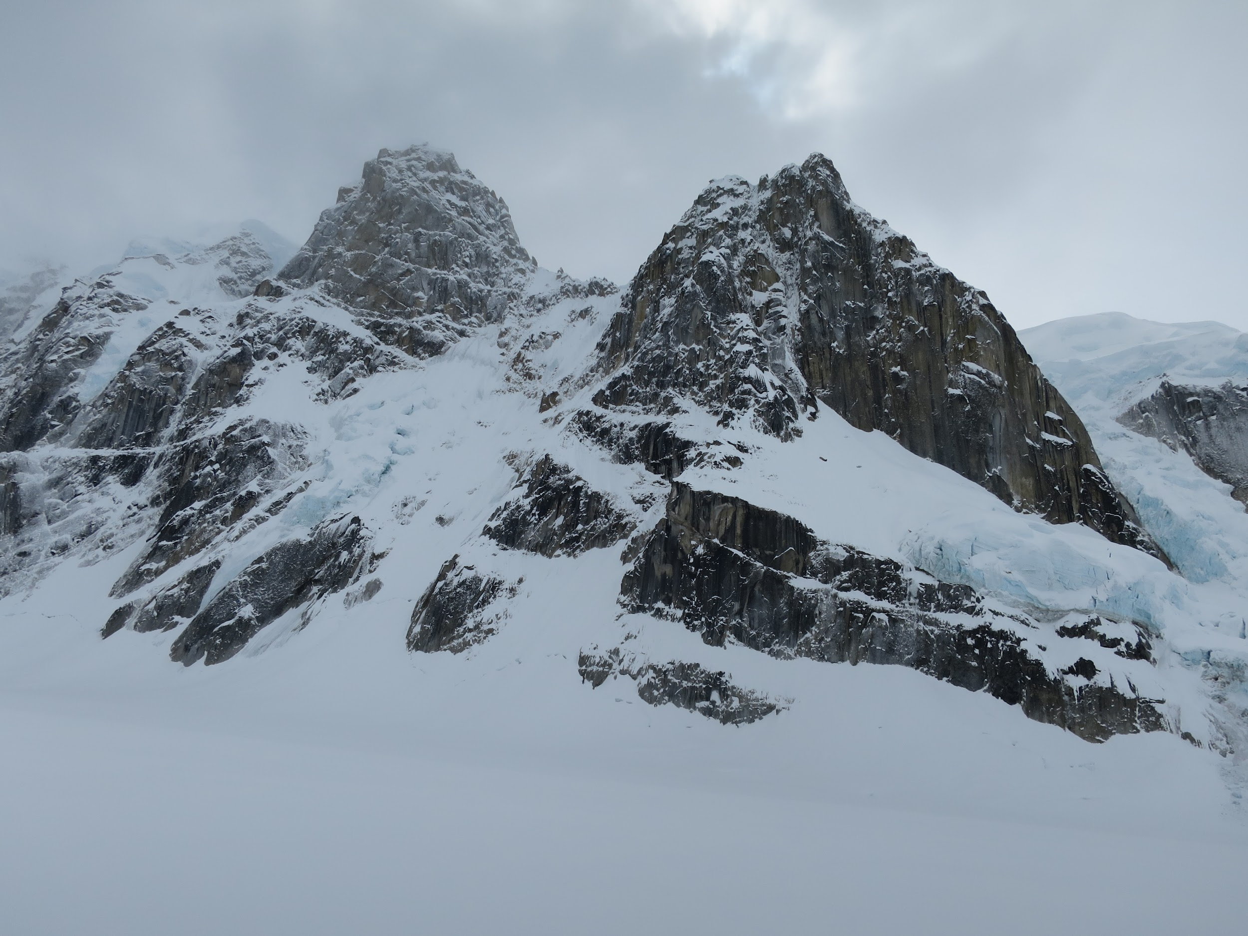Photo: Pt 9000’ on the right, We used the left of centre depression to access the central groove during our unsuccessful attempt.
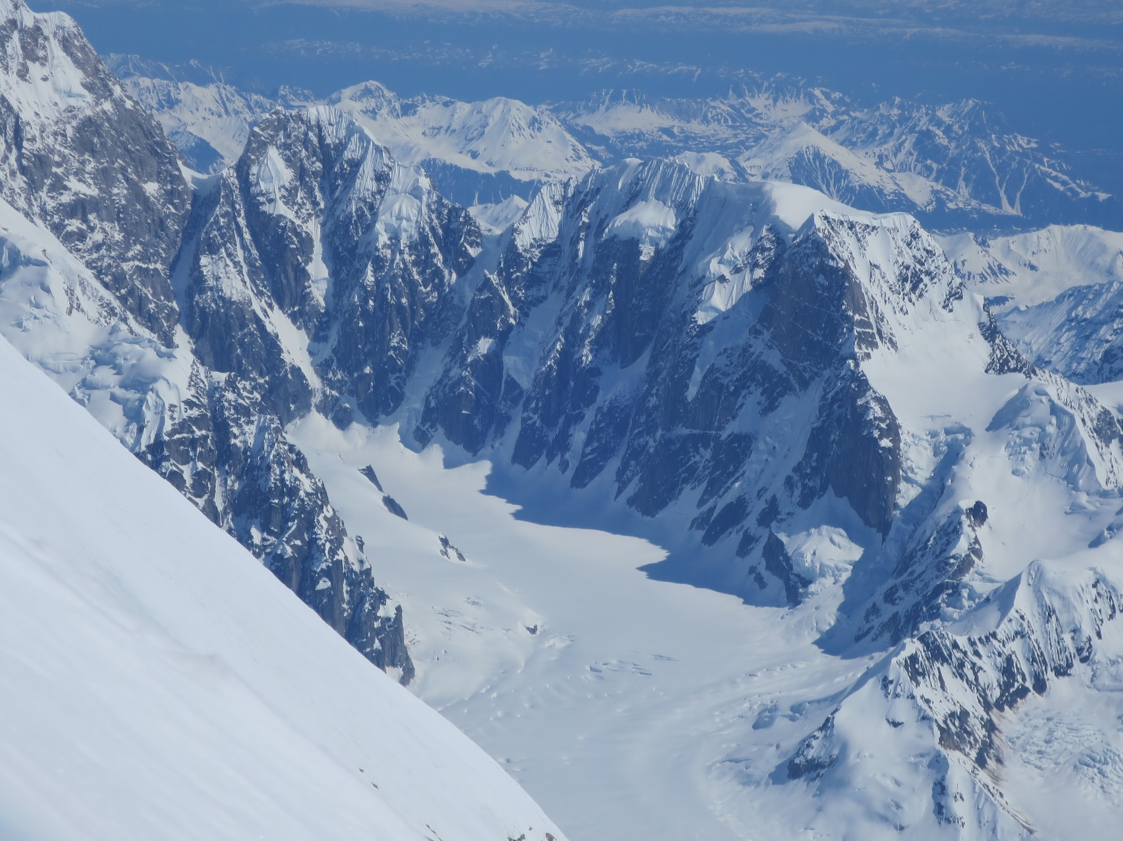
Photo: Thunder glacier cirque as seen from the summit ridge of Foraker. Much blacker by the end of May.

Infinite Spur
The Infinite Spur takes a direct line up the chaotic south face of Mount Foraker, soaring 2800m from the Lacuna glacier to the south summit. First climbed by Michael Kennedy and George Lowe over eleven days in June 1977, the route has since gained test-piece status. After a flurry of repeats at the turn of the century, the route received it's last ascent in 2009 at the hands of the Swiss Anthamatten brothers. Whilst not as technically difficult as the nearby North Buttress of Mount Hunter, it's scale combined with the lack of easy descent from Mount Foraker's summit make for a committing venture.

After spending a day approaching the base of the route we crossed the bergschrund early on the morning of May 26th, climbing steep snow and mixed slopes before belaying at the base of the crux M5 mixed pitches. With these dispatched, and the end of Pete's block, Ben took us up through the first rock band and to our first hacked bivi ledge. The early demise of this ledge saw us up and away before 1am, straight into the second rock band. More quality ice and mixed climbing led us up and onto the ice rib, where we were passed by Colin Haley and Rob Smith, on their way to making a record-breakingly fast ascent of the route. Colin would come back around for a mind-blowing solo of the route a few days later, describing a harrowing storm-bound descent as crossing the line into unacceptable danger. From here, two pitches of South Stack style choss led us through the black band and then to the top of the knife edge ridge, where we chopped an airy bivvy after 24 hours of the go.

After reluctantly climbing out of our two-person sleeping bag the three of us shared the lead up seemingly endless snow and ice slopes, to be confronted with bitingly strong winds on the summit ridge. Luckily the gusts abated and we reached the summit late on May 28th, bathed in golden dusk sunlight for a shared emotional moment, before beginning our descent of the Sultana ridge. After a night spent in a handy sheltered crevasse, and a day traversing the peaks of the Sultana, our precious weather window finally came to an end, leaving us descending Mount Crosson in typically Scottish conditions. A final three-hour bivvy spent waiting for waist-deep slush to refreeze and we were onto the Kahiltna glacier and back to base camp for a late lunch, feeling deeply sated by our intense experience.

Our ascent was the 10th of the route, the 9th completed the day before by Rob and Colin. We were the first Brits to climb the route. The experience of climbing such a big, committing route, has left us wanting more- we are keen to attempt something similar but unclimbed, and with this in mind are already looking towards a trip to Pakistan in 2017.

Accidents/Illness
No accidents/illnesses to report.

Google Earth
Google earth is quite poor for the area visited, particularly the south side of Foraker/ Lacuna glacier, with images too bleached to be of use.

Logistics

Shopping
We shopped for food at Walmart in Anchorage.
Outdoor equipment was purchased from REI and AMH in Anchorage. Wide range of gear available. There is also a second hand gear/consignment store opposite REI that is worth a look.
There’s a great second hand book store, Titlewave, on the same row of shops as REI.

Permits
You must register 60 days in advance to purchase a permit to climb on Denali and Mt Foraker. Before entering the range climbers must attend a briefing session at the Talkeetna ranger station, which we found to be very helpful as our ranger was Mark Westman, who had himself made a previous ascent of the Infinite Spur.

SAT Phone
We hired a SAT phone from Satellite Phone Store, opposite REI.

Anchorage
We stayed at the Arctic Adventure Hostel, which is clean and reasonably priced.

Talkeetna
The roadhouse breakfasts are justifiably famous, as are the fairly wild nights in the Fairview Inn...

Transfer
We used Go Purple Transfers to take us and our baggage from Anchorage to Talkeetna. For the return journey we rented a hire car from Fairbanks, where we visited friends for a few days after completing our climb.

Gas
Gas canisters from REI in Anchorage, white gas for MSR stoves from TAT

Glacier Flights
We flew with Talkeetna Air Taxis. They’re the biggest outfit in the range, and are very friendly and helpful. They have a bunkhouse in Talkeetna that it is free to stay in when in town before and after climbing.

Waste Disposal
All rubbish was flown from the glacier. The National Park provides clean mountain cans for the disposal of human waste, which is then either flown out or deposited in a crevasse depending on location.

Budget
Expedition Costs:
Travel -
2,700 (International flights)
1,500 (Glacier flights, inc. bump from Thunder glacier to Kahiltna Basecamp)
300 (Shuttle between Anchorage and Talkeetna)
Food and Stores - 1,100
Peak Fees and Liaison Officer - 800
Insurance - 1,000
Other and contingency - 300
TOTAL: 7,700
Expedition Income:
Number of Members - 3
Amount of Personal Contributions - 4,450
Details of grants:
BMC - 1,000
MEF - 1,650
AC - 300
AAC - 300
TOTAL: 7,700

Equipment

Tents
We used a three person Mountain Hardwear Trango 3 tent, which seems to be standard issue on Denali. We used a one-two person Black Diamond Hi-light single skin tent on Foraker, which was quite cosy with three people. We also used the fly from an old tent as a cooking shelter whilst at BC.

Sleeping Bags
Whilst climbing the Infinite Spur we shared two lighweight Rab sleeping bags between the three of us, zipping them together to make a large down quilt. For future trips whilst climbing as a three I would consider taking a purpose-made down quilt. We used larger, warmer, individual sleeping bags whilst at BC and on Denali’s West Buttress.

Clothing
We used clothing from various manufacturers, but principally that supplied free of charge by Rab. Layering wise, we tended to use a base layer, fleece, hardshell, synthetic insulated layer, down jacket on the top half, and on the bottom half hard or softshell salopettes with either one or two layers underneath.

Hardware
On the Spur we used two 60m half ropes, 1.5 sets of wires, DMM dragon cams small to large, a few birdbeaks and assorted pegs, 12 quickdraws, 2x 240cm slings for belays when leading in blocks.

Sponsors
Food and equipment was provided by Rab, DMM, Crux, Mountain house meals and Chia Charge energy bars.

Info
Alaska climbing, Supertopo guidebook, by Joe Puryear
High Alaska, by Jonathan Waterman
Supertopo forum thread for Infinite Spur.

If future teams want any extra info about the above then please feel free to get in touch: will.thomas.harris@gmail.com

