Gangstang 2016
  - MEF 16-31
The first ascent of the north west ridge of Gangstang (6162m) in the Lahaul district of the Himachel Pradesh Himalaya, India, by Malcolm Bass and Guy Buckingham, June 2016.

Gangstang 2016 Expedition (MEF 16-31)

Summary

The primary aim of this expedition in May and June 2016 was to make the first ascent of the NW Ridge of Gangstang (6163m) in the Lahaul district of Himachal Pradesh, India.

Gangstang lies near the Chandra-Bhaga River and is normally approached from Keylong (3350m) for the Voie Normal (SW Ridge) from the Gangstang Glacier. However, for this expedition we approached from the road head of Nainghar further to the west.

The expedition consisted of two British climbers, one Indian Liaison Officer, an agent guide, a chef, and a chef’s assistant.

The expedition was blessed with excellent weather with a usual pattern of late afternoon and very early morning mist, drizzle or snow and fine days. Because of the good weather window, the expedition was able to acclimatise and achieve its objective in short order.

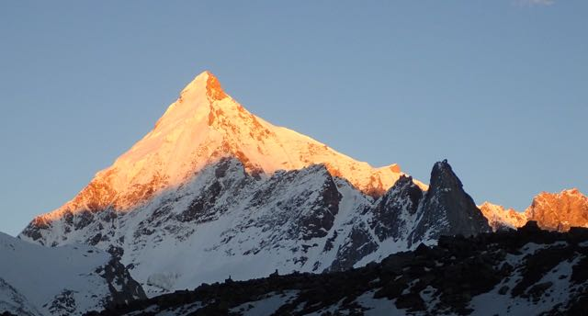

Gangstang showing ascent and descent of NW and SW ridges: Photo Guy Buckingham

Expedition members

Malcolm Bass (Leader)
Guy Buckingham (Climber)
Mr Parmender Sharma (Liaison Officer)
Mr Bhim Bahadar Lama (Rimo Guide)
Mr Santabir Sherpa (Chef)
Mr Dawa Bhutiya (Assistant)

Climbing history of Gangstang

Gangstang, which was first reportedly climbed by Italians in 1945 and again in 1973 by a team from Calcutta, is most commonly climbed via the SW Ridge. Successful parties have approached from the Gangstang Glacier to the East. In 2001 a Japanese party broke new ground by approaching the peak via the glacier below the North Face and from here made the first approach of the East Ridge. In 2007, Martin Moran brought a commercial expedition to the Thirot Valley. During that time his team successfully climbed what they called Thirot Shivling (5324m), a prominent rocky bastion at the far end of the NW Ridge of Gangstang, PD- and established a partial new route up a curving snow couloir on the west face of Gangstang before joining the standard SW Ridge (D-).

Permission and other administrative issues

It had been originally planned that the expedition would go back to Rimo III (7233m) in the East Karakoram Range. Rimo III lies near the head of the North Terong Glacier which is a tributary of the Siachen Glacier. This is militarily sensitive area. Unfortunately permission was turned down at the last moment, leaving the expedition looking for a suitable project on an “open” peak to ensure no issues with further permissions. After various long and in-depth discussions covering numerous ranges and countries, with the help and support of Martin Moran, the objective of Gangstang was chosen. The NW Ridge had yet to be climbed and the pictures from the previous expedition promised and excellent line on a peak reminiscent of the Matterhorn or Shivling.

The nearest open peak is Phabrang (6172m) for which we applied through the Indian Mountaineering Foundation (IMF) and permission was duly granted. As a requirement of the permission, the IMF allocated a Liaison Officer and we were very lucky in being allocated Mr. Parmendar Sharma, a young, ambitious climber who was both friendly and amenable to our objectives. Our other Indian members were employees of our agent. The process of applying for the open peak did not take long with less than a month between applying and permission being granted.

Insurance for mountaineering above 6000m continues to be expensive. The most cost effective method that we found and used was to use an extended policy under the Austrian Alpine Club plus a basic cover for a standard holiday to cover lost luggage etc. Also satellite phones are still an issue in India, although officially there is the intention by the government to change the law banning them, they are still not allowed. However, the use of a satellite texting device (such as the Alpine Club InReach which we hired) was deemed acceptable.

The Plan

The expedition plan envisaged eleven phases:

- UK Phase. (Permissions, grants, equipment)
- Fly to India with all kit
- IMF Briefing
- Road Travel to Road head (Nainghar)
- Walk to BC (Alias Got)
- Acclimatization
- Climb route and descend
- Walk to Road head
- Road and Rail travel to Delhi
- IMF de-brief
- Fly home (Write reports)

The execution followed the plan with only a change in timescale at the end as the weather allowed the objective to be completed earlier than expected.

NW Ridge of Gangstang taken from top of couloir. Photo: Malcolm Bass
The Trip

We arrived in Dehli on the 27th May, having flown in from Manchester. We specifically chose a flight with a large luggage allowance to be able to avoid the rigours and inexplicable ways of working of Indian customs when dealing with freight.

We met our Liaison Officer and Rimo Expeditions representatives at the IMF. On completion of what must be close to a world record swiftest IMF briefing (always worth trying to ensure the Vice President is double booked) we departed for Chandigarh. Prior to departing we had a long and fruitful shopping trip to top up with suitable hill food to supplement the freeze-dried rations and supplements we brought from the UK.

It was somewhat of a daze that we arrived in Chandigarh towards nightfall after a long journey. Chandigarh is a very modern city only being built in the 50s and 60s and very much on communist lines, where every street and square looks exactly alike. It was pleasing to note that this had not prevented the locals from stamping a distinctively Indian ambience on the city. One point to note, if going out always take a map or interpreter as it is almost impossible not to get lost amongst the uniform streets and squares. .

We were up early next morning for the next leg of the journey with a long drive to Manali. It was good to get off the plains and into the much cooler and less humid foothills. The journey was very busy with many cars and coaches as we had managed to tie in the journey with the main Indian holiday, and Manali is an exceptionally popular local tourist destination. We stayed in a very pleasant hotel outside of the main hustle and bustle of the town but only had a limited time to enjoy it as we out again early in the morning for the last leg of the jeep journey. By this time we had been met by the chef, Santabir and Dawa his assistant. Santabir had worked on a previous trip with Malcolm and was soon to re-establish his mark as both a shy individual and an excellent cook. Dawa was more outgoing and provided excellent service with a real care for his charges.

From Manali, we proceeded over the Rothang pass (4000m) down into the Chandra-Bhaga River valley. The Rothang pass is exceptionally popular with Indian tourists, and there is a flourishing trade in of the hire snowsuits to allow those from the plains their first experience of snow. As such the road, which is under constant threat of rockfall and landslide as well as constant repair, was very busy and required queuing at times. It never ceases to amaze that the natural anarchy of Indian drivers still allows the traffic to flow.

Once past the pass, the roads were much quieter and it was easier going down the main valley. Of note there is a huge engineering project to build a tunnel from Manali through to the Chandra-Bhaga valley which with considerably ease the journey; however it will not be completed for another five years. After a journey through numerous small villages we turned off towards the road head of Nainghar. The road was exceptionally narrow with the trucks only just fitting on the bridges.

Once we arrived, our Rimo Expeditions guide, Bhim, introduced us to one of the elders of the village who was most gracious in allowing us to camp close to the village that night. Bhim would remain with us for a few days to ensure that we were properly settled and remained as our constant mother hen, clucking around to make sure we didn’t get into trouble and kept on the straight and narrow – all done in our best interests and very welcome it was.

Nainghar was a very idyllic village with a mixture of old housing and one very modern dwelling. It sits as the last stop prior to the popular pilgrim way to the sacred lake of Neelkantha. It is very easy to romanticise about village life, but there seemed to be a real sense of community with everyone sharing in the work with both humour and diligence. It was the time for planting of crops and tending of the animals as they were being moved further up the valley as the snows were melting. There was a real curiosity about our little band and it was a very enjoyable evening and morning.

The next morning, after the obligatory bed-tea and breakfast, we proceeded up the valley to our intermediate camp. By that time of the year the camp was in a very pleasant meadow, there were many flowers starting to appear and the valley was very green. It was good to be able to take advantage of some of the huge boulders on the path, although some of the landings were less than perfect, instilling a good sense of precaution prior to the start of the trip.

After a relaxed start we made the final move to the Base camp (4200m). Again this was another short day, with camp being established by about 11am. Some of the porters used the opportunity to visit the sacred lake prior to departing back down to the last camp where they had left their personal equipment. The camp was in a very pleasant spot next to the main river and with an excellent view over to the main objective. This was to be our main home for the next three weeks and with the exception of a few passing pilgrims it was left to our small team.

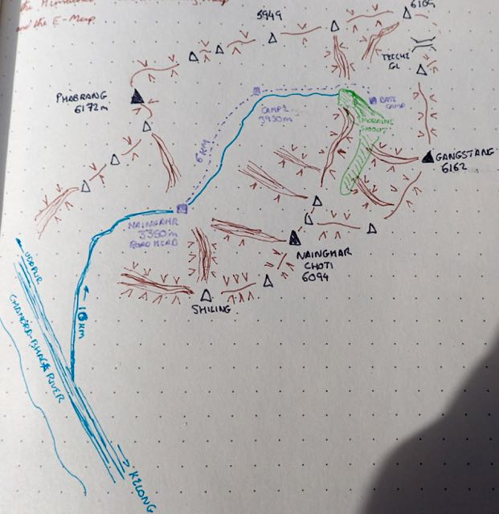
Sketch map of area in the vicinity of Gangstang

We spent the following day at base camp with only a small foray up the moraine to better spy out the lie of the land and gain just a little height. With the weather on our side we did not wish to wait too long before starting our next phase of the acclimatisation.

Our Liaison Officer, Palmi, was very keen to join us and had some excellent previous experience. He is very keen on climbing Everest and has a plan which will hopefully see him completing his dream within the next couple of years. Our first objective was just to gain height, so on 1 Jun we headed up the moraine and continued past a huge rock buttress, which we poetically named “The Lump”, continuing up snow ramps until we had gained a height of around 4900m. It was a beautiful day and so we were able to hang around for a little time to admire the view and let our bodies get used to the lack of oxygen. With an early start we were back at camp by midday, which was fortunate as it got unpleasantly hot in the afternoon, and we were glad of the shade offered by the mess tent.

The next day was due to be a rest day, but seeing how everyone was feeling pretty well; we took the opportunity to advance our next and final acclimatisation phase by 24 hours. So we promptly packed up for a night out and Malcolm, Guy and Palmi headed back up the moraine and headed East across the front of the NW Ridge of Gangstang towards the base of Neelkantha (5324m). This peak stands as the bastion at the end of the NW ridge of Gangstang with a very distinctive rock feature on top looking like a figure in a lotus position watching over the sacred lake.

As we went past the lake, Palmi took the opportunity to offer a prayer whilst we paid our respects. On the side of the lake is a small monument surrounded in gifts, especially small iron tridents or trisuls, there is also a small box with donations to help establish a proper temple on the site. Once past the lake, we established our camp on a moraine band (4500m). After an uncomfortable night getting used to sleeping in the tiny tent, we rose early to head around to the west face as early as practical to head up the slopes to the summit. It was a long way around before we found a slope that looked probable. There was a snow gully which wound its way through a series of rock buttresses. The slope was very pockmarked and, along with serious debris from snow slides and rock fall, this concentrated our minds on ensuring we were back down prior to the sun getting on the face.

We continued up the slope which remained at an almost constant 30 degrees until we reached the NW summit after about 4 ½ hours. There was only time for the quickest of photographs before we were moving with alacrity back down the slope towards our tents. Once we had re-packed it was off back to base camp and a well-earned slap up meal including pizza and cake.

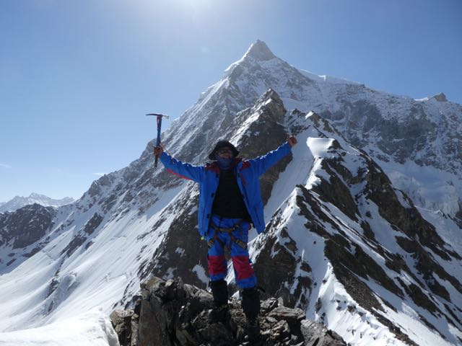
Liaison Officer Parmender Sharma on the summit of Neelkantha: Photo Malcolm Bass

Once back at base, it was time for a proper rest day, with a whole day devoted to anything but mountaineering, although it couldn’t be helped that we had a little play on some of the excellent granite boulders surrounding the camp.

Now feeling that we had just about enough acclimatisation, it was time to plan for the main objective. This consisted of a day sorting food, logistics and suitable climbing equipment for the route. Not knowing what was in store, we planned for a five day trip, thinking that would allow us sufficient time to climb, with just enough contingency for unforeseen eventualities without adding too much to the weight of our packs.

Early on the morning of 6 Jun, we headed back up the moraine and toward the base of the glacier that sits under the North face of Gangstang. It was a little unfortunate, but we could see no way around getting on the glacier early, climbing a frozen stream before the sun hit it, and then waiting all day in the heat prior to an early start the next day. Once on the glacier we were in real luck as there was a large erratic boulder under which we could both get shade and which during the day produced a small melt puddle allowing us to get drinking water. We did use the opportunity to head up towards the start of the climb, not only giving steps to follow next day in the in the dark, but also allowing us a good close look at the proposed route onto the ridge.

From what we could see, we were in luck, there was a large snow cone which would allow an easy angled snow slope onto the ridge and the bergschrund above was covered over; it then looked like a steady snow ramp into a broad couloir and then onto the ridge. It was with the usual sense of anticipation that we went to bed that evening, both engrossed in our own thoughts about the days ahead.

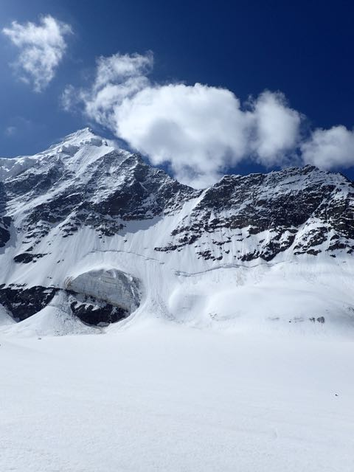
Looking up towards the ridge and route from the glacier below the North Face: Photo: Guy Buckingham

With a 1am start we headed back to the snow cone and made our way up towards the couloir. For the first half of the climb to the ridge everything was very smooth. The climbing was not above grade Scottish II and we were able to move together smoothly and efficiently. It was not until we traversed left under the rocky outcrops that the angle steepened and the extreme effect of the sun on the snow which left it very crystalline and insecure came into play. As we approached the ramp, there was a choice between unconsolidated snow and very hard, brittle grey ice: however Malcolm spotted a small subsidiary couloir on the side for which we aimed. This proved to be a grade Scottish IV mixture of dinner-plating ice and loose rock but it did allow us to approach the upper reaches. From then on it was unconsolidated snow up to the cornice which was exceptionally insecure and un-protectable. Unfortunately Malcolm wasn’t fast enough to untie from the ropes before Guy, in the lead, began his tenuous grappling with the cornice! Luckily it all turned out alright.

It was 0730 on 7 Jun, when we reached the ridge and with only a short break we made good on our timings and proceeded towards the “First Tower” and started making our way along the ridge. We stuck to the ridgeline, climbing in crampons on ground that was mostly V Diff to Hard Severe with several short harder sections with moves of 5a and Scottish technical 6. The rock was mostly okay as long as you took care where to stand and what to pull on. We sometimes rock climbed with bare hands, sometimes with gloves, and sometimes we used our ice tools. Malcolm led as we made good progress up the “First Tower” via crimpy slabs, steep walls, and classic jamming cracks towards the next obstacle, another tower, which we had dubbed “The Citadel”.

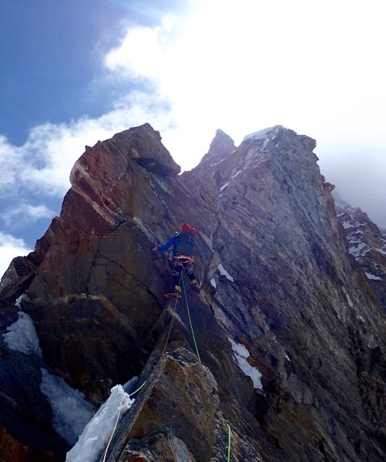
Malcolm getting to grips with The First Tower: Photo Guy Buckingham

By the time evening was approaching, we were looking for a suitable campsite, and they were in short supply. We eventually decided on a small snow ledge half overhanging the north face and anchored everything, including ourselves to the adjoining rock. It wasn’t too bad an evening and although we both didn’t get much sleep (not much of the tent was actually on the ledge); we were at least able to rest.

The next day took on the Citadel, an imposing and large rock sculpture block our path. It was obvious that we were not going to tackle it head on and the route on the North side would have meant a balancey and tenuous day working between unconsolidated snow bands with little protection. This left the dank west face which lived up to its promise of uncompromising and loose terrain. After a 5a traverse onto the face the day was then spent on loose mixed climbing around a Scottish technical grade of 4/5. With the limited views we had to guess at when we were far enough around before heading up again, and so it was with light hearts that we regained the ridge at a horizontal section on the right side of the Citadel just as the evening was drawing in. (The winter of 2015/16 was unusually dry in Lahaul, as it was elsewhere in the Himalaya, so conditions on the route might not have been typical: with a bit of consolidated snow this this section might go more easily and more enjoyably)

Luck remained on our side as we soon came across a bivy site which allowed not only a flat campsite (after a solid hour of chipping ice) but also allowed us to camp without being tied in. We both had a better night’s sleep and were looking forward to the challenges of the next day and hopefully the summit.

The 9th Jun started well, after progressing over some snow slopes we approached a grey rock tower, different in appearance and feel to the previous rock. Although “The Grey Tower” was still loose and looked similar to a large pile of unstable Jenga, its blocky nature allowed for good progress if taken with care. It was here that the last technical crux of the climb came (Tech 6). Thin torqueing cracks led up a short wall to a rockover onto the top of a large block. It was only when fully committed to the block, that you could see it was completely overhanging the west face and felt some distance apart from the main ridge: a hole between the block and its neighbour allowed for a full appreciation of the drop below.

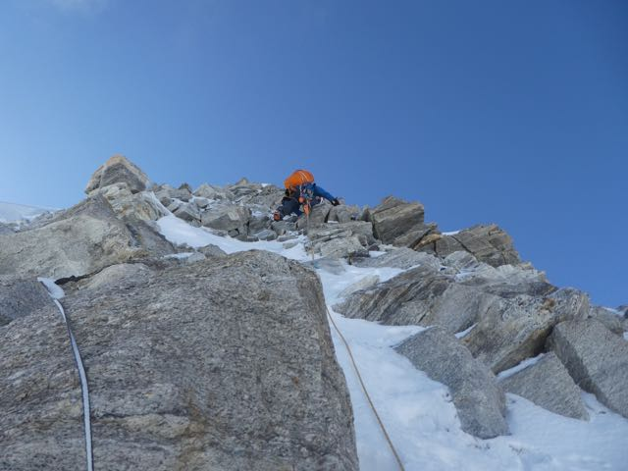
Guy working his way up the Grey Tower: Photo Malcolm Bass

Once above the tower, the ridge began to merge into the north face and the climbing became a monotonous round of small rock buttresses interspersed by sections of featureless grey ice that was both hard and brittle. By this time we were feeling the effects of the altitude and the previous work resulting in a sequence of very slow moving pitches with both of us making a beeline for any rock showing from the ice in order to rest the calves when leading.

By this stage the weather had deteriorated with a barrage of icy wind and snow being blown across the west face. It was getting towards evening and both had donned down jackets to battle the cold when the top finally came in sight. It was a fairly subdued pair who finally topped out with the weather curbing too much enthusiasm and only a quick selfie taken before thinking of a good campsite.

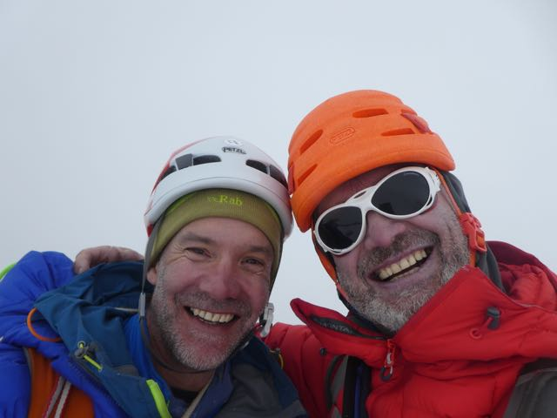
Summit Selfie with Malcom and Guy: Photo Malcolm Bass

The route down was none too obvious and the visibility was in and out so we only went about 100m under the summit ridge to some soft dry snow which allowed for an easy site for the final campsite. Both being exceptionally tired it was an effort to cook and drink before sleeping.

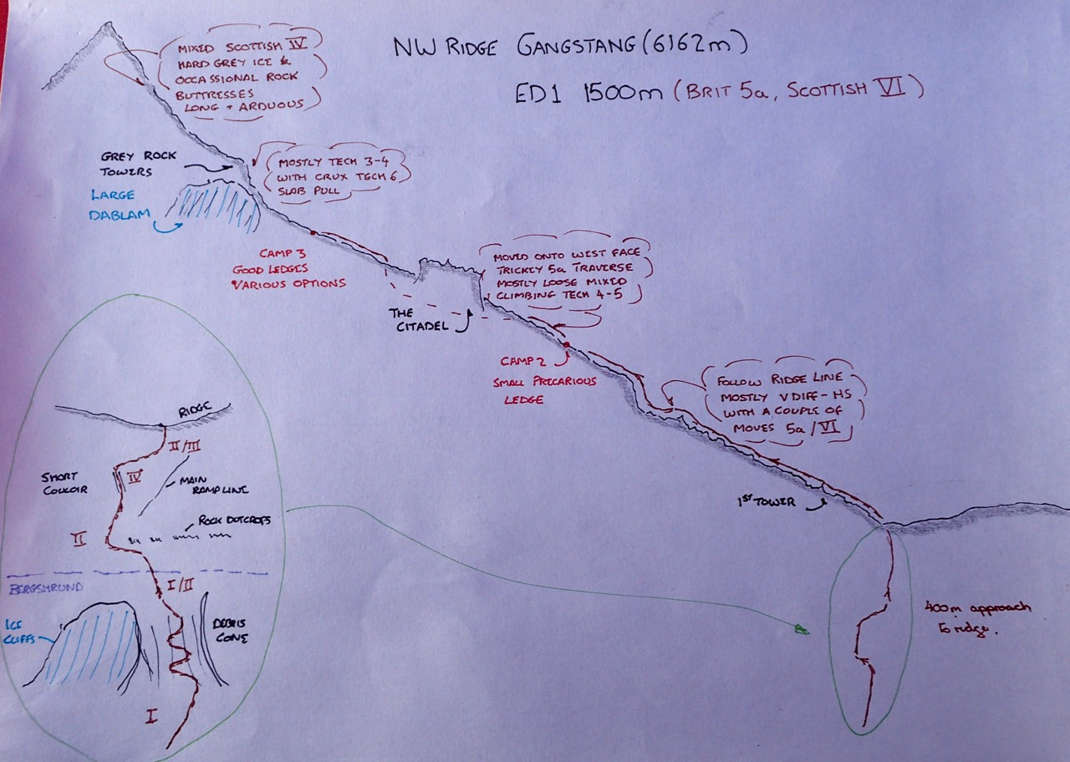
Sketch topo of the NW Ridge route: Guy Buckingham

Next morning the weather started badly, again with poor visibility but this soon cleared and we were able to see the right way down. The way was easy enough, with only a small section of grey ice to be tackled before an easy stroll down the snow ridges towards the west face. We were making our way along the route used previously by Martin Moran; unfortunately this included a short trip up a small tooth on the ridgeline which meant wading up hill in knee to thigh deep snow. It did feel like the mountain was reminding us who was boss.

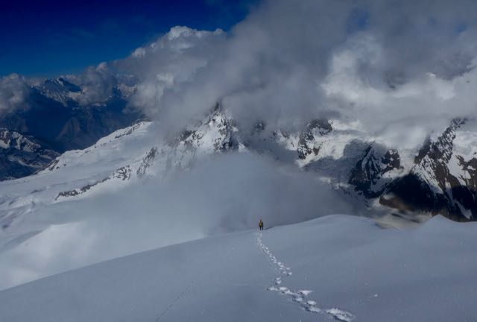
Guy heading towards the descent couloir: Photo Malcolm Bass

We were soon at the couloir leading to the basin at the bottom of the West face and with four abseils, a lot of down climbing and some bum sliding we were at the corrie floor and in relative safety, therefore time for man-hugs all round. It was then just a matter of six hours of moraine bashing with tired bodies and heavy packs until we eventually reached base camp with welcome tang, pakora and many more man-hugs.

With the weather being on our side we had achieved our objective much quicker than anticipated and therefore were able to finish earlier than planned. So after a few days rest at Base Camp we headed back to Delhi and on to the UK.

Other possibilities in the area

We were not taken with the north face of Gangstang; it was covered in seracs when we were there.

Approaches to the unclimbed 6000er Nainghar Chotti looked complex, and we did not see any strong, natural lines.

There is an attractive pyramidal peak on the ridge line between Gangstang and Nainghar Chotti.

There are multiple possibilities for alpine rock climbs on peaks and towers to the north of the Thirot Nala. The terrain is complex and hard to read from the valley. The British guide James Edwards came very close to the top of one of these with clients on the 2007 Moran trip.

There are some great looking possibilities for classic alpine routes up the long gentle ridges running north from the Thirot Nala up to peaks just shy of 6000m. We have not researched this carefully, but suspect that some of these peaks might be unclimbed.

We only made the most superficial start on the superb bouldering found around and just below BC. Attractive, large, independent granite boulders, many with good landings. Some needed a bit of dry lichen brushing off, but some were good to go.

Accounts

Notes on accounts

Rimo Expeditions were our Indian agent. These costs cover road travel, accommodation, Indian wages, porters, food, fuel, tent and BC kitchen equipment hire.

The BMC (British Mountaineering Council), The Mount Everest Foundation, Montane, The Austrian Alpine Club and The Alpine Club all generously gave us grants towards the cost of the expedition.

All other costs were covered by the two expedition members.

Support for the expedition

Expeditions to the greater ranges are inevitably expensive and would be untenable for climbers without huge private means if it weren’t for the excellent grants available to support British alpinists attempting new routes and first ascents. The grants strategically prioritise new routes and first ascents, and this focus enables the UK, a country with no glaciated mountains, to maintain a proud reputation as a major alpine climbing nation. This plays its part in creating a strong national culture of outdoor pursuits which benefits health and wellbeing, and supports a vigorous outdoor pursuits economy. The British Mountaineering Council, Mount Everest Foundation, Austrian Alpine Club and the Montane Alpine Club Climbing Fund grants were of this type. We are extremely grateful to all these organisations for these grants.
Montane generously supported us by providing funding, superb clothing and a backpack, and there continues to be a close partnership between Malcolm and the brand.
High5 Sports Nutrition kindly provided us with bars, gels, sports drinks and recovery drinks. These are perfect for fuelling endurance efforts in the mountains, and are very convenient for quick recovery in bivouacs.
Lyon Equipment very helpfully supported Malcolm with excellent La Sportiva boots, Petzl hardware, and Beal ropes.
RAB have been very supportive of Guy and provided him with the excellent summit tent essential for the rest and recovery of the pair en-route.

Report compiled by Guy Buckingham and Malcolm Bass, The Alpine Club.

It is noted that when talking to a local professor from a nearby college, Mr Suresh Kumar, that the traditional name for the peak is Neelkantha, which we will use in this report.

