- Present - 29 people on Zoom

- Full minutes and also Area Newsletter - available on BMC Lakes Area section of BMC website

- Impact of Covid-19

Rob Dyer - reported on position so far. BMC Covid-19 Access Advisory Group set up to advise the Government on Covid-19 issues. Had reported to English and Welsh governments.
No response from the English government so far !! – General shock at the response of England with all the outdoors opened with no time or distance limits as long as back home by end of day! The approach by BMC for walkers and climbers to
(a) be self-reliant,
(b) be aware and consider locals,
(c) appreciate from landowners point of view
(d) travel alone except with members of your household,
(e) promote stay local, if you can, to avoid crowding on popular locations
Welsh government used BMC-like approach – more restriction on travel etc
Things will no doubt change as time moves on and will need to develop plans.

Other issues –
- Comment made re two aspects for the Lakes with (a) the fells and activities etc and (b) the towns and urban businesses. Promoting discussion with LDNP and Richard Leafe.
- Concerns raised by MRT with issues of Covid-19 and other commitments of members. There was a recent press release (22/05/2020) outlining “Safety on the Mountains whilst Exercising - and highlighting need to avoid accidents and be active within your limits.
See following link and article
  - https://www.grough.co.uk/magazine/2020/05/23/lakeland-teams-warn-be-prepared-for-longer-wait-for-rescue-during-covid-19-crisis#
- Mention that some clubs had received grants from local authorities for club huts as rate paying entities. Any issues Clubs should contact Jane Thompson at BMC to discuss.
- Issues of travelling to hotspots where car parking issues with each person having to take their own car (unless from the same household)
- There are details of the LDNPA website about the availability of car parks.
- Birds are fledging earlier, due to the good weather, however birds have nested in new places due to no climbers there during the lockdown.
- Still important to check positions and/or be aware of local situations. Check RAD on BMC website.
- Looking to update the Regional Access Database (RAD) for the Lakes on the BMC Website access issues, including in relation to nesting and also parking..

If you are aware of any access issues or new bird nests on crags will you please contact the Lakes Access Rep – James Bumby on email jkbumby@yahoo.co.uk

- Equity (Equal Opportunities) Steering Group

Presentation by Cressida Attwood (Chair) and James MacHaffie (Secretary) including a video.
- The BMC now has the 2nd highest-ranking of Sport England rankings.
- A large part of their work involves the Group looking at barriers that underrepresented communities face when they want to do any of the activities the BMC covers and then suggesting strategies for removing those barriers.
- There are several areas that the Group looks at very closely. These are people –
  - With disabilities,
  - People from black and minority ethnic groups (BAME)
  - Women and girls.
  - With Mental Health issues
  - LGTBQ
- More details on BMC website
- Would like to establish Youth and Disability Clubs in areas.
- They would welcome experts in mental health to help with the group.

- BMC

Lynn Robinson (BMC President)
- AGM to be a virtual meeting on 13/06/2020 - 3.00 pm
  - Members being emailed/written to re AGM
  - 3000 places at AGM – need to be preregistered
  - Still can vote by proxy or on the day
  - Agenda much reduced.
  - Had hoped for discussion etc on Organisational Development Group (ODG) but to be delayed to 2021 - this gives more time for consultation
- There are weekly boards meetings
- BMC strategic plan – from last AGM being reviewed with Covid-19 in mind.
- Effect of Covid-19
  - Sports England has been phenomenal with their support.
  - Some staff have had to be furloughed
  - Membership – excellent
  - Insurance – big money earner has all stopped!
- Please stay as a member!
- There is an online “Ask the Board” event on 04/06/2020

Fiona Sanders (ODG Chair) – reported on Organisation Development Group
- Also, piece in BMC Lakes Area Newsletter – on BMC website
- Lot of work has been done and is coming to completion on most areas.
- Establishment of Welsh Committee to work with Wales
- Recognition of Strategy for Club – this is ongoing to complete in September
- Ticked most areas – need to look at –
  - Inter-relations in the BMC and other organisations
  - Communications – Chris Stone working on this!

- An issue raised about 4x4 vehicles on The Knott, in the Northern Fells, which seems to be the use of 4X4 vehicles on non-permitted tracks. The indication is given that if this is seen -
  - The BMC accepts activities where they are legal but oppose the use of 4X4 illegal offroading.
  - Any such activities should be reported to the police on number 112
  - Should have registration numbers of vehicles
  - Would be good to have photographs – but be careful if taking photographs!
  - Also, notify the Lake District National Park Authority (LDNPA)

- The Lakesfest planned for September 2020 has been cancelled – there is a provisional date to have this event on 10 – 12 September 2021.

- George Band Award - congratulations expressed to Ron Kenyon for being awarded the George Band Award, for 2020, for his contributions to the BMC, rock climbing and working with young climbers. see the video of the interview with Ron

- Additional information about climbing walls - The Climbing Walls situation is being handled by the ABC. Latest info looking like possibly early July opening with a limit on numbers, though some doubt as to if that would be financially viable. Looks like 1 climber per 9m square of the building. Nothing definite yet.

https://www.facebook.com/BritishMountaineeringCouncil/videos/883313198813329/
Link to video with the latest info

Next Meeting - 9th September 2020

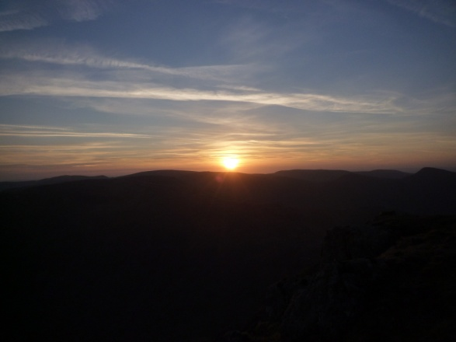 New dawn – over High Street

The BMC was founded in 1944 with membership open to all, "regardless of race, ethnicity, religious belief, sexuality or socio-economic status”.
https://www.thebmc.co.uk/a-brief-history-of-the-bmc

