Stikine Icefield 2018 – Unnamed First Ascents Attempts
Alaska Mountain Women

Beth Loudon, Julie Tullis Memorial Award
I would like to extend a significant thank you to the British Mountaineering Council for their support of our expedition. While we were not able to achieve our initial objectives, we were thankful to have had such a significant and transformative experience in the Alaskan Wilderness. We were met with a series humbling challenges while in the field – freestanding serac walls, avalanches, and poor weather conditions. Yet all members of the group remained safe, calm, and logical, as past experience informed respect for the magnitude and power of the mountains. I look forward to many more adventures with the British Mountaineering Council community. I am ever thankful.

Alaska Mountain Women was an all female 21.04 mile ski mountaineering climbing
project with two first ascents objectives (UTM coordinates 0662272E 6327803N and 0659830E
6316386N) of unnamed, unclimbed peaks on the remote Stikine Icefield in Southeast Alaska.
The route incorporated snow covered glacial travel, icefall navigation, and travel on steeper
30-50 degree slopes. The goal of the climb was to cultivate a strong community of local women
dedicated to challenging and educating others and ourselves about alpine glacial
mountaineering and remote mountains. We shared our story and planning process along the
way in hopes to spark a desire for exploration amongst other outdoor enthusiasts.

To prepare for the expedition the team members met bi-weekly since October 2017.
One meeting was dedicated to route planning, fundraising, outreach, logistics, and grant
writing. The other meeting’s purpose was to review skills such as knot/rope handling, building
anchors, belaying, fixed rope ascension, ski travel communication on a rope team, ascending a
fixed rope, 2:1 and 3:1 crevasse rescue systems, self arresting, technical movement on snow
and ice, snow step-kicking, rope snow travel management in crevasse terrain, route finding on
glacier, snow protection, probing techniques, avalanche knowledge, crampon technique,
transceiver use, off-trail navigation, and map reading. All expedition members were required to
have a current Wilderness First Responder certification, have taken an Avalanche I course, have
at least one winter of backcountry skiing experience, and at least one summer season of snow
covered glacial travel experience. The skills practice, mandatory prior experience, individual
certifications, along with the group planning meetings tremendously contributed the
expedition’s overall success. In the seven months leading up to the trip, the group learned how
to work together for a common goal, practiced skills, read incident reports, and learned from
each other’s diverse backgrounds and skill sets.

The expedition occurred between April 30th, 2018 to May 8th, 2018 with Beth Loudon
(Mountaineering Fellowship grant recipient), Hannah Rosenkrans, Rebekah King, Mary
Gianotti, Katie McCaffrey, and Auri Clark. The group ferried to Petersburg from Juneau on the
morning of April 30th. The original plan was to fly onto the Stikine Icefield that day if the
weather permitted. Weather was not permitting until the afternoon of May 2nd.
Poor weather conditions on the helicopter flights over caused the helicopter to land at
an unplanned location on the East Fork of the Patterson Glacier, seven miles to the west of
where we had originally planned to be dropped off on a medial moraine right above the
exposed blue ice of a lower icefall (coordinates 56 57ˈ35. 98ˈN, 132 32ˈ36. 98ˈ W at 2380
feet of elevation). Limited visibility prevented the helicopter pilot from landing above the
second snow covered icefall or from flying close enough to determine if there was a potential
route through it. That night the group camped at the drop off location.
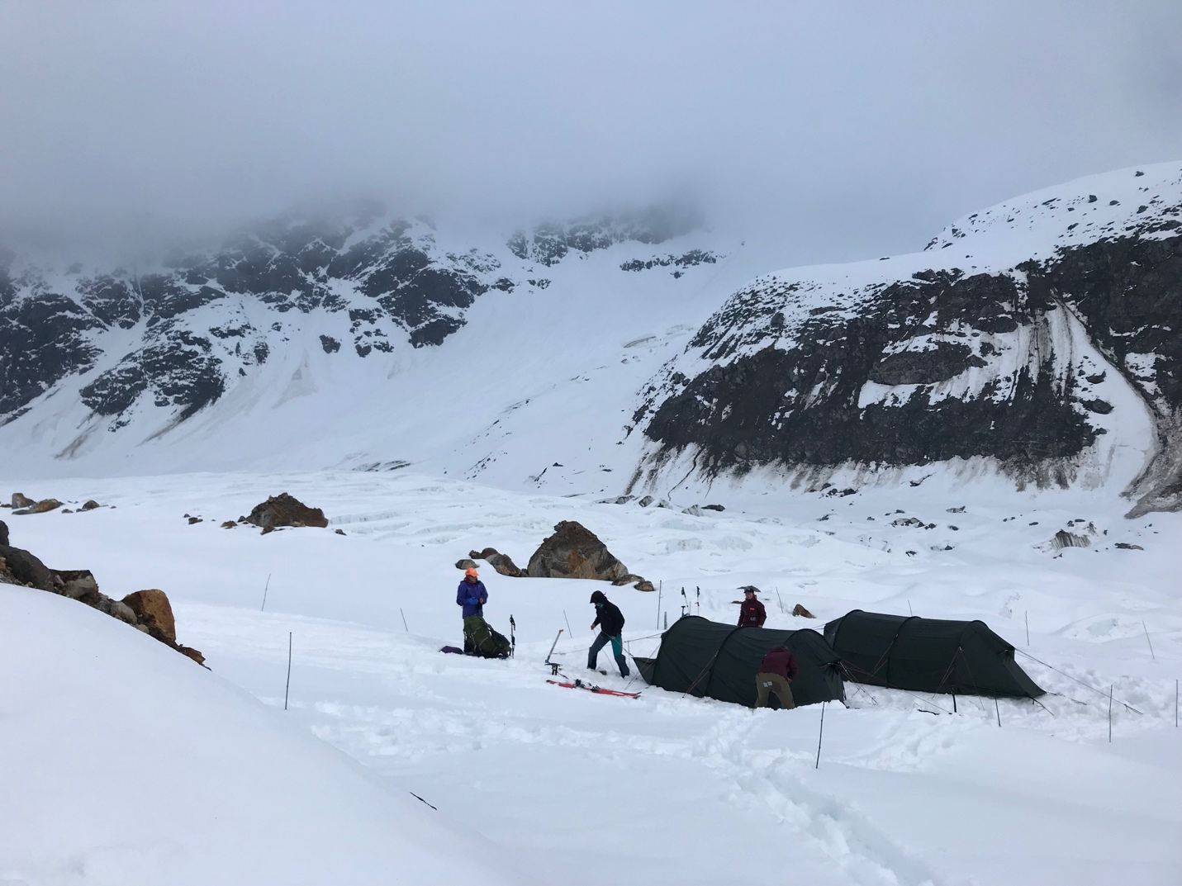
Our first camp and drop off location. Photo by Beth Loudon.
The next day the group skied roughly 2.5 miles up glacier to a camp in the middle of the
snow covered glacier approximately a quarter mile from the base of the snow covered icefall at
coordinates 56 57ˈ13. 35ˈN, 132 28ˈ59. 30ˈ W at 3230 feet elevation.
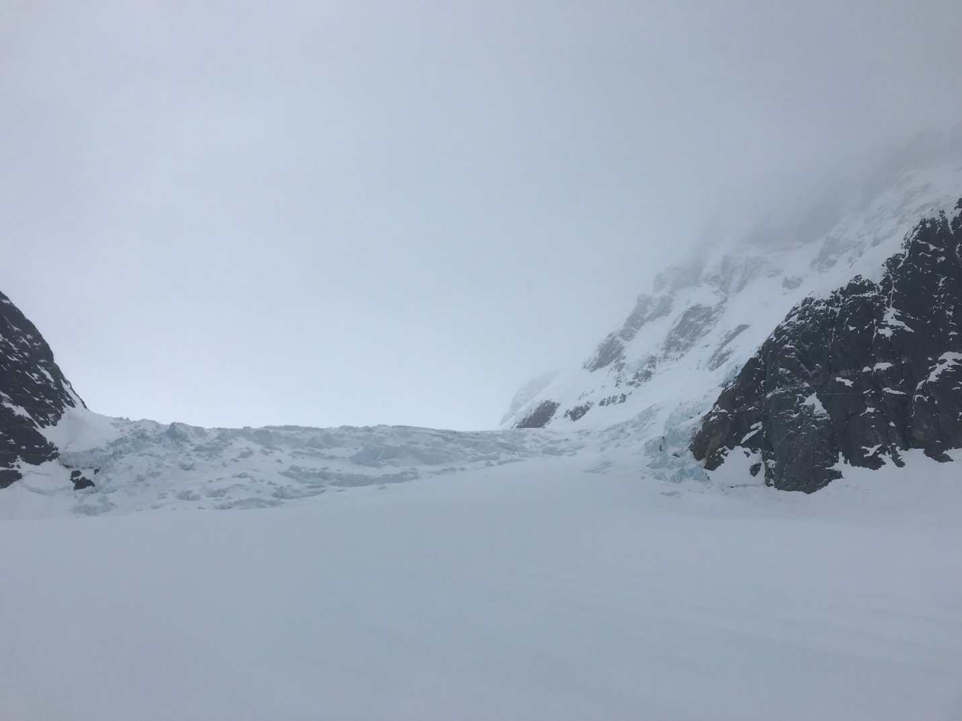Photo of the snow covered icefall, taken from our second camp. Photo by Beth Loudon.

The next three days were spent base camping at the second campsite and attempting to
scout a route on the icefall. Each day two members of the expedition would stay in camp in
case of emergency and a rope team of four members would search for a route. Both the
members in camp and the members scouting the icefall had emergency communication
devices- either a satellite phone or an InReach. Additionally, one member of the rope team had
a beacon on. We did not have everyone on the rope team turn their beacon on because of the
rope team. The first two days navigating the icefall were 30-40 F temperature days in rainy
snowy white out conditions.

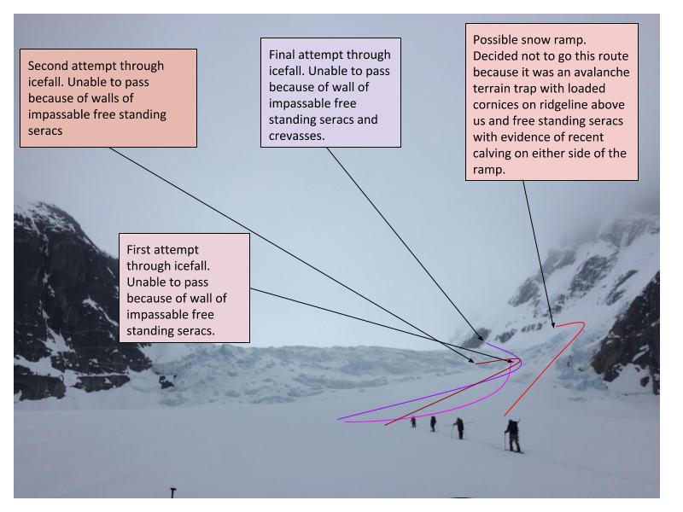
Diagram of three days of scouting a route through the icefall. Photo by Auri Clark.

Looking at the icefall from camp, there appeared to be two snow ramps on the south
side of the icefall that looked like they could go. When closer to icefall, the group realized that
the ramp farthest south was beneath loaded cornices, several free standing serac walls with
recent calving activity, and additionally was on a slope of over 30 degrees. Because of these high
risk factors, the team decided to not attempt the farthest south snow ramp and decided to focus
on a route through the other southern snow ramp. Each day the group made it closer up the
icefall. First day the team traveled ~75% up the icefall, the second day ~80% up the icefall, and
the final day the group traveled ~90% up the icefall. However, each scout ended because of
the inability to get through free-standing seracs and deep crevasses.

On the final day of icefall navigation, the weather increased drastically overnight to over
60 F with blue skies. This quick change in temperature after several days of wet heavy snow
loading caused the snowpack to become unstable. A loaded cornice on the ridge to our south
broke. The avalanche cascaded down to several free standing serac walls. The snow caused the
serac walls to collapse and begin moving towards the rope team. The avalanche stopped roughly
50 meters away from the rope team. The rope team was outside of the terrain trap and too far
north to be affected by that particular avalanche.

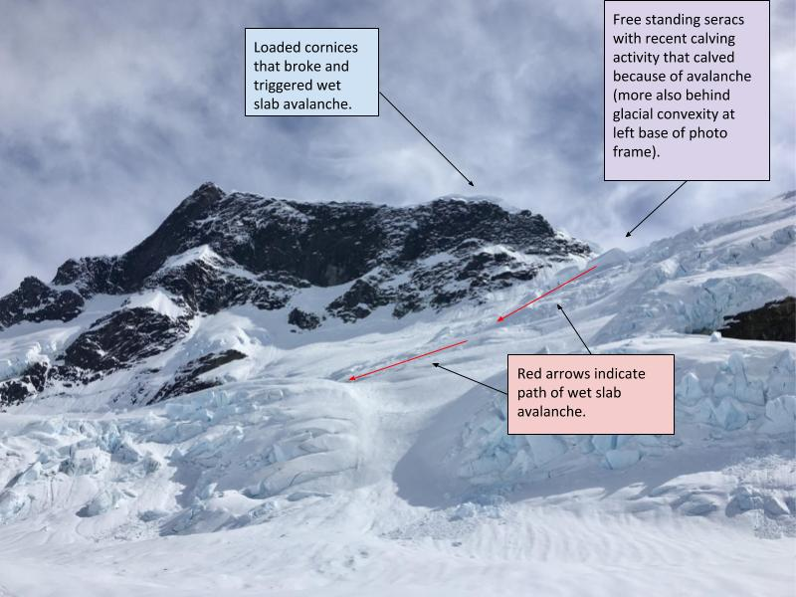
Diagram of wet slab avalanche that occurred on the north facing slope directly south of the
snow covered icefall on the east fork of the Patterson Glacier. Photo by Auri Clark.

However, after the close encounter with the avalanche, the group decided to be back to camp.
The camp was situated over 100 meters west of the icefall in the center of the snow covered
glacier on a less than five degree slope. The campsite was in a safe zone from avalanches. After
the day of bluebird weather the team accessed the weather forecast. The weather was
forecasted to have another two days of flyable helicopter weather until another storm system
moved in. The storm system moving in was predicted to be in the area for over a week. Because
of uncertainty of how long the storm system was going to last, the expedition decided to have
the helicopter pilot fly us out while we still had the weather window. The following morning the
crew skied back to the original helicopter drop off spot. The next afternoon the pilot came to
pick the group up.

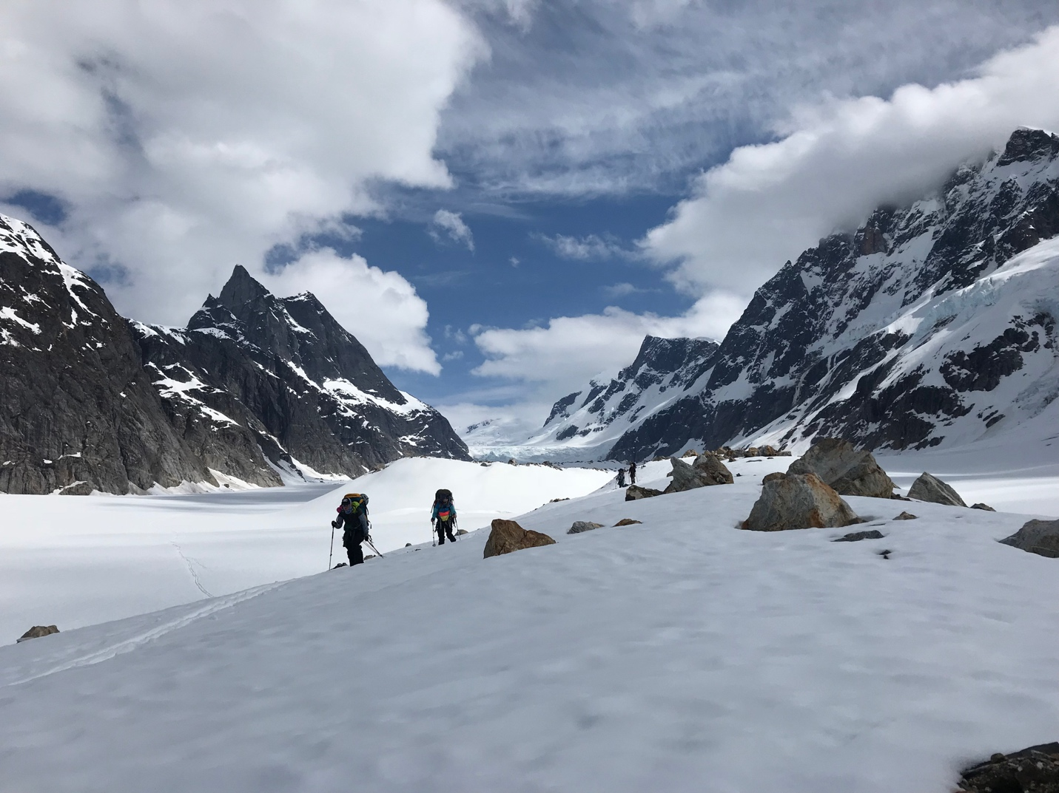
Ski back to the original helicopter drop off point. Photo by Beth Loudon.

Because of the high avalanche risk, poor weather conditions, and impassable icefall we
were unable to reach our original starting point of the traverse or find another way to reach the
desired peaks. Even though our initial objects were not achieved, it was incredible to be able to
challenge ourselves, alongside other individuals who have a love of Alaska.

Everyone on the expedition pushed themselves, while simultaneously respecting the power of
The mountains. When the mountains speak it is important to listen. One of the biggest lessons
one can learn from the mountains is how to allow yourself to be humbled by them.

