British Patkhor Expedition 2023

Supported by:

Mount Everest Foundation
British Mountaineering Council
Alpine Club

Contacts for further information:

Mick Fowler mick.fowler6@gmail.com
Simon Yates simon@yates.u-net.com

The compilers of this report and the members of the expedition agree that all or any of it may be copied for the purposes of private research.

Aims of the Expedition

To make the first ascent of a line on the East/North face of Patkhor (6,083m) and traverse the mountain descending to the south.

The Team

Mick Fowler (67) Retired. British.

Regular climber in the greater ranges for over 30 years. Recent expeditions include Mugu Chuli West Face (2011), Prow of Shiva (2012), Kishtwar Kailash West Face (2013), Hagshu NE Face (2014), Gave Ding North Face (2015), Sersank North Face (2016), Chombu attempts 2019 and 2022.

Simon Yates (60) Writer and Lecturer. British.

Over 35 years of alpine and expedition mountaineering. First ascents include; West Face Suila Grande – Peru, Leyla peak – Pakistan, Nemeka – Pakistan, Monte Ada, Monte Iorana I & II – Tierra del Fuego, SW face Hispar Sar – Pakistan, Mount Alverstone, Mount Vancouver Yukon – Canada, numerous first ascents in eastern Greenland etc.

Introduction

Mountaineering in Tajikistan is not controlled by a system of permits. For UK nationals a visa is required along with a permit – a GBAO permit -to enter the Gorno-Badakhshan region. Both can be arranged on arrival but we played safe and arranged ours on-line before leaving the UK.

History

At 6083m Patkhor is the highest peak in the Rushan Pamir. It was first climbed by a Russian team including Evgeny Abalakov (brother of Vitali Abalakov) via the West Ridge in 1946. Since then there have been several ascents from the south and one ascent from the north.

The north face route was climbed in 1975 by a six man Leningrad team led by Oleg Kapitanov. They climbed a line between the two huge ice cliffs on the north face for which they were awarded 3rd place in the High Altitude Technical Ascent Class of the USSR Championships.

Preparation

Our objective was attempted by the American team of Pete Dronkers and Spencer Gray in 2017 and they were both extremely helpful in supplying photographs and information. Much information can be found on Pete Dronkers’ website: http://www.petedronkers.com/expeditions--climbing.html

Our intended line of descent was climbed by the Czech team of Tomas Cimr and Vita Dubec in 2019 and they too were extremely helpful in supplying photographs and information about the south side.

On the recommendation of the Americans we used Odina Nurmamadov of Pamirmount Tours to help us with in-country arrangements. He is very well connected and we found his services to be excellent. His contact details are as follows:

Odina Nurmamadov

WhatsApp: +992 905901052
Email: odina.nurmamadov@pamirmount-tour.com

WhatsApp is his preferred means of communication.

Visa/GBAO Permit

UK nationals are eligible to apply on-line for visas and GBAO permits.

In theory this is straightforward but we found the website difficult to navigate and it is best not to leave things until the last minute.

In particular do not expect a typical computerised visa issuing experience. Be ready to answer follow-up questions and explain your itinerary in detail.

Also, be aware that (at least in 2023) Tajikistan issues both electronic visas and e-visas which can get confusing. E-visas are sufficient for mountaineering trips.

Travel

Most flights to Dushanbe go via Russia which was out of bounds to UK citizens due to the war in Ukraine. We flew with Turkish Airlines which gave a 30kg baggage allowance. The flight times were such that we had an 18 hour layover in Istanbul.

Arriving at Dushanbe early in the morning on 1st July we were met by our driver and left immediately for the mountains. The first half of the drive, to the town of Kaliakhum, is on good tarmac roads over the Shurobod pass and down to the spectacular Panj/Pyandzh river (formerly known as the Oxus).

Kaliakhum is a fair sized town with a limited supermarket and a grocer where we bought fresh vegetables for base camp.

The river here marks the border between Tajikistan and Afghanistan. At the time of our visit the border was closed and there was some tension on the Tajikistan side with a significant number of army patrols and many sniper shelters.

From Kaliakhum the Pamir Highway deteriorates markedly and is mostly unsurfaced. In 2023 the road was being seriously upgraded with assistance from China and being held up by roadworks for several hours was a constant risk.

At the town of Rushan, the only other substantial town we drove through, we turned off up the Bartang valley. The road became single track and the scenery spectacular with the Bartang river surging between huge dry rock walls and scree slopes stretching up for hundreds of metres.

After 16 hours or so driving from Dushanbe we reached our driver’s village and spent the night there. The hospitality of the local people was exceptional and, having pampered us, they were most reluctant to accept any payment.

A 2 hour drive the following morning took us to the small village of Basid where we were welcomed by Odina and spent the rest of the day resting and repacking.

We had arranged two donkeys for the following morning, 3rd July, and these turned up as planned. One of the donkeymen lived in Devlok, a small village 2 hours from the road, and lunch was had there. The day’s walking posed no problems and ended at about 3pm when we reached a bridge that needed repairing before the donkeys could cross. The rest of the day was spent repairing the bridge. The following day was again easy walking (although we understood that stream crossings and snow slopes can sometimes make it treacherous) and led to an obvious point where the donkeys could go no further.

From here a snow bridge enabled us to cross the river and the donkeymen helped us carry loads up for a couple of hours. The next day we and the donkeymen carried up the rest of our kit and established a base camp at about 3,750m. A stream provided clear water but the site was not good and two flat spaces had to be cleared for our tents.

We had no support at base camp and cooked for ourselves.

Acclimatisation

During our first night at base camp it rained, sleeted and then put down a couple of centimetres of snow. This quickly cleared in morning sun and we walked to a good viewpoint for the North Face of Patkhor noting that the Russian 1975 route between the two huge ice cliffs dominating the face now looks extremely dangerous.

On 7th July the weather was reasonable and we walked up the moraine and then dry glacier before turning left and up to camp at about 4,900m. It snowed during the night and the following morning but, after an enforced stop to wait for better visibility, we managed to reach a col at about 5,300m where a cairn indicated that others had been here before.

The 9th July was a perfect day which we spent walking up a c5,400m peak to the south of the col. Our camp and the c5,400m peak gave us excellent views of the East side of Patkhor and our intended approach couloir.

Having spent two nights at about 5,300m we felt sufficiently acclimatised and descended to base camp. After a day resting, eating and preparing we left base camp on 12th July for our attempt on Patkhor.

Attempt

On the 13th we walked for about 6 hours to bivouac on the highest moraine beneath the prominent couloir which leads to a col at about 5,200m on the NE spur of Patkhor. The 14th saw us climb the couloir to a good bivouac site on the col. This was the highpoint reached by the Americans. The sky was completely clear and we seemed to have hit a perfect weather window. We each ate a freeze dried meal that evening. Mick ate all of his and Simon only managed a couple of mouthfuls before deciding it tasted bad. Within 30 minutes or so chemical burps started to burn our throats. This was exactly the reaction that Mick had with a freeze dried meal in 2019 and so we knew what was coming and had time to prepare as well as we could. Sure enough intense diarrhoea started shortly afterwards and lasted the whole night. Mick also vomited a little. In the morning we felt utterly drained. We opened our remaining dehydrated meals and, having smelled them, concluded that 6 of the 10 we had were off. That left us with only 4 meals of 800Kcal each. We calculated that if we dropped to half rations and all went according to plan then we had enough food to complete the climb and descend the south side but would have no food for the 2 day walk out. We decided that we were prepared to continue on that basis but felt so wasted that the day started late with the intention of trying to climb a few pitches and seeing how it went. An utterly exhausting day ensued with us slowly climbing grade III ground and 50 degree ice slopes to a bivouac spot a little short of our intended site on the edge of a couloir which looked to provide the only weakness through the upper section of the face.
On the 15th we gained and climbed the couloir which gave Scottish IV/V climbing to a fine bivouac spot at the foot of the summit snow ridge. The sunset was perfect and we had high hopes of reaching the summit and the head of our intended descent route the next day. To our surprise though it was snowing when our alarm went off. Mindful of our low food supplies, we started anyway hoping that the weather would improve. After crossing an awkward pinnacle the snow ridge itself had huge cornices and was hard ice so we followed a line of rocks below the crest. Visibility was poor and eventually it became clear that we had strayed a long way from the crest. The slope was not difficult but we experienced whiteout conditions and then, after a few hours, we came across an unexpected rock buttress and ice cliff. Being unsure of our exact whereabouts and with our tracks rapidly filling in behind us we decided it would be foolhardy to press on and so retraced our steps back to our previous bivouac spot. We spent the rest of the day pondering the situation and wondering whether it would be sensible to continue if the weather was good the following day. As it happened the snow continued throughout the night and the following morning we readily made the decision to descend. We ate the last of our food that evening and started to descend the couloir via abalakov thread abseils early the following morning. We reached the col bivouac that day and set the alarm for midnight in order to get a down our approach couloir before the sun loosened stones. Annoyingly the alarm failed to go off and we ended up oversleeping and spending a further, foodless day on the col. The next day all went well and we started to descend at around 1.30am. The top section of the couloir was quite steep and we decided to abseil. On the third abseil, the last before we would start to downclimb the abalakov thread pulled and due to tiredness, exhaustion or whatever we had failed to clip the thread into the back-up screw. Simon fell and slid around 100m and sustained injuries which were later ascertained to be 5 broken ribs and 2 crushed vertebrae. Mick was able to climb down and a slow downclimbing descent continued. Simon was unable to carry his rucksack and after unsuccessful attempts to climb with it or lower it Mick removed crucial items such as passport and satellite phone and dropped the sack hoping that it would fall all the way to the glacier. In fact though it got stuck somewhere and was not seen again. We managed to safely get to a flat spot at about 4,200m on the glacier where we assessed the situation. It was clear that Simon’s back was injured and the way down from here was initially over very rough, unstable moraine and about 20 miles to the road. Concern about inflicting serious damage was such that we felt it sensible to call our insurance company and try to arrange a helicopter evacuation. We had lost our tent and Simon’s sleeping bag in the dropped rucksack. After two nights sharing a bag on the glacier we were losing faith in a helicopter arriving so Mick descended to at least ensure that food and shelter could be brought to Simon. Out of the previous 10 days 4 had been on half rations and this was the 6th with no food at all. After 4 hours of descending Mick met a rescue team coming up. They had food and a tent and Mick was able to direct them to Simon’s position. The following day it became clear that no helicopter was going to arrive and Simon started what turned out to be a painful 3 day walk down to the road. Here we rested for a day before travelling to Dushanbe airport and taking our planned flight back to the UK.

Lessons Learned

The obvious lesson is to be very wary of relying entirely on freeze dried food. This is the second expedition that Mick has been on which has been ruined by freeze dried food. We have raised the issue with the company that made the food and discussions are ongoing.

As regards the accident tiredness and not double-checking things was the main cause. Our 22cm abalakov screw had broken earlier in the trip and we were using a 16cm screw to make the threads. Also we had used up all our abseil tape and were using thin prussic loop cord which probably put more strain on the thread. We had tested the thread with a strong outward pull but that obviously wasn’t a good enough test. That said the ice was rather wet and that should have alerted us to possible weakness. Not clipping the back-up screw into the thread can only be put down to tiredness exacerbated by lack of food.

There are very few helicopters in Tajikistan and those that there are appear to date back to Soviet (pre 1991) times. No authority could be secured for an attempted helicopter evacuation from 4,200m and there was some suggestion that the landing limit was only 2,000m. In short mountaineering expeditions to Tajikistan should not rely on helicopter evacuation.

Accounts

Expenditure

Flights 2013.02 Road transport in Tajikistan 946.55
Other transport costs 437.95
Visa/GBAO Permits 83.64
PCR Tests 198.00
Insurance 1139.80
Hill Food 123.54
Food/Accommodation 521.95
Mountain Gas (12 cylinders @ $10 each) 97.97
Equipment 60.85
Agent Fee ($200) 163.20
Donkeys/Porters 807.82
Satellite Phone costs 347.42
Carbon Offset Payment 100.00

Total 7041.71

Income

Mount Everest Foundation 4000.00
British Mountaineering Council 1050.00
Alpine Club 1400.00
Personal Contributions 591.71

Total 7041.71

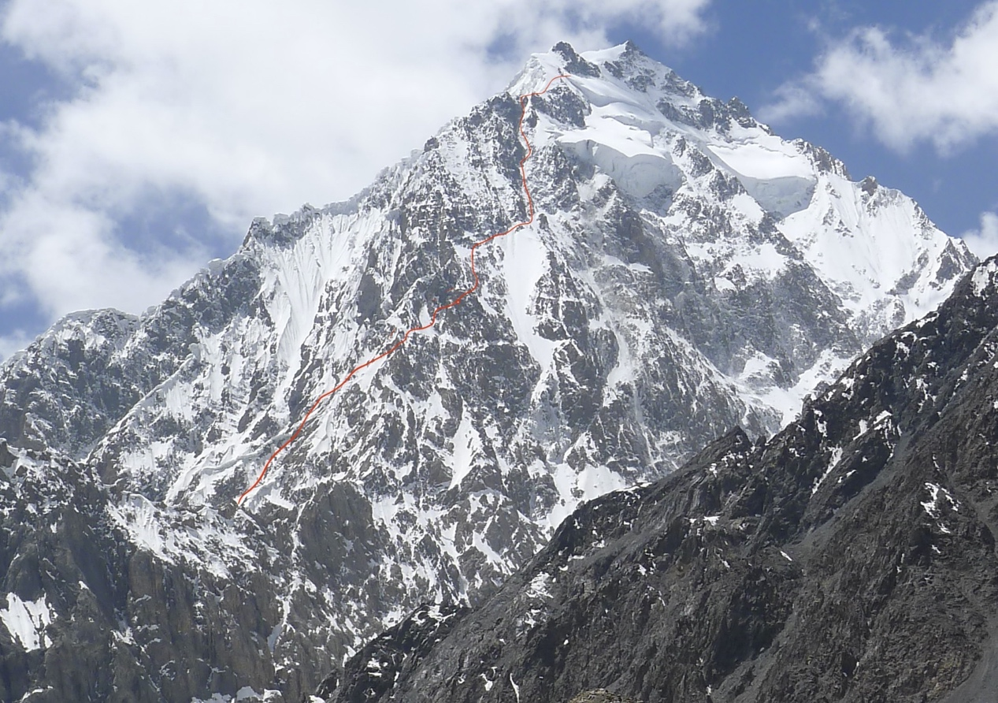
NE Face of Patkhor showing line taken and highpoint

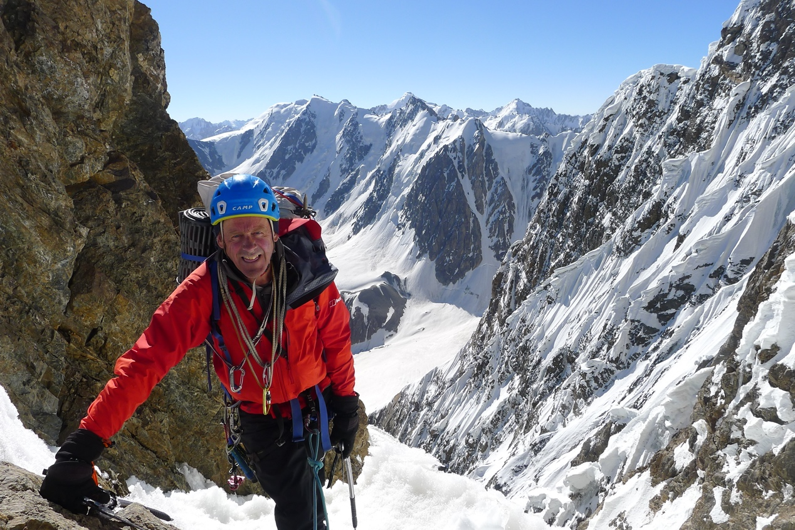
At head of initial couloir on Day 1 above bergschrund.
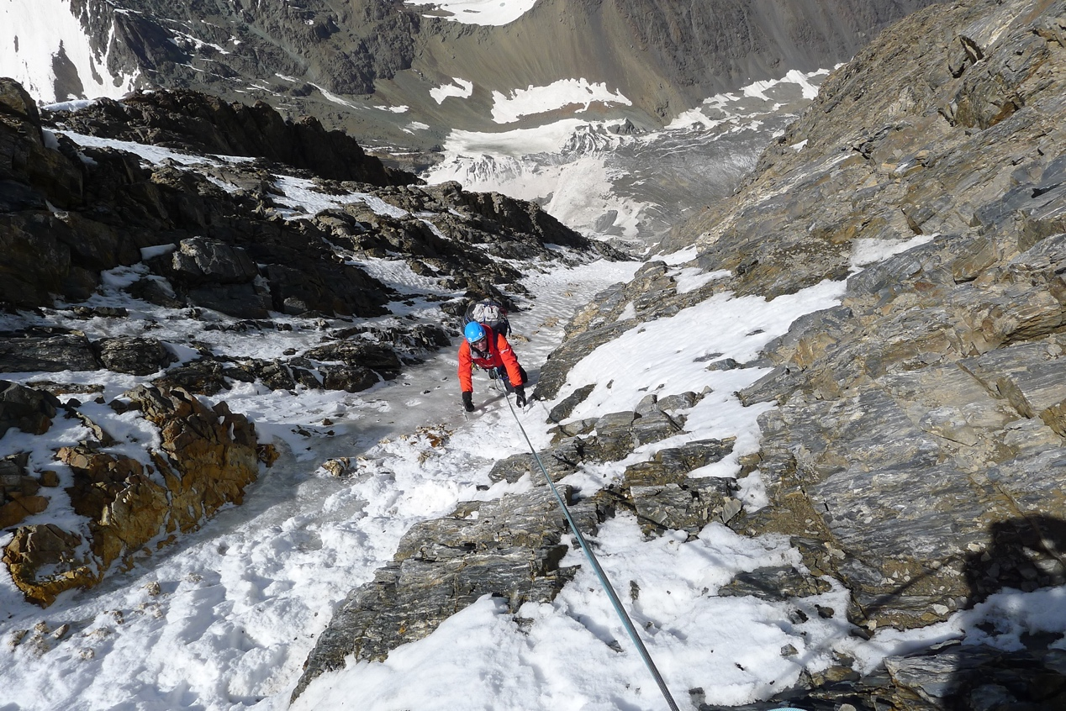
Couloir on day 3 above bergschrund.

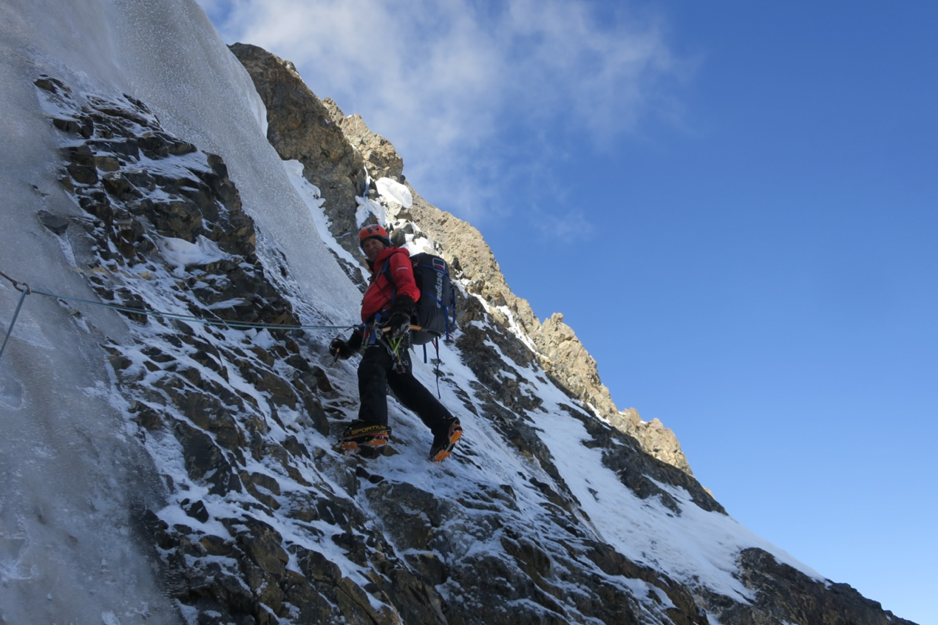
Couloir on day 3 above bergschrund.

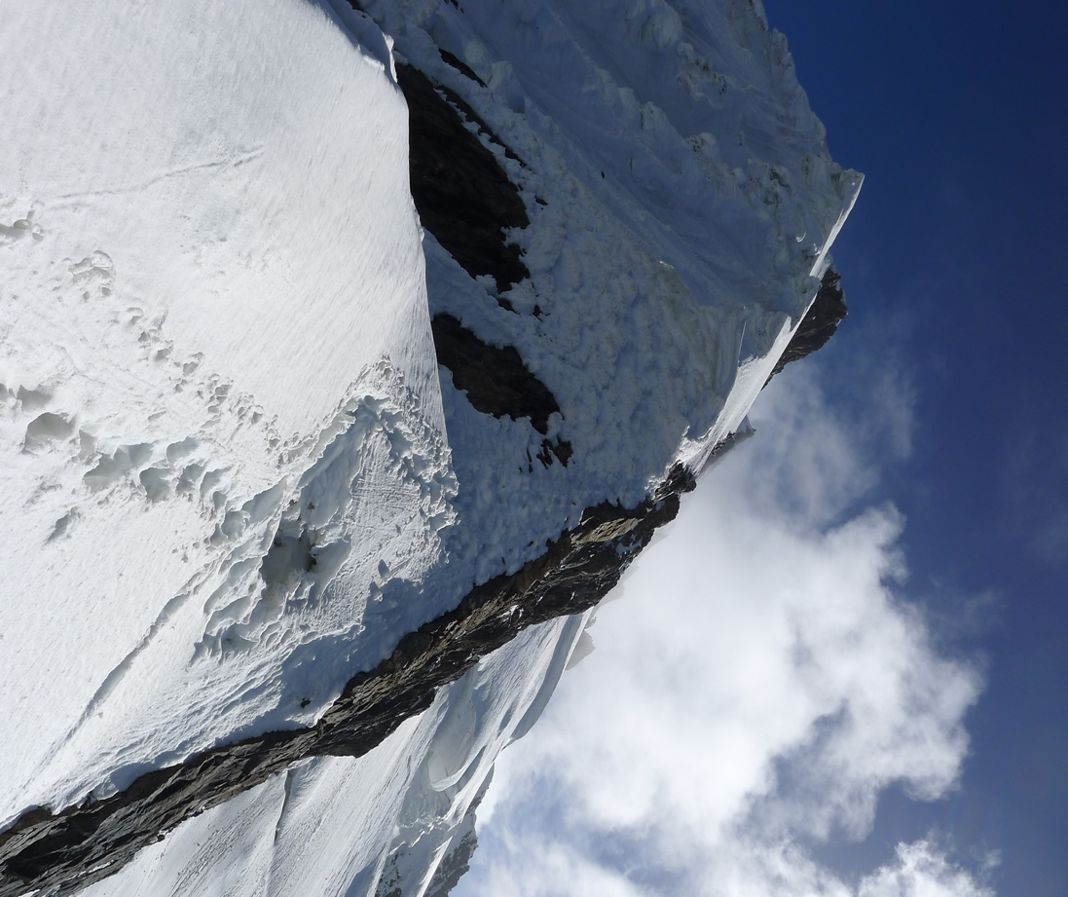
Looking towards the summit from our top bivouac

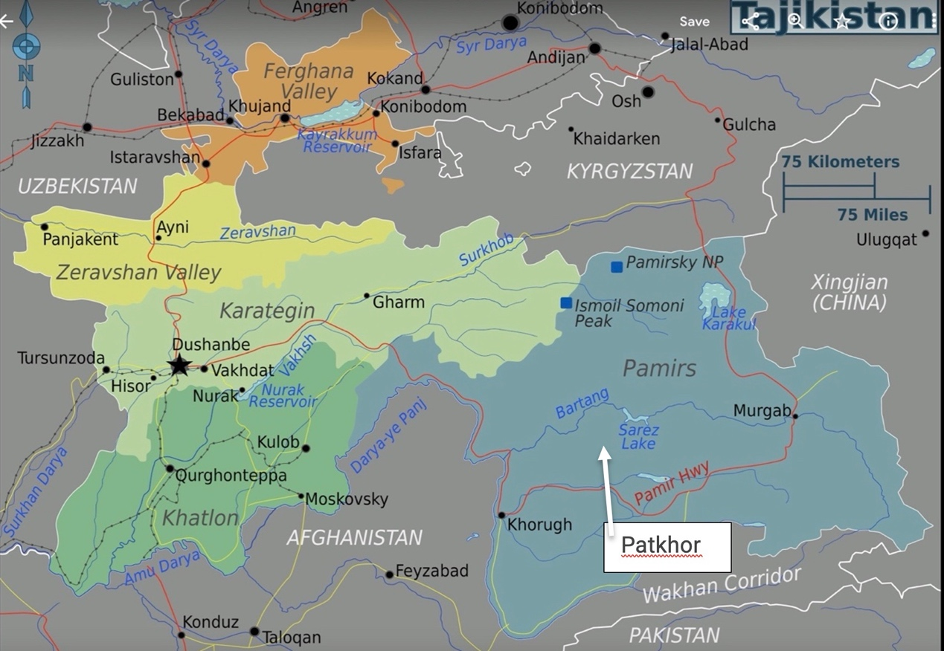
Map showing route (red line) from Dushanbe to the Bartang valley and Patkhor

