Khurdopin Sar Expedition 2023
Virjerab, Shimshal, Hunza, Pakistan
June/July 2023

Report by Philip de-Beger
Philip.debeger@btopenworld.com

Key Objectives: Our primary objective was to make the first ascent of Khurdopin Sar 6,310m 36°15'26.30"N 75°33'29.56"E. Our intended route was a traverse of the West Ridge including peaks 6140m, 6100m and Khurdopin Sar 6,310m.

Expedition Members:
Philip de-Beger- Expedition Leader
Aleksi Mujirishvili- Climber/Doctor

Summary Itinerary
16th to 19th of June – Travel to Pakistan
20th to 21st travel to Shimshal
22nd Organise kit in Shimshal
23rd to 25th Approach, Shimshal to BC
26th July to the 11th of June Carries to ABC/ Waiting for a weather window
12th to 13th of July return to Shimshal
13th to 16th Travel to Islamabad and depart
Phil Departs 16th of July
Lekso leaves 18th of July

Trekking Phase
For the trek, we were accompanied by 6 porters and a trekking guide on the approach and 5 porters and a guide on the return journey. It took 3 days on the way in and 1.5 on the return. essentially the first and last days were half days on the approach, although the 3rd was a full day for the porters who needed to return to the last camp.
We stayed at established camps, they had some stone huts as they are winter pastures for the yak. Although we stayed in a tent.
Trekking/approach route
Camp 1, 3,311 m 36.36579, 75.42639
Camp 2 3,534 m 36.33786, 75.51572 (we used this one on the approach)
Main Camp 2 3,482 m 36.33210, 75.48828 (we used this one on the return)
Base Camp 4,093 m 36.30590, 75.59412
For the return only camp 2 is required

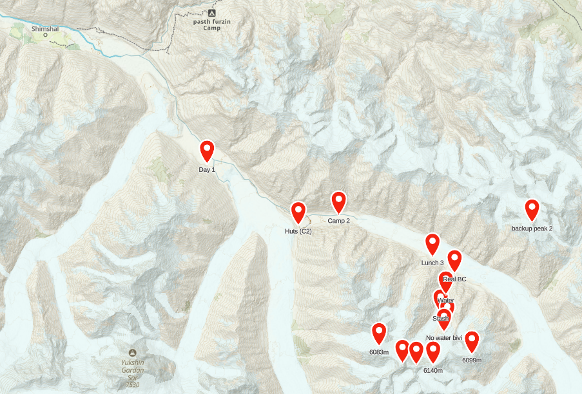

Expedition Phase
After arriving in Base Camp, the team rested for a day before establishing a cache a few hundred metres below the ABC. We then rested a day at BC before moving up to ABC and sleeping there for a night. At this point, we felt we were adequately acclimatised and had flown the drone for a look at the route and felt positive about the climb. However, on checking the satellite phone on return to base camp our new forecast indicated 2 good days of weather, followed by rain/snow for the remainder of the expedition. We decided to move up anyway, as we had 9 days and were optimistic the forecast would change. It didn’t! We spent the week in a small Bivi tent at ABC, a nice camp with a small stream nearby, then we bumped up to a slightly higher camp just below the slope, which was above the freezing point, so it required snow melting. The snow didn’t relent and with no time left, we dropped back to base camp on the 11th of July, and left on the 12th midday with the porters, arriving in Shimshal on the 13th. The weather changed for our return, and we had a sunny hike back.

Base Camp 4,093 m 36.30590, 75.59412
Abc 1 4,746 m 36.27903, 75.58927
No water Bivi 5,004 m 36.27387, 75.58699
Backup water source 4,321 m 36.29428, 75.58820

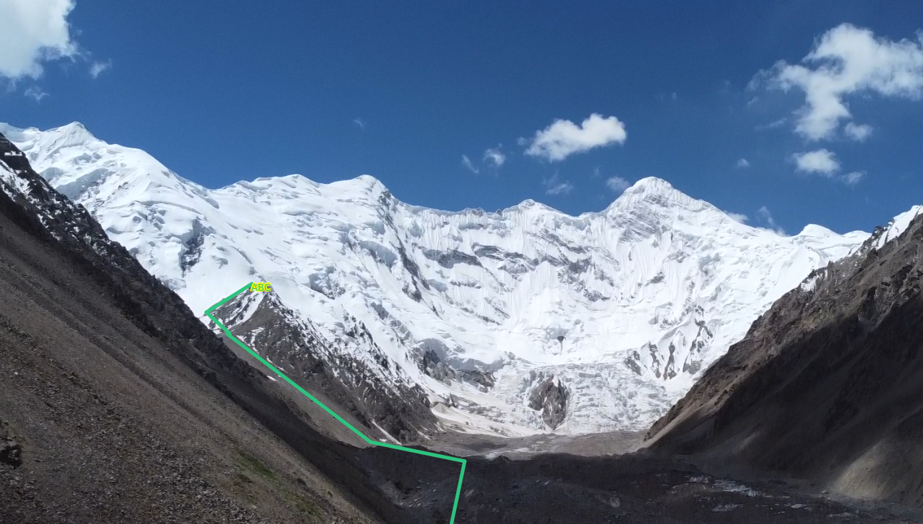
No routes were attempted, we only made it to ABC 36.27387, 75.58699 (5040m), due to around 20cm of daily snow dump for more than a week, we decided not to attempt any routes.

Local support

Because it is a border area, we needed to have a guide. Nazir Baig accompanied us for trekking between the Base Camp and Shimshal. +923554366290. He provided us with 6 porters in and 5 out and accompanied the porters and us.

Porters cost, 14,700 Pakistani Rupees plus tips for a carry between Shimshal and Base Camp
Guides cost, 6,000 Pakistani Rupees a day, plus tips
A jeep from Gilgit to Shimshal is 24,000 Pakistani Rupees, although this is the local rate. After the rains that prevented our climb, there was rockfall which damaged 5 local jeeps. However, we managed to take a local one to Gilgit, albeit without a door.

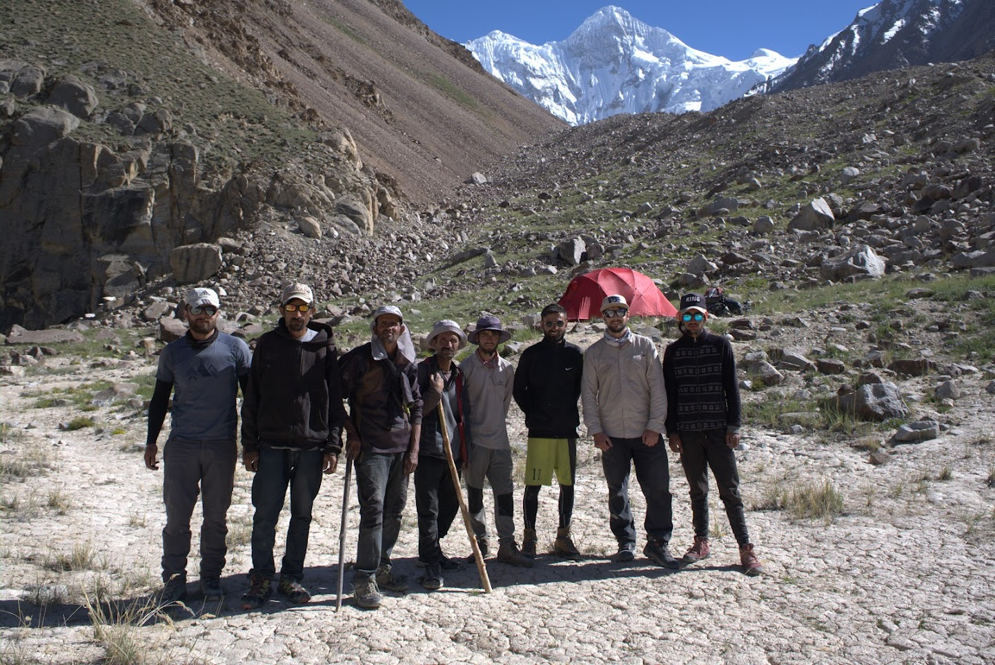
Above our approach team after establishing our base camp with our objectives in the background, photo by Nazir Baig

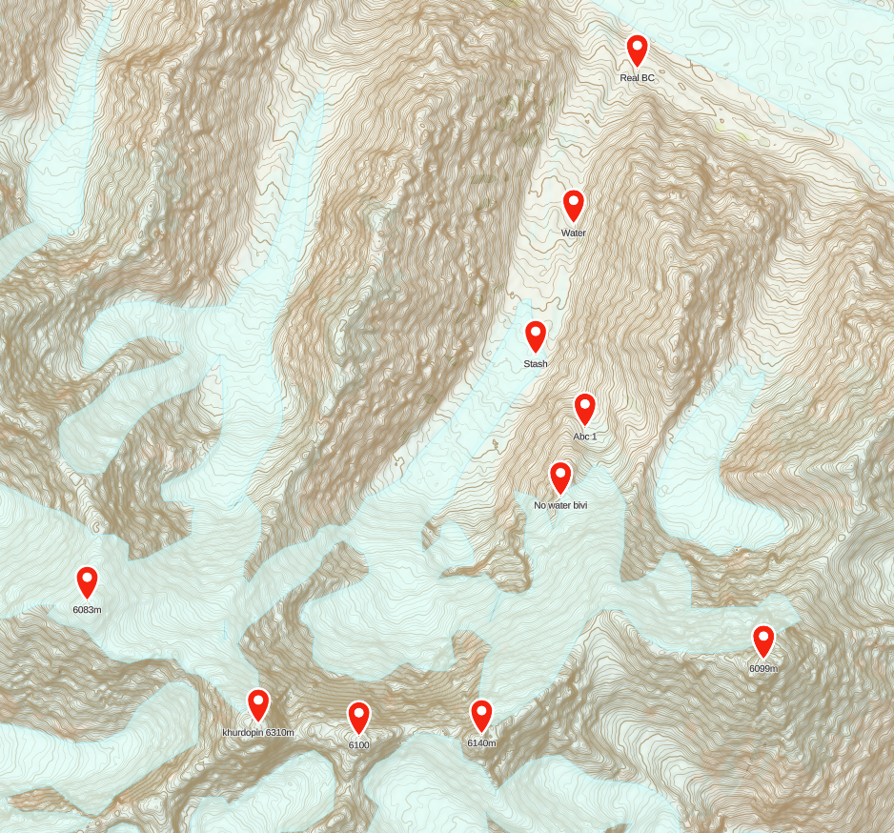

Environmental Impact:

We calculated the carbon footprint of the expedition to be 2.893 tonnes of CO2e; as a result, we offset 3 tonnes through Circular Ecology

Lessons learnt

-We had a lot of issues getting a Hotel in Faizabad, Rawalpindi, near where the buses go from Islamabad to Hunza. This is because the hotels there are not allowed to host foreigners. It’s suggested it is for security as many political protests take place in this area.

-Thuraya. We were using an old Thuraya Hughes phone. However a lot of the text messages we received displayed as hexadecimal. We discovered that if we put the sim card into our mobile, we could then read the message, we believe this is because the old Thuraya can’t display the more modern formats. We know this is an issue that has plagued other expeditions, so hopefully this fix might be useful to others.

-The drone was very useful for scouting

-Our water at the base camp came from a pond, however, our filter stopped working correctly and we didn’t have a backup (other than boiling or tablets), however, we found a delicious clean stream at 36.29428, 75.58820, which made a good rest day activity.

-The local wooden sticks used by the Shimshali are very useful for crossing steep sections of the glacier, during the trekking phase.

Budget

Expedition Costs |  | Expedition Income
International travel | 1800 | MEF | 2500
Domestic travel | 160 | Alpine Club Montane Climbing Fund | 1400
Permits and peak fees | None | Peter Bays | 500
Hotels Shimshal/Islamabad | 350 | Team members | 490
Expedition members' insurance | 650 | BMC | 400
Food and fuel | 1300
Agency fees if applicable | 400
Porters and pack animals | 600
Carbon Offsetting | 30
TOTAL | 5290 | TOTAL | 5290

Background information

In July 2012, a Polish expedition led by Krzysztof Wielicki established their base camp at the junction of the Virjerab and Spregh Yaz Glaciers. They made the first ascent of a 5900m peak, which they named Khushrui Sar above the Spregh Yaz Glacier. They also attempted to climb what is now called Harjoldur Sar 6104m, in the Chot Pert group on the north side of the Virjerab glacier.

In 2015, Peter Thompson led an expedition to the Virjerab. Khurdopin was attempted during that expedition however the slopes were only in condition for a few hours in the early morning. It was decided that a Bivi on the summit ridge would be required to enable conditions to refreeze before a safe descent was possible. They did however make the first ascent of Harjoldur Sar 6105m in the Chot Pert valley.

In 2016 a Dutch expedition led by Bas Visscher attempted a repeat of Khushrui Sar (the peak the Polish climbed in 2012) and a First ascent of peak 6099, they failed due to warm weather and suggested climbing in colder conditions outside of the normal season.

Tim Seers expedition in 2017 originally planned to try Khurdopin, but their plans were thwarted by a large glacial surge making travel impractical. However, conditions have now improved and the glacier is now passable.

Acknowledgements
Massive thanks to the Mount Everest Foundation, the Alpine Club Montane Climbing Fund, Peter Bays and the British Mountaineering Council for their support.

