British Kichatna Expedition 2022
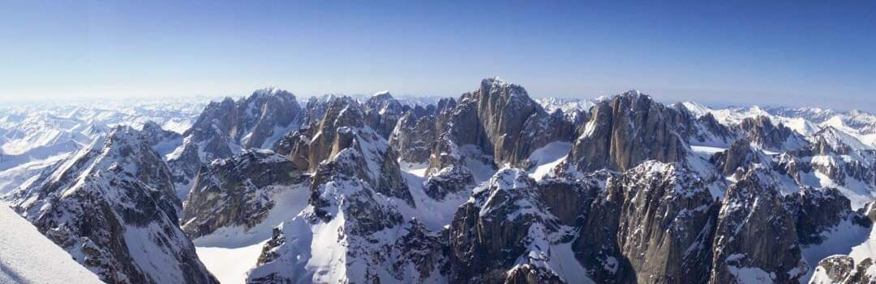
Supported by:
British Mountaineering Council
The Old Church
177-179 Burton Road
West Didsbury
Manchester
M20 2BB
UK
0161445 611
OFFICE@THEBMC.CO.UK
The Mount Everest Foundation
Royal Geographical Society
1 Kensington Gore
London
SW7 2AR
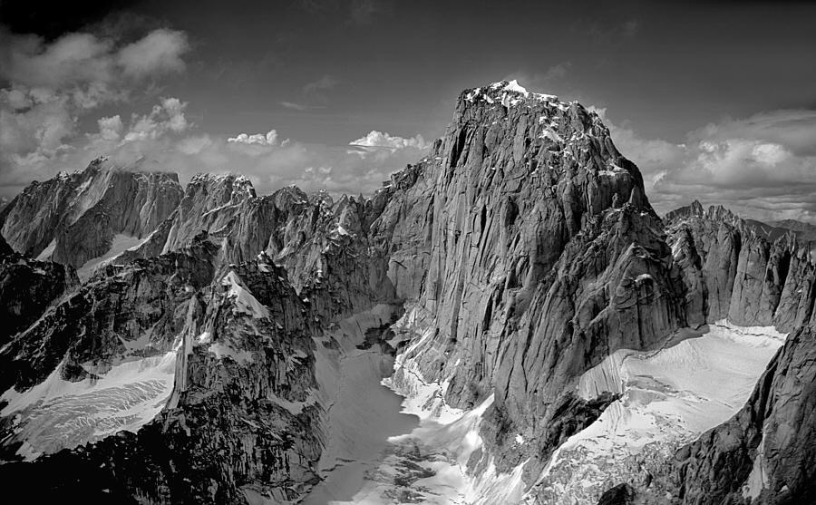
The compilers of this report and the members of the expedition agree that all or any of it may be copied for the purposes of private research.
Aims of the Expedition
During the first Expedition to Alaska that Twid made he spotted an incredible unclimbed line on the East Face of Kichatna Spire. On this Expedition in 2000 Twid and Stuart McAleese had an attempt at the line but backed off after 100m due to the loose rock and nature of the climbing. Twid vowed to return to climb this gem and make the First British Ascent of this majestic Spire of granite. With good friend and fellow IFMGA Guide Martk Thomas this is exactly what they achieved.
Mike and Mark have dubbed their new line ‘Thunderstruck’ and offered a grade of VI A3+/A4 6c. The route, which the pair summitted on the 8th June, comprises 33 pitches, covering over 1,200m of climbing.
`It was the climb of our lives!` Possibly the Best Big Wall Climb either of the team had. ever climbed.

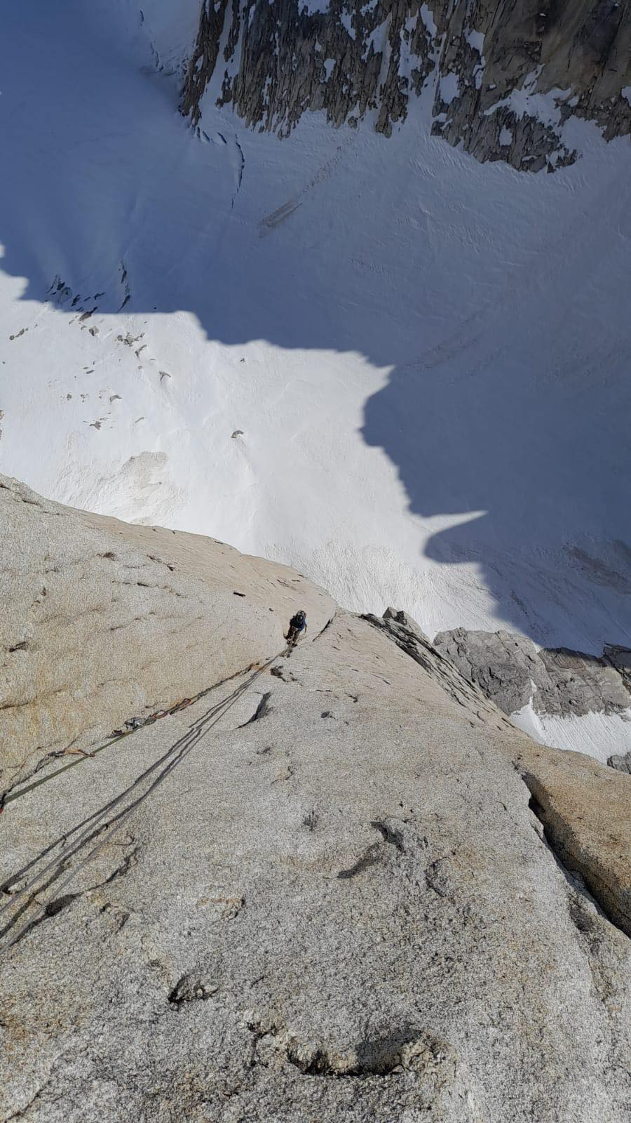

Details of team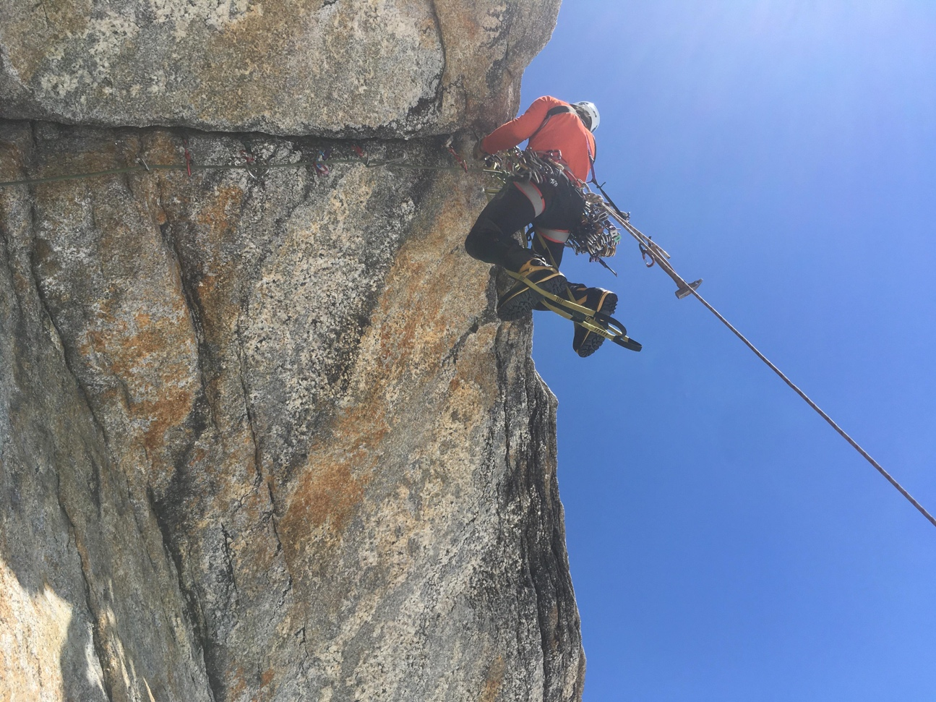
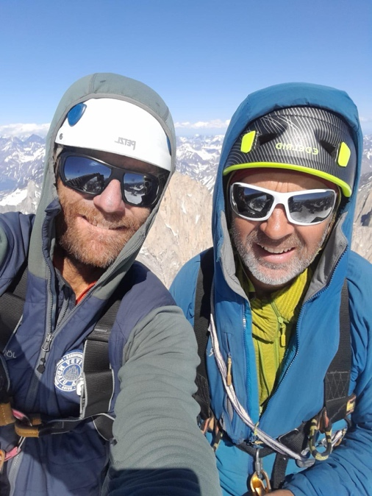
Mike ‘Twid’ Turner, 55, English, IFMGA guide, (twidturner@aol.com)
Climbed over 80+ E7/8grade rock routes many first ascents, many 8a sports routes. Winter climbing at Scottish 7 ice and mixed 8. M7, Extensive experience winter climbing worldwide. Scotland 30 yrs. of winter climbing, Norway, Iceland, Canada, US, Morocco, Alps, Slovenia. 30+ yrs. of Alpine Summer and of winter Alpine Climbing. High lights North faces of Eiger, Jorasses 3x , Doites, Divine Providence, Fisch etc30 yrs of Expedition Highlights: Alaska 15 Expeds (Ist Supa Dupa Coulior, Off the Wall Bonkers, Hard Arteries), Baffin 2 trips (The Citadel, Artic Monkeys) Patagonia 8trips ( 1st Caveman, For a fist full of dollars, For a few dollars more, The Devil Rides Out, The Good the bad and the Ugly) Borneo, Pakistan 3Expeds (Beatrice, Nawas, Greater Trango) Mali 2, Madagascar, Greenland, US, Brazil, Morocco 15+ trips. Last 6 nominee Piolet D’Or.High Lights Vitalstics E8 Gogarth, Scrabble mixed 8 Scotland, Octopussy Colorado M8, Super Dupa Coulior Alaska 1st , Nawas Pakistan 1300m Big Wall, Arctic Monkeys Baffin 1600m 23 Days.
Address: Chalet Namnam et Glouglou, Chemin des Cibles 3, Huemoz, Vaud, 1884, Switzerland
twidturner@aol.com
0041 799588412
Mark Thomas, 46, Welsh, IFMGA guide, (twmjunior@hotmail.com)
1st ascent of 1600m big wall route Baffin Island in 23 days, New Winter Routes in UK winter at Grade VIII,8 inc ‘Soul Vacation and Gnomon, New winter routes in Alps at grade VIII,8 inc Jottnar. Longer Alpine routes inc N.Face of G.Jorasses, Droites, Dru. New peaks in Greenland (Watkins Mountains). 4 expeditions to India Himalaya – 3 new peaks inc 6000m+, 4 new routes, unfinished 1st ascent N.E Spur of Nanda Devi East (with Martin Moran), Trishul 6150m – 2nd ascent to true summit. 1st ascent of ‘No Rest For Wicked’ 900m big wall route Atlas mountains. New rock routes Lake District inc ‘Fever’ E4 6b and ‘Revival’ E5 6b, New rock routes N.Pembrokeshire and Ceredigion inc ’20 Years after’ E6 6b. Hold the record for climbing all rock routes on Ynys Lochtyn, Wales - 109 routes up to E4 6a, 2.2 kms of climbing in 5hrs 37 mins. Held the record for the Lakes 15 classic rock routes round, solo, un – supported. Qualified IFMGA Mountain Guide, making guided ascents of routes such as the Traverse of the Chamonix Aigs (Twice), West Ridge Salbit, East Face Grepon, Aig Noire Peutery, N.Face Droites and Hard Himalaya ascents inc Trishul 6150m and Tharang 1 6066m alpine style. 00447816873884
twmjunior@hotmail.com
Simon Hitchens was the 3rd climber who was due to climb with the team. Unfortunately, Simon received a negative Covid test on the drive to the Airport and had to drop out unable to fly. A real loss to the team and hard for Simon.

The Mountain
Kichatna Spire is the highest Peak in the Cathedral Spires, sometimes referred to the Kichatna Spires. The granite, range is on the lefthand end of the Alaska Range and is stuck out by itself. The Range is has some of the most specular granite summits in North America and is very similar to scale and beauty to many famous Patagonia Peaks. Unlike Patagonia the range sees very little traffic from climbers. A handful of Expeditions a year, often 1 or 2 trips. The legendary bad weather and harsh conditions puts off many climbers. This summer oof 2022 was the best summer on record. There was hardly any precip and the blue skis stretched for weeks. Luckily for the team the endless good weather helped.

First Ascents: "Kichatna Spire”, 8985 feet, September 23, 1966 (Richard Millikan, Arthur Davidson).
http://publications.americanalpineclub.org/articles/12196727200/Kichatna-Spire
Co ordinates 62°26'57.2"N 152°47'00.9"W
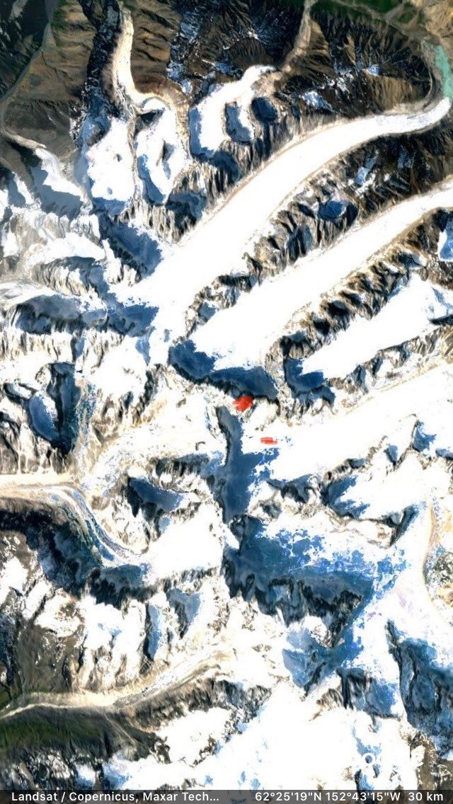

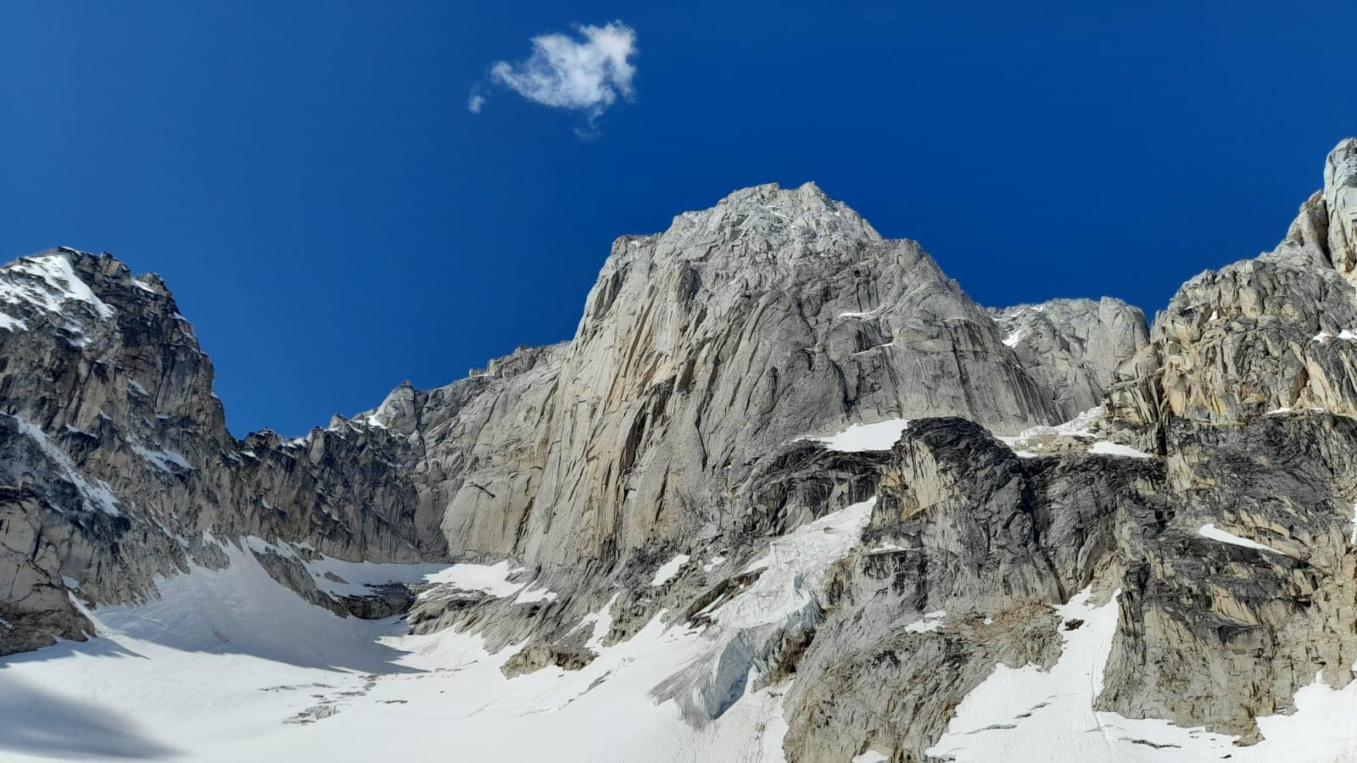
`Thunderstruck` took a slender Pillar on the right handside of the huge East Face of Kichatna Spire. It was approached via the Shadows Glacier. The face received sun in late morning till late in the evening. The Rock was clean overall and the line of the climb followed a crack line for 950m then mixed rock and ice terrain to the summit. The Alpine terrain involved snow and ice climbing in crampons and the final ridge took the best part of a day to negotiate the summit block. The True summit was reached with spectacular views across the whole Alaska Range. For the whole period of the Expedition we were the only climbers in the range.
Approach to the Climb. Paul Roderick of Talkeetna Air Taxis flew the team from Talkeetna early on the Sunday morning. The Flight was about an hour and it follows the southern side of the Alaska Range past Denali, Foraker and Mount Russel. The Pilots can only fly with full vision(no clouds) and clear skis. After the single engine Otter landed on the glacier all the equipment was transferred to the glacier. Paul flew off leaving the team to drag their equipment a kilometre up the Shadows glacier to a safe base camp away from the run out from various Seracs. The Seracs at the Col between the Shadows and Sunshine Glaciers being particularly active.
From base camp the Shadows glacier was followed for one hour to the base of the climb and wall.
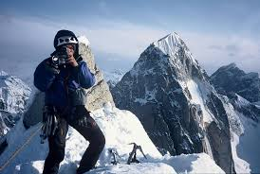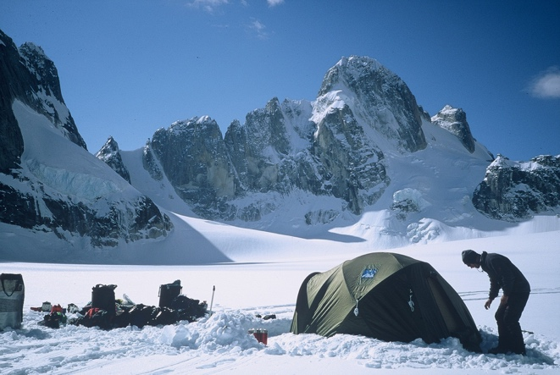
Summit of Citadel. Kichatna behind Mnt Gurney and Shadows Glacier
The East Face of Kichatna Spires is a huge wall which had some existing routes climbed over 20 years previously. The scope for more routes is plenty. The line which Twid had tried 22 years previously had a lot of loose rock on the bottom. As the team arrived at the base of the wall it was evident there had been a huge rock fall and the loose section was now lying on the glacier! There was still a very bad section to negotiate but not as bad as previously. The Pillar of the climb followed a safe line with no rock fall or avalanche potential as the Pillar protruded away from the main face. The team didn’t hear or see much rock fall for the whole trip.
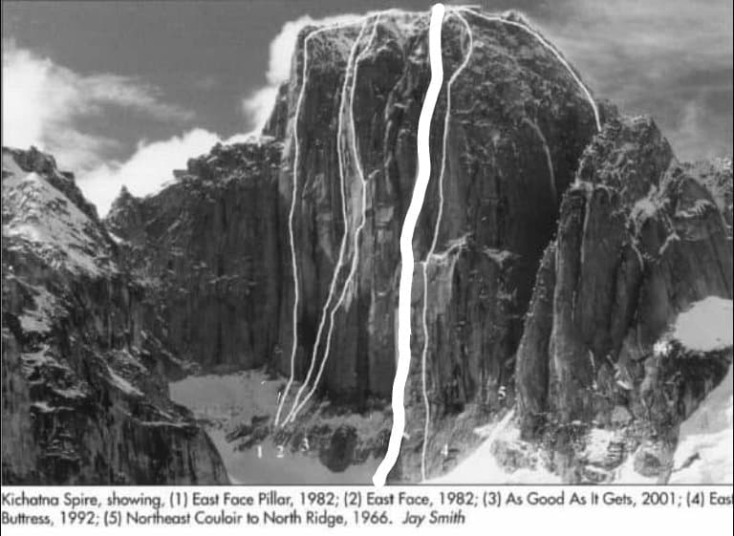

The Climb
Kichatnas 2022 - 'Thunderstruck Marks Notes
FA - M. Thomas and M. Turner, 29th May 2022 - 14th June 2022
We set off from the airstrip in Talkeetna, totally psyched for the challenge which lay in waiting for us high up on the Shadow Glacier. Myself and Twid would have to dig deeper than ever before on past Big Wall trips, it was just the two of us, the work load was going to be immense. We had absolutely no idea what the wall would throw at us, but straight away, having spent two days leading through the initial, desperate, roof section, we knew, we were in for the fight of our lives. The following twelve days, we spent climbing on hard aid, A4, free climbing, hauling, jumaring, finding snow and completing some super committing and exposed pitches. The Upper roof section proved to be inspirational, the total exposure and commitment, overwhelming. Never did we feel the challenge was within our grasp, over every roof and at the top of every crack, lay another test piece of climbing, always testing our resolve, always pushing our limits of endurance. 'Thunderstruck' is the real deal, a modern, strong, eye-catching line, up one of the most glorious towers any climber could wish for on an expedition. We were blessed with glorious wall to wall sunshine, we were also blessed with such an opportunity to express ourselves on such a masterpiece, sculpted by the forces of nature. We left Kichatnas as totally spent, but riding a wave of success, against challenges which laid down before us, beyond our wildest dreams. How lucky we were to have un-locked those hidden secrets, up there, high above the glacier, just two climbers and a whole load of determination. 'Thunderstruck' will offer the modern big wall climber a whole load of adventure, from splitter cracks to delicate slab, from big jamming roofs to an elegant Alpine Ridge, it has it all, we had a blast!

Day1 No time to make too many plans, we land on the 'Shadow Glacier', bundle our kit out of the ski plane and take our first loads up to the base of our intended route. In the afternoon heat, we break trail, dodging crevasses, to the base of a good corner. The 1st pitch goes free up to the big terrace, beneath the first, huge, impending overhang. We cache the kit, fix a line and abseil back to the base, then skip our way back to BC for our first night on the glacier, mashed spuds and soup for dinner, yum!

Day 2, 30/05/22 - With clear skies above, we get an early start up to the base of the pillar, ascend the fixed line, then get psyched for a 2-day, overhang extravaganza! I set off, free climbing at first, but soon ending up on poor runners, aiding on hooks and creaking cams behind booming downward facing daggers of rock. Half way through my day, a micro cam explodes from its brittle flake, in turn my hooks and rp's rip and unzip my progress to a good size 5 nut, a moment to compose, then up again to nail it. A high point under the roof is where the day ends, as I abseil back to the terrace and we head to BC for another feast and banter.

Day 3, 31/05/22 - Back for the battle. From the high point, over the roof, then a tenuous traverse back left into another mega corner, yes!

Day 4 and 5, 1-2/06/22 - Into the groove. Great days moving pretty quickly up the open corner, the odd difficult bit of aiding, but generally, great climbing and amazing rock. We fix more line and make a long abseil back down and over the roof, down to the terrace and onto the glacier to BC, a long day, all the days are long when there are only 2 climbers doing all the work!

Day 6, 03/06/22 - The second roof. A stunning roof crack, aiding out felt breath-taking, the lip, somewhat disappointingly void of gear, again, some A4 climbing on hooks and mashies, nerve testing, technical and exposed - truly amazing! I fix the line, above is a wide chimney and crack, leading to our bivi ledge, we pray for snow, but there is none, but the ledge is half decent!, another very long abseil back to BC, Twid cooks up a feast of Steak and yummyness! We have a visitor in the evening, but only prints are left, seems like a wolverine payed us a visit, didn't see that coming!

Day 7, 04/06/22 - A day of stocking the ledge. Our last night on the glacier, tomorrow we head up to the ledge and pull up our ropes.

Day 8, 05/06/22 - The big jumar, then a complex pitch above the ledge, to access the upper crack and corner. Another 60m pitch before we decide our day is done, I find a cave at the top of this pitch - filled with frozen snow, hallelujah, we fill a bag, we descend to the ledge, set up the portaledge, Twid gets the canvas, I decide, the small ledge underneath will do nicely, enough space to lay outstretched, but no rolling in the night! 1st night on the wall, amazing.

Day 9, 06/06/22 - Porridge and coffee, then another day in paradise, up to the cave, then a swing to the right and the corner and crack above. Progress is good, we are on fire, the feeling of flow is insane! A good day, we head for the ledge, with a load of fixed rope in place and a load of snow for water, awesome!

Day 10, 07/06/22 - Hoping to make it to the top of the pillar today and access the upper ridge, all goes well, then a rather complicated section, involving a tension traverse, but soon, the ridge is in sight, we make one more pitch onto the ridge and fix a line, it's late and getting cold, tomorrow we need to go light and fast and make an attempt for the summit. A long abseil back to the ledge and another feast of smash and chorizo!

Day 11, 8/06/22 - Alpine start, feeling a little weary now, been a long and demanding climb so far, we pack for the day, including crampons and axes for the, hopefully, the summit ridge. A long, heavy jumar to our high point, then, a day full of transitions, from hard Aid to free climbing, scrambling and small roofs, rock shoes, then eventually, onto snow and mixed. The summit ridge proves a lengthy and involved affair, towers and downclimbs, snow, ice and mixed, a labyrinth, until the final summit block. The way up the East side seems impossible, but there is a sneaky way to traverse round to the West side, then up gentle snow slopes to the top, stunning, overwhelming with views to reward us for all our toil and efforts on what felt like one incredible journey, up some absolutely wild terrain, from the very start to the very end, totally Thunderstruck!

Day 13, 09/06/22 - After a long night descending back to the ledge, we prepare for another full day of getting all the gear back down the wall and constructing retrievable abseils, it all goes relatively smoothly, as soon we are back on the glacier and with a pre cached sledge, we slip slide our way with a massive load back to BC, collapse into the tent. High 5's and Smash, with reduced fat custard for pudding, heaven!

Day 14, 10/06/22 - Coldest night of the trip so far, fully downed up and waiting for the ski plane. It arrives and we depart this incredible arena, so much adventure, such incredible climbing, we will be back!

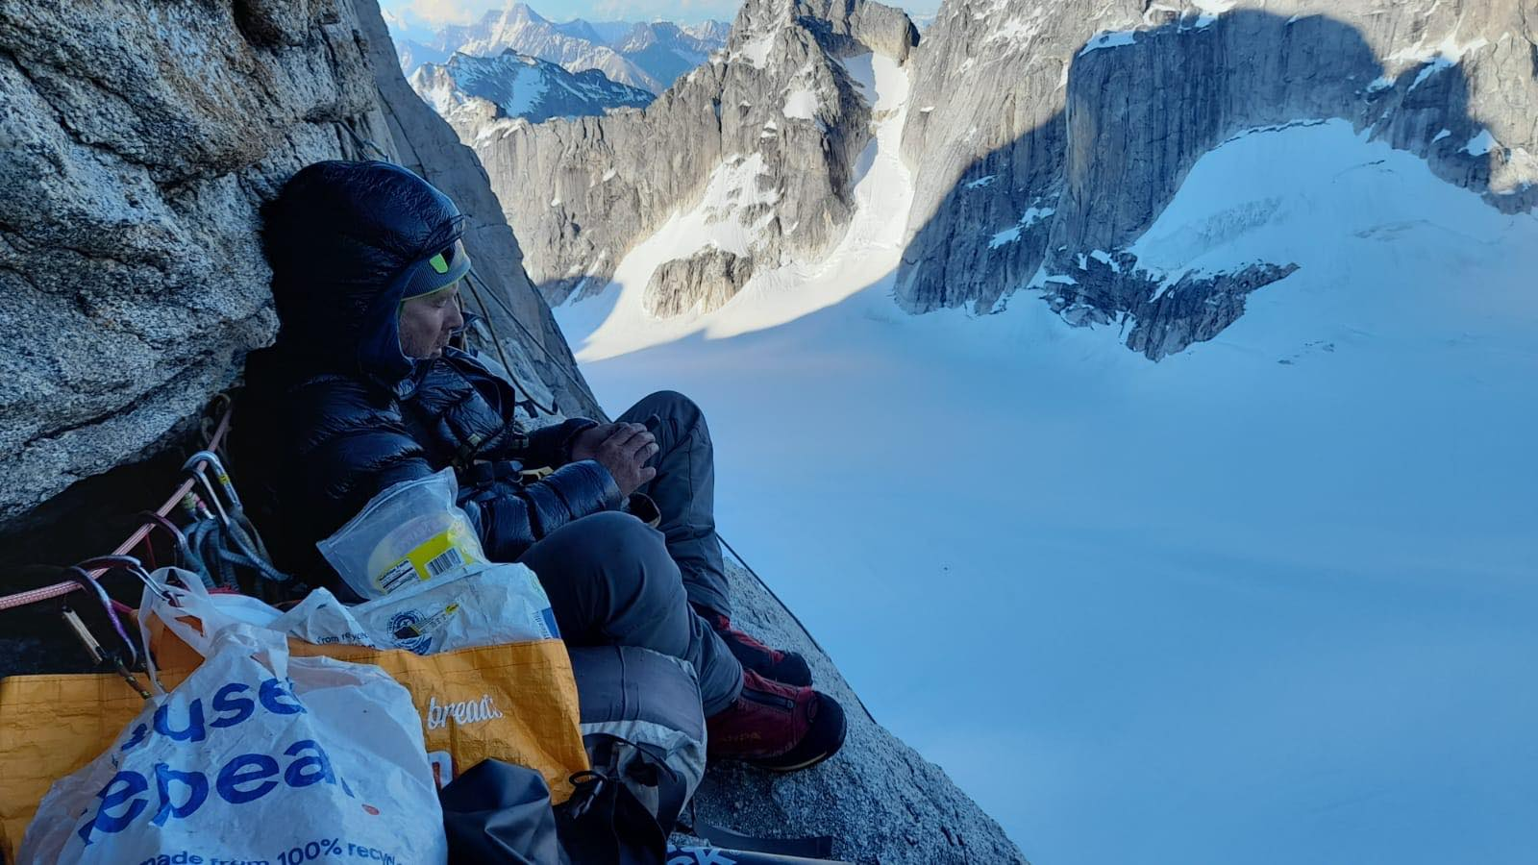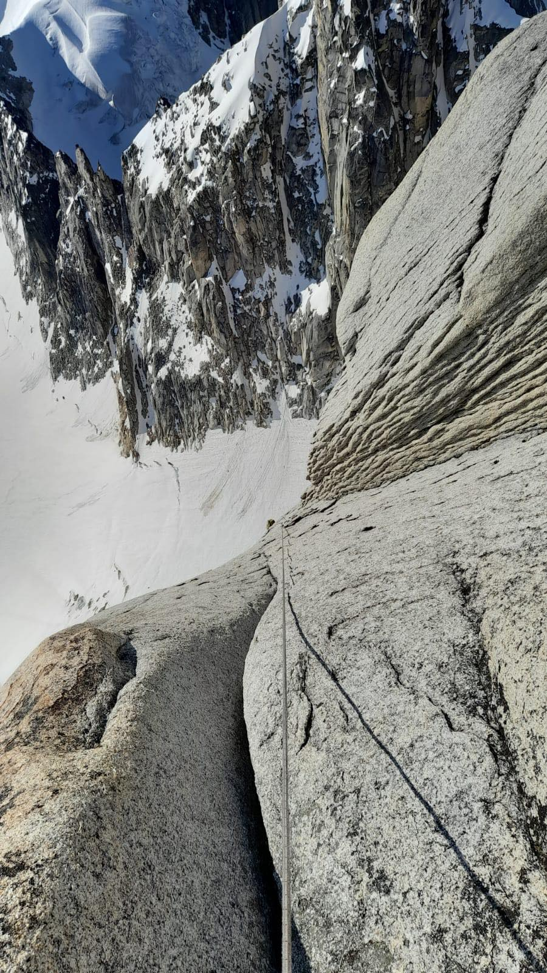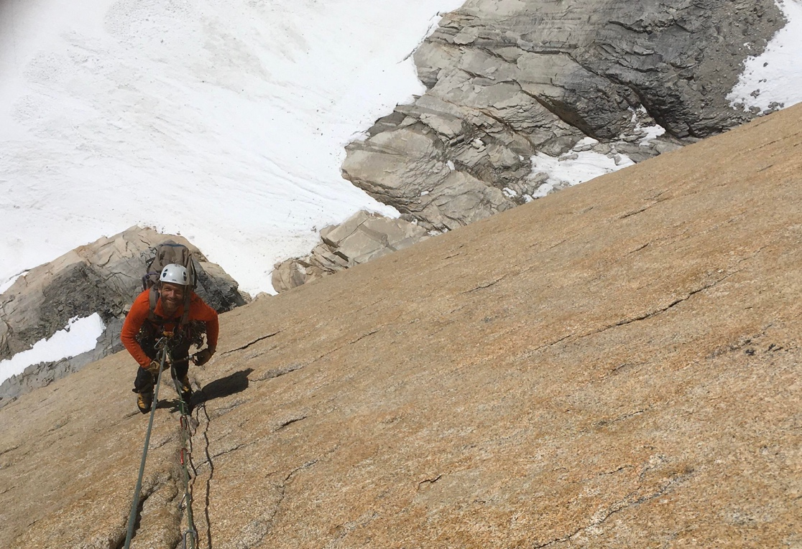

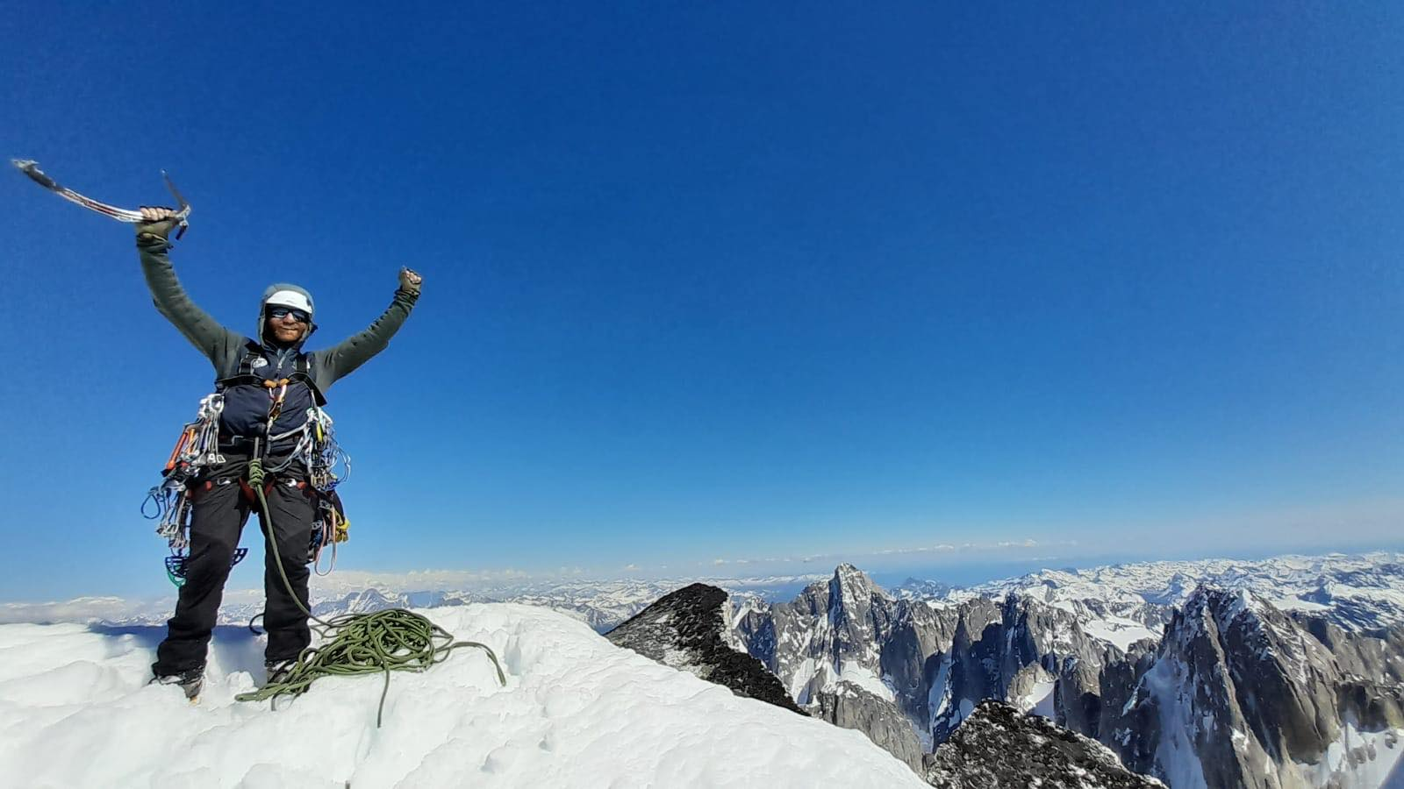
Travel to Talkeetna
Flights to Anchorage
The team travelled to Frankfurt via either Heathrow or Geneva Airport. Flights had been bought with Condor Airline which is based from Frankfurt. The Big advantage with Condor is that the flights are direct to Anchorage and avoid transfers within the US. This limited the chance of lost bags and lost time with entry administration. For the flights to the US ESTA VISAs were organised online months before travel. Condor flights are very competitive but extra bags are difficult to organise and have to be purchased after the initial payment for the flights. The Frankfurt flight leaves at 11am and arrives at 10.30am the same day! You just feel bad with the jetlag!
Transfer to Talkeetna via Purple Transfers see details in appendix. The 2.5hr drive from Anchorage to Talkeetna is a slow drive with nice views. Watching out for Moose! When you arrive at Talkeetna it is a small Village with the strap line À Drinking Town with a Climbing Problem`. That’s about right! There are many bars and restaurants and the Fairview Bar is the oldest in Alaska! They ask you leave your guns at the door!
Flights Talkeetna to Kichatna
Flying to the Kichatna Spires is not an easy flight to sure that will go. The small planes have supercharged engines to allow them to land and take off on snow. Weight is restricted to 120lbs per person. We had extra with our heavy rack and gear. We also rented sledges to help move our gear along the glacier and wands in case of storms and to mark crevasses, which their many. To fly into the Kichatnas you need a solid pilot who knows the Range. Paul Roderick who owns Talkeetna Air Taxis is the most experienced pilot who flys into the range. Hes an enthusiastic climber so understands your needs. Paul dropped us off on the Shadows like he has dropped on every trip Ive done to Alaska with skill and plenty of humour poking at the Brits! The flight in was clear and spectacular. We could see the East Face of Kichatna from a distance. By far the biggest wall in the Range. It looked awesome!
Its important to create a flattened runway for the planes to take off. We spent 5-6 hrs trudging out a flattened track for the returning plane. Snows shoes or skis essential. 400 yards.
Accommodation
On arrival in Anchorage, we transferred straight to Talkeetna and stayed in the TAT lodge. This is a basic bunkhouse for the climbers. It’s an ideal place to organise and dry out any gear. TAT runs a shuttle van to help move your gear from the bunkhouses to the airstrip. You can leave your travel clothes with TAT in a lock up while in the hills. Plus, they can take care of passports and wallets in a safe in their office.
On the way home the team stayed in a cheap Hotel near the Airport in Anchorage. The Puffin was clean but nothing special. It had a free drop off at the airport which is worth considering.

Food and Stores
Big Shop was done in anchorage at CostCo and Wall mart. Gas and dehydrated food was bought at REI. Tidal Wave books is a great second hand book shop near the REI.

Equipment
To attempt such a big project we came with a big rack of gear.
30 quickdraws, ,4 sets of wires, 3 sets of cams,15 pegs,8 pekers, Mashies,Hooks, Portaledge
In the end only nuts, cams and pekers were used. Only pegs were placed on the hard roof pitch.
Base camp tent. 3 person. Good for storms. Held down with snow filled bags for life.
Bivi tent
Ice Climbing gear
Skis and Snow shoes for getting about
We took two jet boil stoves which worked well.
At night the temperatures were very cold. 4 season bags Useful. We wore warm trousers plus thermal leggings for the whole climb. It was cold climbing.
We carried a full first aid kit on the hill and a big base camp first aid. Rescue will only arrive in good weather so you are the rescue. Both of us were First Aid trained in the last three years.

SAT Phone and Garmin Inreach
Its impossible to walk out of the Kichatna Spires, the Rivers are too wide. So having good comms is essential. Iridium network works well Globalsat doesn’t. We took an iridium phone and a Garmin Inreach. The Sat phone allows us to talk to the pilots about flying conditions. Its essential for calling the planes. The Inreach is a standard bit of gear for Alasaka. Most teams use one for contacting the airlines, weather forecasting and calling for rescue. TAT will have a date which they will come in to pick you up regardless if they haven’t heard from you. It can take days to get picked up if weathers bad. So the Sat phone can help with weather info on the ground for the pilots. Can save a lot of time hanging around waiting.

Environment considerations
Everything that went in came out. All rubbish was brought out and deposited in the recycling centre in Talkeetna. Clean mountain cans are given for free from the Rangers station in Talkeetna. They supply bio bags for the human waste. On return to Talkeetna the cans are returned to Ranger station for processing.
All food was kept in a blue plastic barrel not to encourage any animals to forage. It was interesting to see Wolf tracks crossing the glacier to cross the col to the Sunshine glacier. No easy feet!
Glacier movement. It is clear from Twids first Expedition to the Shadows glacier in 2000 that the glaciers have changed. There are more open crevasses. A rope was used 100% of the time on the glacier and is highly recommended. Serac movement, in particular, on the col crossing to the Sunshine Glacier is extensive. It’s hard to imagine now using this col as a passing point the Col constantly cleaves serac fall and avalanches.
Budget
Sponsorship
The team had no gear or clothing sponsors. But many thanks to our financial backers the BMC and MEF provided funds to allow this Expedition to take place. Through there help we felt we climbed an Internationally significant climb. We will thank them through our talks, articles and journal reports. Many Thanks.

MEF Grant £3500
BMC Grant £750

Expenditure
- Equipment(hardwear and new portaledge tent). £638.00
- Baggage extra £289.00
- Food/gas/ £362.85
- Talkeetna Air Taxis Flight to Kichatna Spires £1782.00
- Accommodation £178.53
- Flights to Alaska £1845.00
- Train Tickets Home £150.00
- Transfer Anchorage to Talkeetna £160.20
- Sat phone sim card £160.00
- Insurance £900.00
- Denali Park Entrance Fee £24.00

Total Spend of Expedition £6489.58

Simon Hitchens Flights, insurance or travel are not included in the accounts. Accounts for just Mark Thomas and Mike Turner

Useful contactsSat Phone Simm Card
Lucy Angell
Global Telesat Communications

Transfer Company
Go Purple Shuttle Tour
P.O.BOX 111036 Anchorage, AK 99511
reservations@gopurpleshuttle.com
907-644-8098
Toll free
866-813-5589

Talkeetna Air Taxi · 14212 E 2nd St, Talkeetna, AK 99676.
Ranger Station Talkeetna 2241 B St, Talkeetna, AK 99676, United States

