Moroccan High Atlas Expedition

21st-30th January 2013

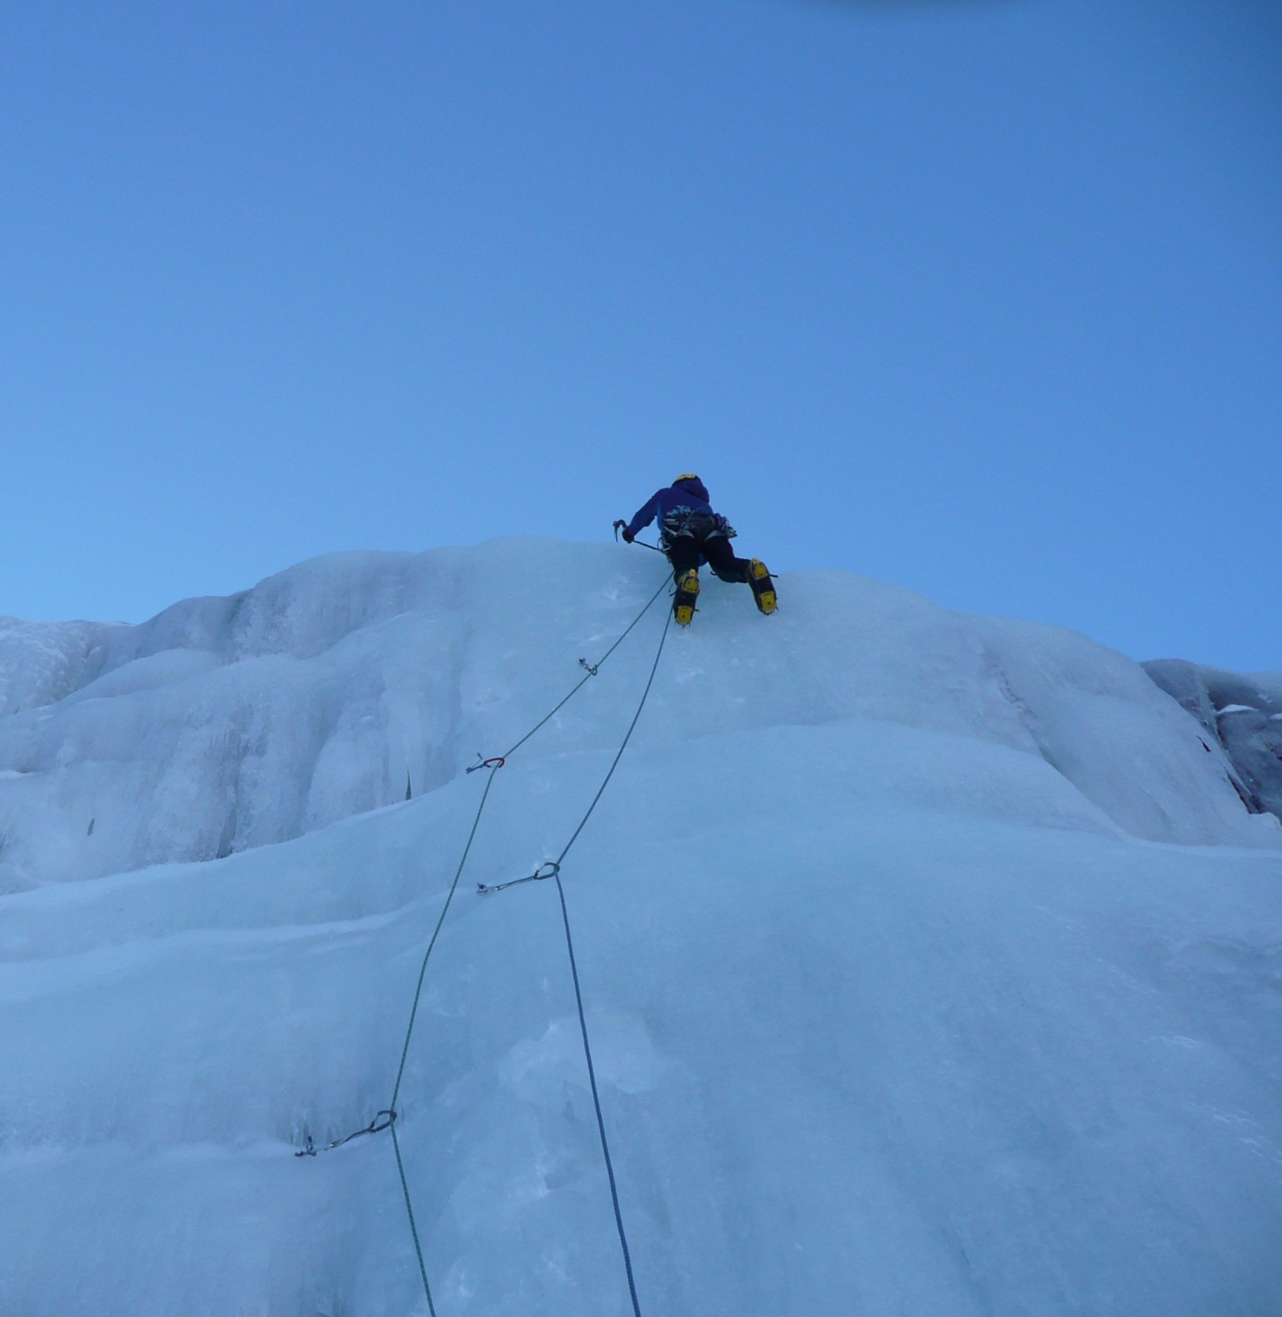

Contents
Introduction 4
Expedition Summary 4
Travel (21-22 Jan 2013) 4
Reconnaissance (23 Jan 2013) 5
Climbing Day (24 Jan 2013) 5
Rest Day (25 Jan 2013) 6
Climbing Day (26 Jan 2013) 6
Hill Day (27 Jan 2013) 6
Walkout (28 Jan 2013) 7
Life as a Tourist (28-30 Jan 2013) 7
Acknowledgements 7
General Information 7
Appendices 9
Fig. 1.0 Bou Ouzzal West North West Face 9
Fig.1.1 Pitch 2, fine open gully 10
Fig. 2.0 Fox on a Spit Area 11
Fig. 2.1 Pitch 1, Stand-Geblasen 12

Report written by Will Rowland.
This report may be referenced for the purposes of personal research.
For additional information please contact the author:
Email: will.rowland@live.co.uk
Telephone: 07708391291

Introduction
The following report describes the activity of two climbers on a British Mountaineering Council supported expedition to the Moroccan High Atlas. The expedition primarily focussed on climbing new winter routes with a secondary aim of repeating existing technical routes in the area surrounding the Toubkal refuges. On the 21st January 2013 Connor Holdsworth and Will Rowland embarked on a journey to Marrakesh; this being the party’s first expedition to Morocco and the High Atlas. Transportation and accommodation to and within the country is easily organised and of reasonable/negotiable price. It is possible to book most of your requirements online. If not, it is straight forward to arrange specific needs during a trip. After extended researching it is clear that the High Atlas has a lot to offer for the adventure climber seeking new challenge in far-flung locations.

Expedition Summary
The expedition consisted of six nights and five full days in the Moroccan High Atlas Toubkal area. This region is a developing area for winter climbing, with huge scope for technical ice climbing. Many of the easier ice climbs in the close vicinity to the Toubkal Refuge have been climbed but many harder or more remote ice lines remain unclimbed. There is also massive potential for rock climbing, though much of the rock appears to be of dubious quality. Due to the situation of technical climbing in the area there is a limited resource of written information and the existing guidebooks (Cicerone and Spanish guidebooks) paint only part of the prize which the High Atlas has to offer. After combing through multiple resources on the area, a few unclimbed lines and some established unrepeated routes seemed to provide suitable objectives. On arrival, the mountains had a great deal less snow and ice than was expected after making comparisons with previous seasons. During the following day, reconnaissance revealed our initial objective (unclimbed ice streaks) to be out of condition; however, other adjacent unclimbed lines were ascended in a winter style. The route consists of a 500m+ snow gully and snow field which finishes on the summit rock ridge of Bou Ouzzal. An unclimbed cascade lay below the hut in a peaceful corrie (n’Imouzzer), giving 5 good pitches of ice with easy terraces in-between. Both routes have tricky route finding in descent and are reasonably long undertakings if ice/snow quality is sub-standard. Feeling the expedition had been a success, the last day was spent wandering up Toubkal, a fine 4000m peak. Re-cooperation took place in Marrakesh before flying back to the UK.

Travel (21-22 Jan 2013)
On the 21st January 2013 the expedition party planned to fly to Marrakesh before taking a taxi to Imlil where it would be possible to walk the 4-6hrs to the Refuge Toubkal Les Mouflons. The refuge provides a comfortable base and lies beneath the main concentration of 4000m peaks in Morocco. From Imlil, mules were used to make the journey more pleasant as between Imlil (1600m) and the refuge (3200m) there is fairly significant distance and height gain. Due to wild weather conditions flights all over Europe were cancelled, leaving Rowland in the North of Scotland while Holdsworth made his way to Marrakesh. After flights were rescheduled, Rowland was able to fly to Marrakesh on the 22nd (a day late). Having transport already arranged it was possible to leave London in the morning and reach the Refuge by evening.

Reconnaissance (23 Jan 2013)
On arrival, conditions were not in keeping with a typical January; this month usually providing the best period for ice climbing whilst Spring (Feb-March) offers the most snow cover for ski touring. Due to the lack of ice up high it was necessary to have a recce of the area to scope potential new ice lines, gullies or rock climbs as conditions would allow for all. First we looked at the North West facing wall of Bou Ouzzal which we had been informed was unclimbed ground. There was no icing on the buttress and the rock appeared poor quality. However, on the West North West aspect there were three easy adjacent gullies, the right hand of which looked to be complete and we decided to have a look the following day.

Climbing Day (24 Jan 2013)
Leaving the hut at 7.30 am we were at the bottom of the gully and kitted out 1hr 30mins later. If you like caving, confined spaces and loose rock this route is for you!
Location: Bou Ouzzal (3860m) (Appendix 1.0)
Route: Glue and Tape
Grade/Length: III, 560m
Approach 120m. Follow easy snow to below a chock stone, belay 15m below in a bay on the left.
Pitch 1 30m. Tunnel under chockstone via through route. This pitch will be harder if the tunnel fills in, though easier if chockstone banks out. Carry some lubrication and breathe in. Alternatively, a steep ramp on the left is possible. Belay after the squeeze.
Pitch 2 60m. Leave the belay and descend into the gully proper, follow it and belay on a chock stone before the next step (Appendix 2.0).
Pitch 3 60m. Follow the left slanting gully to a (short) traverse behind a spike to join the main gully line. Belay on left below an ice step.
Pitch 4 60m. Climb the step and follow snow to a poor rock belay.
Pitch 5 50m. Trend right on snow, ice and choss. Several belays possible.
Pitch 6-8 150m. Come back left between two steep rock bands (possible to descend here to the left).
Pitch 8-
Summit Ridge 150m. Ascend easily upwards, then traverse up and right to the summit ridge

Descent Multiple options! We descended back to pitch 8, and continued traverse to the col (Tizi n’Ouanoums) (route finding hard) it is also possible to traverse the ridge in either direction.

Rest Day (25 Jan 2013)
The weather turned, cloud blanketed the hills and a strong wind developed. Lots of mint tea was enjoyed whilst maxi muscle protein bars and cod liver oil tablets were not.
During the less settled conditions the day before, snowfall ensured any rock climbing out of the question. The high ice lines in the Atlas were mainly out of condition but lower lying cascades fed by snow melt from above looked fat. On route to the hut a large cascade above Sidi Chamharouch looked in great shape. A chance meeting with the author of the Cicerone High Atlas Mountaineering guidebook led us to the conclusion that these falls were unclimbed.

Climbing Day (26 Jan 2013)
Starting at 7.30am the falls were seen after about 1hr 30mins walk down-hill on the main track from the refuge. A further 30min plod into the corrie on the opposite side of the valley leads to the start of the initial ice fall.
Location: Fox on a Spit Area (Appendix 2.0)
Route: Stand-Geblasen (pronounced shtund ge blazin )
Grade/length: WI 4. 5 pitches of ice with terraces in-between.
Pitch 1 20m. Start on the lowest ice fall which is climbed direct (crux) (Appendix 2.1).
Pitch 2 60m. Go to the back of the terrace (40m) climb the ice fall 20m.
Pitch 3 Climb the short ice pitch directly above at the back of the terrace. This leads to the first amphitheatre which gives many options.
Pitch 4 On the right there is a long steep ice fall left of a gully. Climb the ice fall- this leads to another large amphitheatre.
Pitch 5 After crossing easy ground climb an easy ice ramp on the right hand side of the amphitheatre which leads to another terrace.
Descent Traverse down and left on easy snow into the first of 2 gullies. One 50m abseil (from a huge block at the top of the gully) leads to the start of pitch 4. Descend steep snow down and right to the top of pitch three. To the far right a steep down climb or short abseil (in-situ) takes you to the terrace at the top of pitch two. Traverse left or right to easy ground and the start of the route.

Hill Day (27 Jan 2013)
It was decided that it was unreasonable to climb in the High Atlas without summiting Toubkal the highest peak in North Africa, especially as the trade route rises from the refuge. After a leisurely breakfast the march up the south cwm began at 10am. The walk was very sociable, chatting with local guides and their clients. The scenery being very impressive gave fantastic opportunities for photographs; the height gain provided excellent view points of the large faces, gullies and ridges amongst the surrounding mountains. The top was reached without difficulty by 12.30pm. After choking on some condensed milk powder in the summit coffee, it was decided to return to the refuge before any further accidents could happen. Refuge at 2pm.

Walkout (28 Jan 2013)
Ibrahim and his mule helped us down to Imlil (4-6hrs). After becoming friendly with Ibrahim during our stay we were invited to enjoy a Tajiene feast in his family home. Thereafter a taxi was organised from Imlil-Marrakesh.

Life as a Tourist (28-30 Jan 2013)
Two nights in a cheap hotel made it possible to have a deserved shower. Marrakesh was explored, embracing the wonderful mix of African and Arabic cultures before flying to London where connections can be easily made to the rest of the UK.

Acknowledgements
The BMC have been very supportive of the trip, giving financial assistance to aid expedition costs. This funding has been gratefully received. The contributions from The BMC have considerably made the expedition more affordable and allowed more to be accomplished, as without funding the duration of the trip would be limited.
DMM have provided fantastic assistance with the trip. The issuing of the latest DMM winter climbing equipment allowed a physical step forward, having reliable gear in remote settings.
As always, friends and family have been incredibly supportive with equipment and all forms of organisation. Oliver Metherell, Andy Stokes-Rees and Des Clark have also provided key information supportive of the trip which has been crucial to our success.

General Information
The walk to the hut from Imlil can be done without mules, however the area is very tourism reliant and by paying for mules it helps the local Berber people to prosper. For ten pounds (per mule) it makes your life a lot easier!
Arranging transport from the airport via taxi can be done through the refuge whilst you book via email, however it may be more cost effective to arrange it on arrival.
The rock is a variety of limestone, sharing similarities such as being very compact and sometimes loose. Carry a range of rock pegs!
The ice climbed was very fat, taking long screws in most places. The corrie was of a North/North West aspect staying well in the shade. The ice was incredibly hard and the first inch was susceptible to dinner plate, thus making first time placements an absolute rarity. Underneath the initial brittle layer the ice was great, though it took many swings to break through and made leading at your grade hard work.
Conditions were found to be variable in the High Atlas. During the night it reaches -20C but during the day you could be sat outside the hut in a t-shirt. Whilst climbing in the shade a typical Scottish Winter layering system worked well, though a warmer down jacket was used as a belay jacket.

Appendices

Fig. 1.0 Bou Ouzzal West North West Face

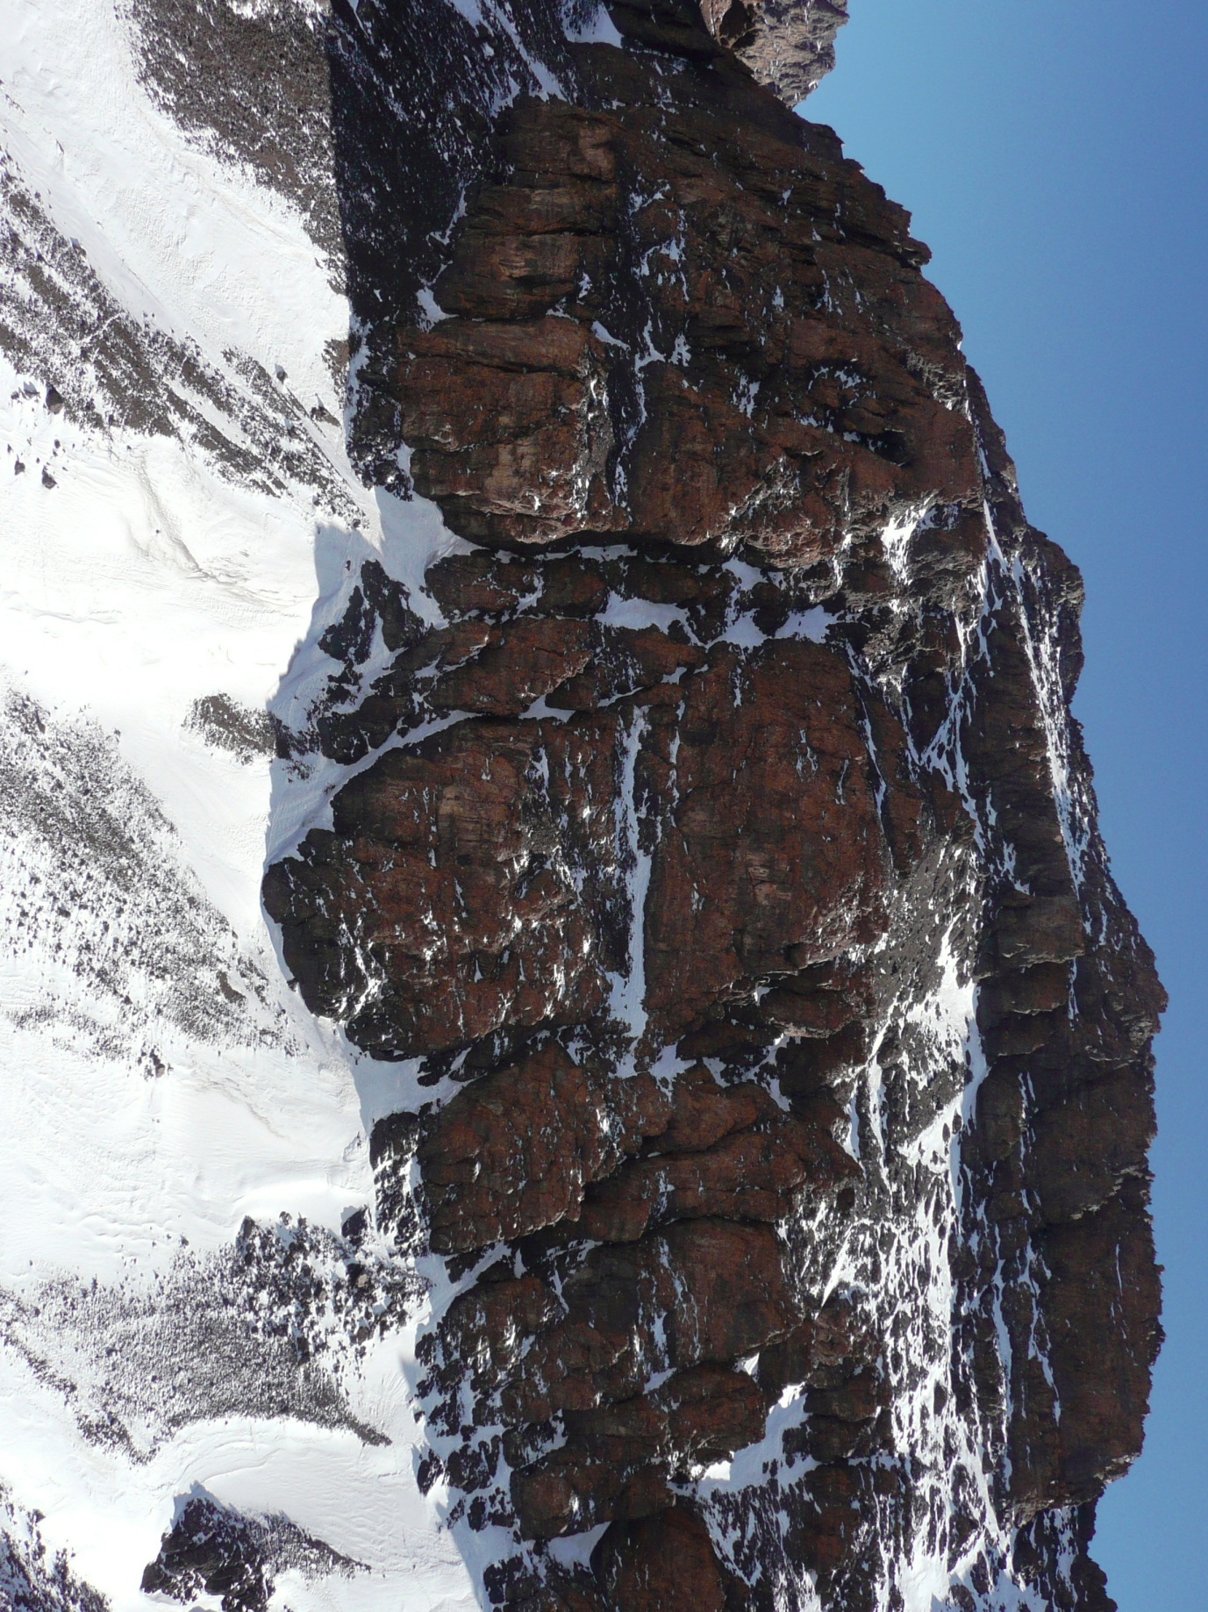

Fig.1.1 Pitch 2, fine open gully
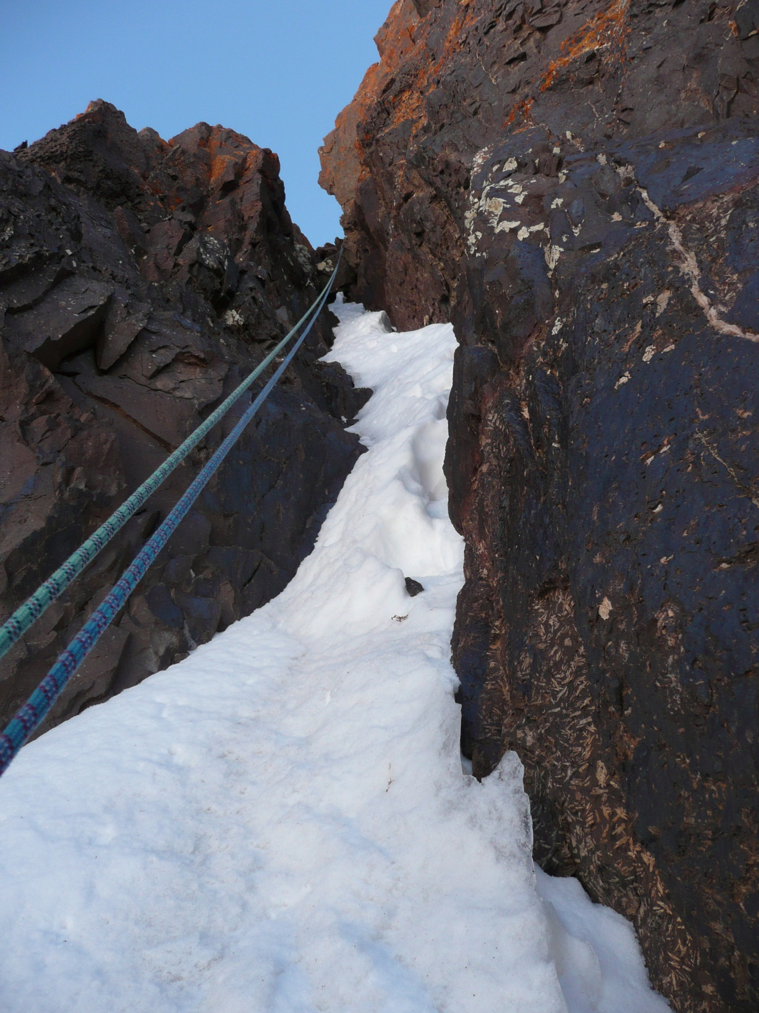

Fig. 2.0 Fox on a Spit Area
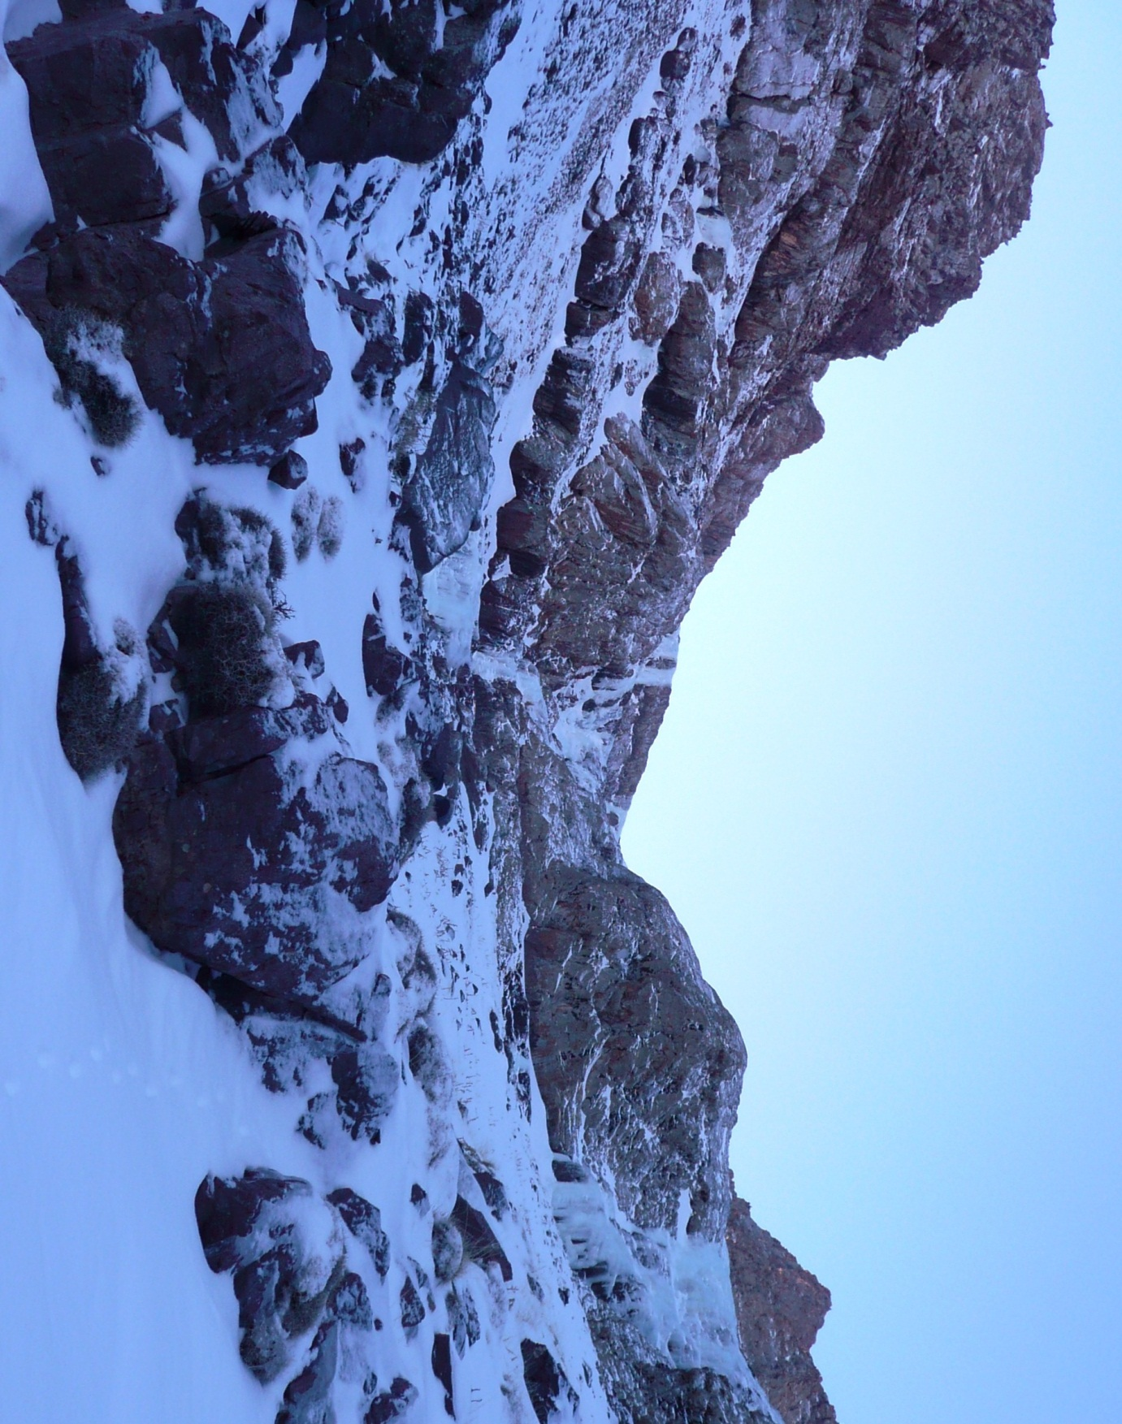

Fig. 2.1 Pitch 1, Stand-Geblasen
