BMC Parental Consent Form for all BMC Climbing Competitions
The following details are to be completed by your parent/guardian. Signed parental consent must be received from participants before they may compete.
Name of Child:.............................................................................................................
Event taking part in:..................................................................................................
Date of event:..............................................................................................................
Location of event:.......................................................................................................
PARENTAL CONSENT: I confirm I am the parent/guardian of the above named child and that I consent for him/her to take part in the above detailed BMC climbing competition. I also confirm that I am aware that climbing is an activity with a danger of personal injury or death and that I am responsible for providing appropriate personal safety equipment for the above named child to undertake this competition. I have read the all the relevant information on the BMC website regarding this event and understand the nature of the competition activity.
Signed (parent or guardian only) .................................................………………..........
Date ………………………….
Name of adult responsible for child on day of the event………………………………...
Emergency contact number…………………………………….…..................................
Please note: without this information the child will not be allowed to take part in the event.
Kind regards,
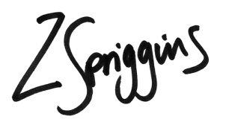
Zoe Spriggins
Competitions Programme Manager
Zoe@thebmc.co.uk

